Detail library and coordinated specification
Linked copies: ID STD-70 · TBP page · BABOOM edition · ArchHub: BABOOM companion
BBM-STD-70-DETAIL_LIBRARY-V0.2 | Office standard | 4 November 2026 | V0.2 | Private controlled WIP draft for office review

Revision history
Version | Date | Change
V0.1 | 16 October 2026 | First controlled draft.
V0.2 | 4 November 2026 | Audit res-026 closure: G231 R23 collection upgrade route and save release via BBM-STD-91 (O-DEC-120); G232 MasterFormat declared a library-only classification with a Uniclass mapping field (O-DEC-116); G233 UAE fire/​envelope criterion sources; G234 W3-C02 sent to the Decisions Log; G230 references trimmed; share paths moved to the 2026-11-04 folder map; links to Manual V0.4/​BEP V0.5. + cross-doc pointer pass. + template alignment (O-DEC-142..148) + folder names without dots (O-DEC-149)

1 Scope categories and existing library
This standard covers SG-064. Technical design lead owns detail adequacy and coordinated specification; detail curator owns library identity/release; discipline author adapts content; independent technical and drawing reviewers check the exact use. Follow BoD, CAD standard, drawings, dictionary and Manual 6.2. Use the editable detail index and check pack and synthetic A3 sample sheet.
The published library is BABOOM-BIM-STANDARD/02-LIBRARIES/03-DETAILS/01-BBM-DETAILS-LIBRARY (renamed from BBM-DETAILS-LIBRARY on 2026-11-04), with INDEX.csv, 01-CAD and 02-REVIT; the old CATALOGUE.html was archived to 03-DETAILS/98-ARCHIVE/ on the same date. Its read-only README describes one-detail DWGs in model space at 1:1 and an R23 (Revit 2023) RVT drafting-view collection. Revit 2023 is out of Autodesk support (O-DEC-120) and is the office template's authoring release: the R23 collection stays at the library save release set in BBM-STD-91 §3 (the template's authoring release, currently Revit 2023; O-DEC-139 as refined by O-DEC-142). Projects upgrade a copy on load per BBM-STD-91 §4, recording the upgrade build and SHA-256 per file; an upgraded copy is never saved back into the library. This session observed 318 index rows/318 unique codes, not 318 technically accepted or rights-cleared details. INDEX.csv 79236 bytes SHA-256 ad6553f4c77ac4f1286f95a808cd13f68013e55f181820629a60f4494207a84d; catalogue 269209 bytes SHA-256 7761ab33e94eefc65af88836754dde9b52b55eb7d0c52e63bd381870450b178c (both read 2026-10-16, before the 2026-11-04 rename/archive). Re-read on 2026-11-04: INDEX.csv has 345 rows, SHA-256 9854d8c43aac0bb3b73c100e9dfce5b4a27367c1cdda9ff92db251118e7dfb88; quote the snapshot used. One indexed CAD path was resolved read-only. Actual native view content, save release, print scale and receiving behavior were not executed. Native RVT filename/year and README claims require owner verification before a new supported-use claim.
Organise details by discipline and technical system/interface, retaining the existing library's pinned MasterFormat section/folder classification and rights restrictions. MasterFormat is a library-only classification exception declared in BBM-STD-72 §3; the office classification remains Uniclass 2015 (Classification_Code, O-DEC-116). The curator records the MasterFormat edition actually used (from the library README/index; it is not stated in the index read 2026-10-16) and each item carries a Uniclass_Code mapping field (Pr or Ss code plus the pinned July 2026 table release) so details join model and specification data. Do not replace it with a second library or claim its historic classification edition is current by renaming it. Preserve BBM-DET-<section>-<nnn> published IDs and never reuse retired numbers. Manual's DET-DISC-CAT-INDEX-DESC is a native view alias, not an alternative immutable asset ID. Conflict W3-C02 records the distinction and is registered in the Decisions Log; the DISC token uses the 3-letter codes in BBM-STD-93 (O-DEC-103). The synthetic DetailID SYN-DET70-001 maps to DET-ARC-GEN-401-TEST_INTERFACE and sheet/detail01/A-40-101; it is not a fabricated publisher classification code.

2 Provenance applicability and reusable metadata
The master index owner retains published identities and adds controlled metadata through an approved extension/mapping, not by overwriting the original share. Each item needs DetailID, technical title/category, source and authorship/rights reference, acquisition/source date, revision/hash, native path/view, scale/units/insertion origin, system/material/location applicability, specification section/edition, BoD criterion IDs, responsible author/checker/curator, review state, permitted use and reuse restrictions. Source year is historical metadata, not authorship, licence, current design or approval evidence. A thumbnail is a discovery aid only.
Treat every reused detail as a candidate: confirm actual substrate/system, exposure, movement, dimensions/tolerances, access/construction sequence, interfaces and applicable code/manufacturer sources. Unknown provenance or permission holds reuse; removing a project name does not grant rights. Do not include client identities or source project details in examples or publicly share the library. Maintain the original privately controlled reference while producing a neutral, scoped project adaptation. Record which content was copied, redrawn, parameterised or excluded and why, without losing source lineage.

3 Graphics dimensions and specification coordination
CAD resources, units/layers/line/hatch/text/font/plot profiles follow BBM-STD-66; Revit categories, view templates, keynotes and sheet controls follow Manual 4 and BBM-STD-67. Use the same semantic detail/spec/material IDs in both environments. A reusable Revit drafting view contains 2D detail content; model-derived sections remain model views with source model/revision and cannot be represented as independent truth by tracing. Register intentional model-to-detail overlays, reference breaks, dimensional limits and update owners. Avoid duplicated contradictory dimensions and unreferenced filled regions concealing the source.
Dimension the feature that is actually controlled: clear gap, centreline, finished face, structural face and nominal product size are distinct. Record unit, tolerance and source; derived dimensions must agree with native geometry and specification. Do not text-override a measured value to match a note. Keynote codes resolve to the exact controlled table/spec clause and revision; manual user keynotes are declared legacy exceptions with an owner. The specification carries material/performance/test/installation requirements; hatch/colour alone conveys none of those properties. Bidirectional checks confirm each placed detail callout resolves to a current target, target title/scale is correct and every specification/material reference exists and agrees.
Published index scale tokens include 1:0 and unusual ratios. Verify them against native viewport/view scale, units and a measured plot before use; never silently reinterpret 1:0 as 1:1 or patch published metadata here. Model space 1:1, drafting-view scale, viewport scale and PDF print settings are separate records. Revit drafting patterns and CAD hatch scaling follow their owning standards; no local stretch of a pattern repairs a wrong model unit. Actual printable fonts and line/hatch legibility require full-sheet and critical-detail review.

4 Competent technical review and manufacturer evidence
Assign buildability and discipline review appropriate to each detail. Check continuity at adjacent systems, movement/tolerances, installation/maintenance access and sequencing; fire compartmentation/penetrations, moisture/air/vapour/drainage paths, thermal/acoustic bridges, structural fixings and durability require the relevant competent designer and source. Record criterion/value/unit, controlled source/edition/clause and applicability, evidence, reviewer and unresolved limitations. No generic minimum sealant width, fire rating or waterproofing performance is invented by this standard. The criterion-source column names the local source: fire, penetration and facade criteria cite the UAE Fire & Life Safety Code of Practice (September 2018 edition plus the emirate Civil Defence amendments current at project start, recorded in BEP); Dubai building criteria cite the Dubai Building Code (Decree 45/2021 as amended by DM Administrative Resolution No. 225 of 2024, plus every DM amending resolution in force at permit submission); Abu Dhabi criteria cite the ADIBC edition published by DMT and in force at project start (2013 edition at 2026-11-04). Instrument rows and editions come from the BBM-STD-51 §3 register (O-DEC-111) and BBM-STD-85. A fire-rated detail also needs Civil Defence approved/listed product evidence for the actual product; ratings are stored as Fire_Rating in integer minutes with Fire_Rating_Standard and Fire_Rating_Source (O-DEC-119).
Manufacturer drawings/certificates/instructions must match actual product, substrate, configuration, environment, dates and use restrictions. A similar product image or old detail does not establish tested performance. Resolve conflicting model/spec/manufacturer requirements with the technical lead and relevant specialist before affected issue; record a change/decision rather than silently choosing the easiest dimension. Authority approval and information acceptance remain separate project records under BBM-STD-12/57. The sample below supplies no manufacturer, fire, acoustic, moisture or structural compliance claim.

5 Native storage release and project adaptations
Store reusable source in the existing controlled CAD/detail-RVT routes with immutable DetailID and source/dependency hashes, exact application/full build, native view/block identity and qualified supported uses. Consumers remain read-only. Curator releases through the established rebuild/index/catalogue owner; this writing assignment performs no native save or share write. Transfer only approved selected resources and inspect units, insertion base, text styles, hatches, keynotes and category dependencies in an isolated receiver. Exploding/importing a whole library into a live model is not an admission method.
Every project adaptation receives its own project record linked to source ID/revision, approved modifications, affected system/location, design criteria and spec/manufacturer revisions, reviewer and issue. Do not change the shared standard to hide a project-specific deviation. Source revision/retirement triggers impact review of all declared consuming projects, drawings/model views, references and specifications; identify replacement and notify owners. Retain issued history and acknowledge withdrawal/replacement. Rollback restores a compatible preserved source and mappings through the curator, then regenerates/rechecks outputs; no unsupported native save-back or isolated PDF patch.

6 Sample sheet forms and acceptance
The synthetic one-page PDF is A3 landscape 420x297 mm. Its title block gives A-40-101, DetailID SYN-DET70-001, native view alias, external logical container CLI-OFF-P070-Z01-L01-DR-A-0001, R01/date, WIP review purpose and unappointed author/checker functions. It depicts two neutral test layers SYN-L1/L2 linked to SYN-SPEC70-01/02 R01. At 1:5 the 50 mm test gap is drawn 10 mm on paper; the separate 100 mm paper bar stays 100 mm at actual-size printing. Line weights 0.50/0.18/0.13 mm are explicitly synthetic drawing-fixture inputs, not a replacement for the adopted office graphic settings. No wall/floor or performance design is implied by the neutral layers.
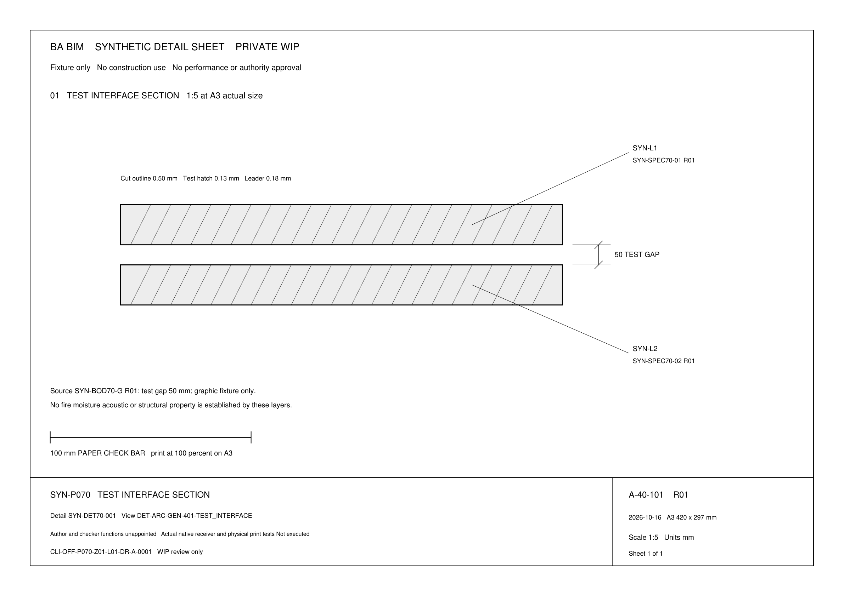
Reduced preview only. Use the linked A3 PDF at actual size for scale tests; the MD/DOCX image is not a measured print.
The workbook Index, Author check, Criteria, Specification, Sheet, Tests and Release sheets have blank forms and a coherent populated synthetic slice. Reviewers record native/source/output hashes, builds/preset, actual measurements and independent evidence. Mutations independently replace a spec revision, remove a target callout, change the gap annotation without geometry or apply Fit-to-paper; expected failures and corrected retests are specified. Reset each test from the original fixture and retain separate failed/corrected evidence. The supplied vector PDF/preview is an actual sample artifact; CAD/RVT export, recipient reopening and physical print measurement remain Not executed.
Before real release reconcile all detail IDs, drawing references, source/model dimensions, specification/material clauses and manufacturer evidence for the declared scope. Review every sheet at full extent and critical details at intended size under BBM-STD-67; perform the qualified native/receiver opening/unit/graphics checks and measure a required physical print. Mandatory source/technical/reference/readability failures hold affected issue. Producer, independent technical reviewer, graphic reviewer, delegated authoriser, curator and recipient decisions remain separately recorded. Synthetic inputs, green script checks and library counts cannot substitute for competent design/buildability review or receiving acceptance. This pack is a controlled WIP standard, not approved construction detail release.

References
• Office Manual V0.5, BEP V0.5, glossary V0.3, BBM-STD-51/54/55/57/63/65/67/72, BoD BBM-STD-12 and MIDP/TIDP V0.3 are controlled prerequisite owners. Synthetic IDs in this standard create no office adoption, appointment or native acceptance.
• ISO 19650-1:2018, clauses 5/11; ISO 19650-2:2018, clauses 5.1.4/5.6.3/5.6.4/5.7, are reading pointers for requirements, container checks, content review and exchange. ISO 19650-3:2020 addresses operational update context; ISO 19650-5:2020 security-minded lifecycle context. Public catalogues/guidance support scope and pointers, not a licensed clause conformity audit; no paid paragraphs copied.
• IMI Framework (formerly UK BIM Framework, renamed May 2025) Part 2 ed5 and Part D ed2 inform purpose, responsibilities and review; both are archived guidance editions on ukbimframework.org/resources, checked 2026-11-04. ISO 7817-1:2024 is the current researched LOIN concepts reference; BS EN 17412-1:2020 BSI record is predecessor context. Preserve an adopted appointment edition until controlled change.
• UAE criterion sources (G233), checked 2026-11-04: UAE Fire & Life Safety Code of Practice, September 2018 (DCD); DM Administrative Resolution No. 225 of 2024 amending the Dubai Building Code; ADIBC 2013 companion code (DMT). Edition rows are held in BBM-STD-51 §3 and BBM-STD-85.
• Autodesk previous versions list, checked 2026-11-04: Revit 2023 not listed (out of support); matrix in BBM-STD-91.
• Read-only published README/index/catalogue fingerprints above; Manual 6.2; BBM-STD-66/67 and NCS v7 public content, ISO 128-1:2020 and ISO 7200:2004 are drawing/field benchmarks. Licensed text and proprietary details are not reproduced. Office controls and actual project/authority adoption govern.

