21 · BIM and Revit Initiation
Linked copies: ID STD-21 · TBP page · BABOOM edition · ArchHub: BABOOM companion
BABOOM-BIM-STANDARD · Office BIM workshops · Presenter: Ahmed Fargaly · Revision v0.2 · 14 October 2026 · Status: training draft for office review

Purpose & scope
Start a Revit model that the next person can understand and the delivery team can exchange. Keep the workshop habit: learn the interface, set the datum first, build real elements, and use the model for coordinated drawings and quantities. This introductory guide covers the starter file, basic walls, families and title blocks; specialist modelling continues in the related guides.

Standards basis
ISO 19650-1:2018 supplies information-management concepts; ISO 19650-2:2018 supplies delivery planning and mobilisation; ISO 19650-4:2022 supports checked exchanges. ISO 7817-1:2024 specifies level of information need (LOIN). These standards do not choose Revit buttons or prescribe an office software release. This guide serves the office Manual v0.1 §3.2 Parameters, §3.3 Worksets, §§4.9–4.12 start view/title blocks/browser/templates, §8.2.3 Project Initiation Methodology and §11 Data Exchange. Resolve conflicts with the adopted requirements and record any office deviation.

Prerequisites and controlled baseline
Work in a training copy until the exercise is checked. Obtain the applicable exchange information requirements (EIR), confirmed BEP, office Manual and approved content library. The BIM manager assigns the trainer/checker; the task-team lead owns the model work. These instructions do not confer project acceptance authority.
Record before use | Value /​ evidence to enter
Project/​training model and revision | [identifier; WIP location; baseline revision]
Revit release and full build | [Help > About; record all build digits; check every collaborator]
Template and content revision | [approved RTE/​RFA identifiers, revision and controlled location]
Requirements and office documents | [EIR/​BEP/​Manual revisions; approved deviations]
Exchange and recipient | [native/​open format, IFC schema/​profile, exporter build and receiving tool]
Trainer, checker and date | [roles; test date; evidence location; decision]

The 2024 workshop is historical teaching evidence. No exact installed build or approved library revision was supplied for this rewrite. Complete this form and run the exercise in the adopted release before project use; do not substitute “latest” for a tested version. References to Autodesk Help identify the documented release, not an office installation.

1. Why BIM and the words we use
Before coordinated information production, each discipline can be working from a different revision. BIM connects information and responsibilities so teams can find and resolve those differences earlier. It can federate separate discipline models; everybody need not author one file. A visible intersection is an investigation prompt, not automatic clash detection or proof of design compliance. Quantities and documents are only as reliable as their scope, modelling rules and checked data.
Term | Use in this office guide
BIM | Collaborative management and production of information; Revit is one authoring tool.
EIR | Exchange information requirements: information required under an appointment. “Employer’s Information Requirements” is a legacy expression; retain it only when identifying an actual legacy document.
BEP | Plan responding to the requirements: responsibilities, methods, tools, checks and exchanges. Distinguish tender/​pre-appointment proposals from the confirmed delivery-team plan.
LOIN | Purpose, timing, actors and objects determine geometry, alphanumeric information and documentation. Collect what is needed, rather than maximum data.
LOD | An optional named convention with an explicit object-level definition. Level of Development and Level of Detail are different concepts; neither is automatically a whole-discipline versus single-element distinction.
IFC | Industry Foundation Classes; agree schema, exchange profile and recipient tests. “Issued for Construction” is a separate status expression; avoid ambiguous abbreviations.
CDE | Agreed information workflow plus technical solutions: WIP, Shared, Published and Archive with permissions, metadata and decisions.

BIM maturity labels are historical framework descriptions. They are not dimensions such as 4D time or 5D cost, and ISO 19650 does not declare that the industry is at “Level 3”. A spreadsheet may be the right information container for a task; it is not inherently more compact, authoritative or interoperable than a model. AI explanations are learning aids: verify definitions against the controlled Glossary and the sources below before adoption; do not upload restricted project information.
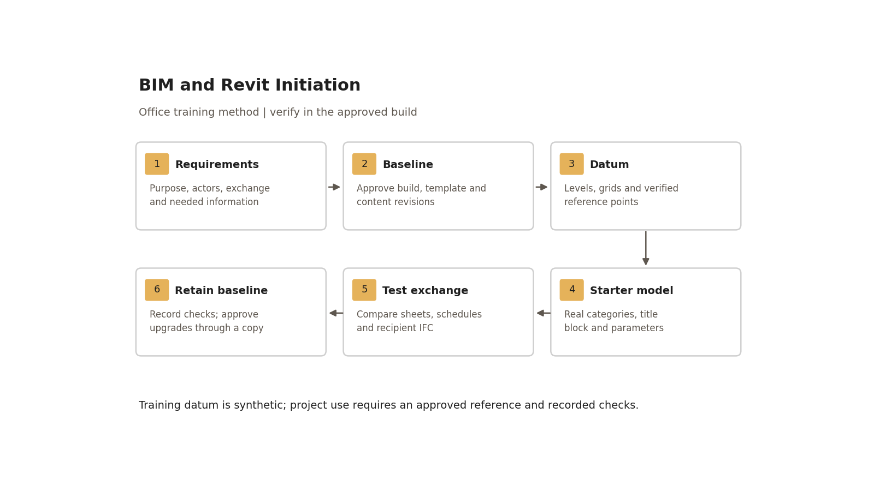
Training datum is synthetic; project use requires an approved reference and recorded checks.

Step-by-step procedure
1. Read the baseline form with the BIM manager. List the intended uses, first exchange, author/checker/recipient and required geometry/data/documents. Agree native and open formats, model split and CDE location before creating a file.
2. Create a new project from the approved template in the adopted release. Record units, discipline, view-template names, object/line styles, annotation types and initial content. Use a controlled working location with adequate space; IT defines local storage and backup, rather than choosing a drive letter from the recording.
3. Find New/Open/Save/Export and Options in the application menu. Add frequent tools to the Quick Access Toolbar. Learn keyboard shortcuts from the adopted configuration: LL, GR, DI and CS are workshop defaults and can be customised. Use the View Control Bar for scale, detail level, visual style, crop and temporary visibility. Different tools are available in different view types/builds.
4. Establish levels in a section or elevation, then grids and dimensions. Obtain approved level names/elevations and the coordinate reference from the designated datum owner. Record units, survey/source revision, model origin strategy and link positioning method. Provisional values must be labelled and held from survey-dependent exchanges. Check at least two separated control points and one elevation against the authoritative reference; do not move the datum to make an unverified link look right.
5. Register each discipline/site reference with owner, revision and reload route. Separate model partitioning from worksets and view graphics. Link through the agreed method, test alignment, and record the receiver check. Guide 30 develops site setup; this starter model still needs an explicit authority and reference record.
6. Make a short sample wall. Duplicate a type before altering it. In Edit Type > Structure, define layer function, material and thickness; place the core boundaries around the intended construction core. Check joins and dimensions in plan/section. Wall Function is a type property. Cladding/finish arrangement follows the specified assembly, not an absolute rule that every non-structural layer must be outside the core. Use sweep/reveal profiles for additions/cuts and test wrapping at inserts and ends.
7. Place a floor, roof and ceiling using the appropriate tool. Roofs can use footprint, extrusion or supported face workflows. A mass has a Mass category; it is not automatically a scheduled construction element. Convert suitable faces to walls/floors/roofs or curtain systems and check the resulting categories. Do not teach that ceilings are always manually sketched or that a room can never be above a roof: use supported tools and test room-bounding geometry, levels and computation settings in the adopted build.
8. Load an approved door/window and a tag. System-family types live in projects/templates and can be transferred through selected standards or approved copying; they are not standalone loadable RFA files. Loadable families include model and annotation categories; profiles are supporting geometry families, not all annotation. In-place modelling needs an approved, documented exception. Purge only after checking dependencies and library needs in a copy; “unused” does not mean safe to remove from a template.
9. Make a starter sheet with the office title block, sample plan and section. Populate sheet number/name/date/drawn-by using the required parameter bindings. Instance values affect the selected instance; type values affect all instances of the type. Inspect annotation at two intended scales: text/symbol size is generally a paper-size setting, while model geometry scales with the view. Do not redraw model geometry to fix paper annotation.
10. Run the startup checks below. Export the agreed IFC sample using the recorded exporter/profile; open it in the receiving tool and compare counts, properties, datum and dimensions. Correct and repeat failed checks. Retain the approved starter revision before enabling production worksharing.
11. Upgrade only by an approved change plan. Preserve the original RVT/RTE/RFA baseline and links, list affected collaborators/add-ins/exporters, upgrade a copy, and repeat sheets/schedules/parameter/exchange tests. Revit files cannot be saved back to an older release. Rollback means restoring the compatible preserved baseline and coordinating everyone’s return, not renaming an upgraded file.

Worked starter exercise
Create a synthetic rectangular room, 6,000 × 4,000 mm between internal faces, with two approved levels at 0 and +3,000 mm, one door and one sample furniture type. Values are training inputs, not a real survey. Place two separated control markers and record their intended coordinates. Make an itemised door schedule, a tagged furniture instance, one plan at 1:50 and a section at 1:100 on a sheet. Export the agreed IFC sample and record native versus receiver counts and tag/schedule/property values. Explain why the chosen geometry is sufficient for the stated training use.

Acceptance criteria / self-check list
Check | Pass evidence /​ failure action
Baseline | Completed form, approved template/​content IDs and exact build; missing approval holds project use.
Datum and references | Levels/​grids and two control points plus elevation match recorded expected values within the project-approved tolerance; log actual deviation and units.
Setup | Correct units, discipline, browser organisation and controlled templates; no unapproved default content.
Wall and elements | Section layer sum equals stated thickness; intended joins, categories and room boundaries verified.
Documents and data | Sheet fields filled, tag agrees with schedule, drawings readable at both scales and output dimensions agree with model.
Exchange | Agreed schema/​profile opens in the recipient tool; required objects/​properties and alignment reconcile; mandatory missing data fails.
Upgrade readiness | Compatible baseline preserved; sample upgrade/​rollback plan and named decision owner recorded.

Common mistakes
• Calling a software version an ISO requirement: complete the approved baseline, then test it.
• Moving a link by eye: resolve units/origin/datum with the coordinate owner and repeat the control-point check.
• Editing a shared wall type for one wall: duplicate/type-name the intended variation and check all instances.
• Treating attractive sheets or a successful export as acceptance: check actual values and recipient behaviour.
• Upgrading the only copy: restore the preserved compatible revision and escalate before any team rollout.

Related guides
• 22 — Work Sharing and Collaboration: central/local/cloud access and handoff.
• 23–24 — CAD/complex walls and curtain assemblies: element-level development.
• 25 — Project Initiation — Worked Example: team setup and mobilisation evidence.
• 26–28 — Parameters and documentation; 30 — Site/datum setup; 36 — Schedule checks.

Assessment record and release
Retain the exercise model/family, annotated screenshots, schedules or exports named above, and the completed checks together in the controlled training evidence location. Record learner, task, exact revisions, checker, date, result, defects, correction and retest. A mandatory failure means rework and reassessment; attendance alone is not a pass. The trainer records competence for this task; project use still follows the approved BEP and appointment authority. Do not distribute sensitive models or screenshots beyond their authorised audience.

Research coverage and correction trace
R01.1: baseline form/steps 1–2; R01.2: steps 2–3; R01.3: steps 4–5; R01.4: steps 9–10 and acceptance table; R01.5: step 11. G21 P1: corrected maturity, LOD and IFC claims; version approval made explicit. P2: startup/upgrade checks and glossary mapping. CROSSWALK C01/C02/C04/C11/C12/C14: current terms, project authority and assessed readiness.

References
Sources used from RESEARCH.md (with supplemental verification in GAPS.md where identified). Edition labels describe source evidence; confirm applicability against the approved project baseline. Standard-level references are used because the supplied research does not verify individual ISO clauses.
Source | Title | Publisher | Year /​ edition | URL /​ evidence note
S01 | ISO 19650-1 — Concepts and principles | ISO | 2018, ed.1 | Catalogue /​ abstract; published, revision underway
S02 | ISO 19650-2 — Delivery phase of the assets | ISO | 2018, ed.1 | Catalogue /​ abstract; publisher result exposes English abstract and status
S04 | ISO 19650-4 — Information exchange | ISO | 2022, ed.1 | Catalogue /​ abstract
S07 | ISO 7817-1 — Level of information need: concepts and principles | ISO | 2024, ed.1 | Catalogue /​ abstract
A01 | Project Templates; Create a Model | Autodesk Revit Help | Revit 2026 | Template contents; creation and backward-compatibility warning
A06 | Create Shared Project Parameters | Autodesk Revit Help | Revit 2026 | Category bindings, instance/​type and tag/​schedule use
A10 | How to set up Shared Coordinates using one Revit model as the Site or Base file | Autodesk Support | 15 August 2026 | Local workflow and cloud limitation
A21 | Schedules; About Schedules | Autodesk Revit Help | 2026 /​ 2024 | Schedule types and outputs; grouping and live model data
S12 | Industry Foundation Classes (IFC) | buildingSMART International | Undated live page; 2024 ISO edition | Version and implementation context

Office source: BBM-STD-01-MANUAL-V0.1, sections identified under Standards basis; applicable confirmed project BEP and controlled Glossary. Preserve the source workshop export unchanged.

