22 · Work Sharing and Collaboration
Linked copies: ID STD-22 · TBP page · BABOOM edition · ArchHub: BABOOM companion
BABOOM-BIM-STANDARD · Office BIM workshops · Presenter: Ahmed Fargaly · Revision v0.2 · 14 October 2026 · Status: training draft for office review

Purpose & scope
Keep the workshop habit: start from the office template, link the datum and disciplines, work through your supported local session, save often, synchronise and hand over cleanly. This guide controls one discipline’s workshared model. Small single-author tasks may use a non-workshared model when the BEP permits it. Worksharing and discipline federation solve different problems.

Standards basis
ISO 19650-2:2018 supports mobilisation and collaborative delivery; ISO 19650-4:2022 supports checked exchanges; ISO 19650-5:2020 supports proportionate access controls. Worksets are Autodesk mechanisms, not ISO layers or security permissions. This serves office Manual v0.1 §3.3 Worksets and Model Partitioning, §8.1 Protocols, §9 Quality, §11 Exchange and §12 CDE/Versioning. The approved BEP selects the actual route, model split and responsibilities.

Prerequisites and controlled baseline
Work in a training copy until the exercise is checked. Obtain the applicable exchange information requirements (EIR), confirmed BEP, office Manual and approved content library. The BIM manager assigns the trainer/checker; the task-team lead owns the model work. These instructions do not confer project acceptance authority.
Record before use | Value /​ evidence to enter
Project/​training model and revision | [identifier; WIP location; baseline revision]
Revit release and full build | [Help > About; record all build digits; check every collaborator]
Template and content revision | [approved RTE/​RFA identifiers, revision and controlled location]
Requirements and office documents | [EIR/​BEP/​Manual revisions; approved deviations]
Exchange and recipient | [native/​open format, IFC schema/​profile, exporter build and receiving tool]
Trainer, checker and date | [roles; test date; evidence location; decision]

The 2024 workshop is historical teaching evidence. No exact installed build or approved library revision was supplied for this rewrite. Complete this form and run the exercise in the adopted release before project use; do not substitute “latest” for a tested version. References to Autodesk Help identify the documented release, not an office installation.

1. From X-Refs to collaborative models
Mechanism | Meaning /​ limit
Central/​local | File-based central stores shared changes and ownership. Each author works through a local derived from central. Cloud collaboration uses managed cache and its supported opening route.
Borrowing | Reserves an element for editing. Related hosts, joins or groups can still block changes; no team split guarantees isolation.
Workset | Groups elements for selective loading and organisation; it is not a layer, discipline boundary or security permission.
Link | References a separate model for federation. Link ownership and reload responsibility remain explicit.
Graphics | Categories, templates and filters control view appearance. Workset visibility alone is not an office graphics strategy.
CDE | State/​revision/​suitability and check/​share/​authorise/​accept decisions; synchronisation alone does not issue information.

The office URS (Unique Referencing System) is a local name for the datum/reference file. Record its owner and revision, levels, grids, coordinates and north strategy. Every discipline checks alignment before linking. A federation file references discipline authors’ information; it does not become its producer.

2. Select the route
Route | Supported opening /​ permissions | Backup owner and control
Network file-based | Revit Open at approved central path; Create New Local. Authorised unique identity and read/​write central/​backup access; never author directly in central. | BIM/​IT administrator records central backup location, retention and tested restore route.
Revit Server | Approved compatible server infrastructure; use Revit’s configured server route and supported local workflow, not OS copies. | Server administrator defines supported backup/​recovery and verifies client builds.
Revit Cloud Worksharing | Revit Home/​Autodesk Docs project-model route; required entitlement, membership and author permissions. | Cloud administrator controls model history/​recovery. Never move/​delete/​edit collaboration-cache contents manually.

A desktop sync-folder copy is not automatically a cloud-workshared model. Test author, viewer, publisher and administrator permissions separately. Record access removal for leavers and a backup restore exercise; retention settings without a tested restore are incomplete.
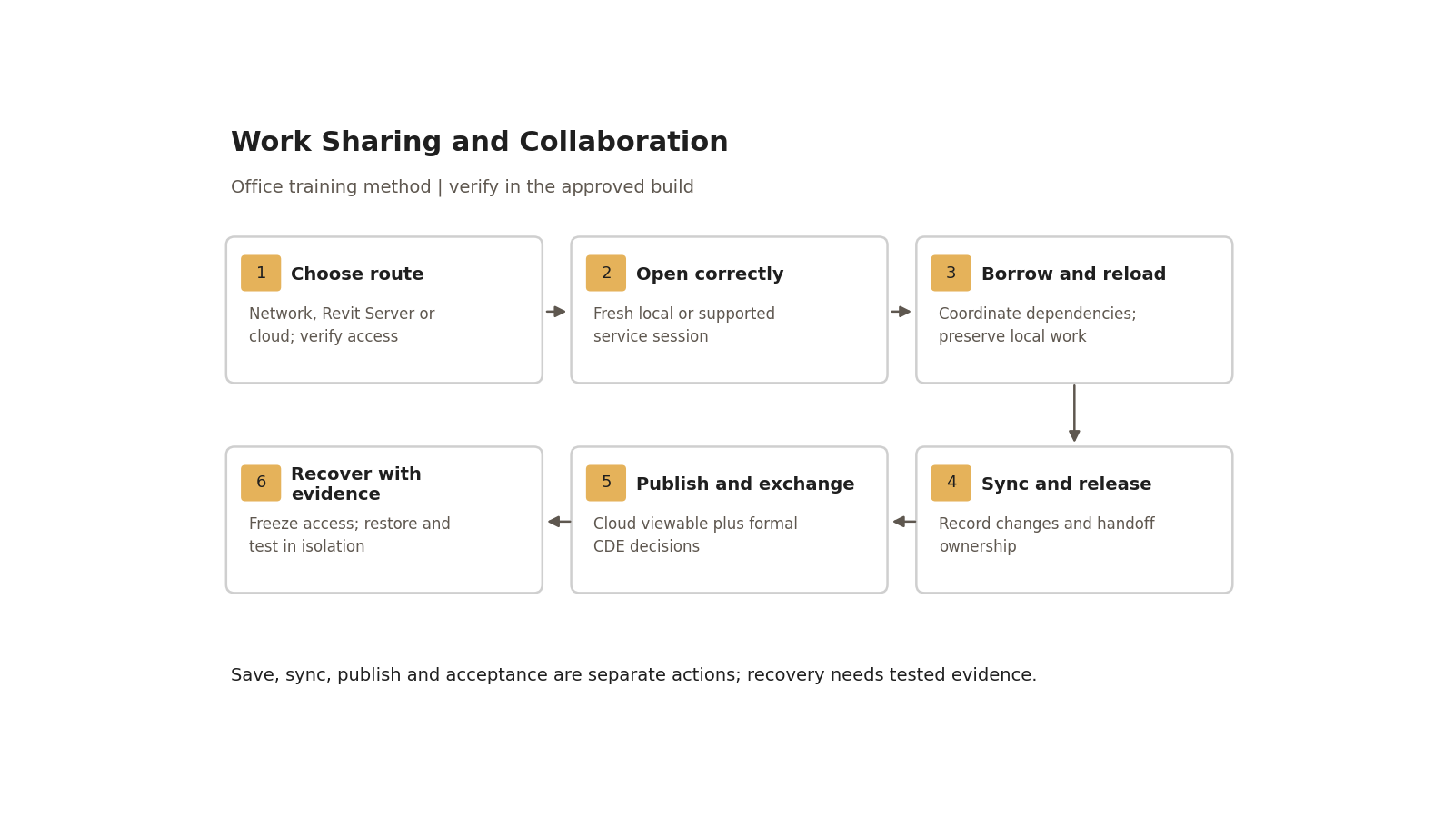
Save, sync, publish and acceptance are separate actions; recovery needs tested evidence.

Step-by-step procedure
1. Confirm the baseline and URS alignment using guide 21. Approve central/model identifiers and access. For a network file enable Worksharing/Collaborate within network, save central using the central-model options and verify backup creation. Server/cloud setup follows the administrator’s service-specific procedure; copying between folders does not change collaboration mode safely.
2. Approve only necessary user worksets. Use the small register below; add heavy scopes only for an actual loading need. New geometry uses the applicable active project workset: inspect placement results. A family template cannot guarantee a destination workset in every project.
3. Open by the supported route. If an old local has unsynchronised work, preserve it before replacing it. An “Append” option does not merge changes. Ask the BIM manager to compare and salvage changes in isolation; copied elements can duplicate data and need retesting.
4. Reload Latest at a suitable pause to receive central changes. Borrow elements as needed rather than taking permanent whole-workset ownership. For blocked edits identify the owner and request release. Coordinate hosting/groups/joins; never impersonate another user to clear locks.
5. Save frequently. Workshop starting rhythms of 5–15 minutes for local save and 15–30 minutes for sync are local suggestions, adjusted for task and network load. Save protects the local session; Synchronize with Central sends and receives shared changes. Record a meaningful sync comment at task boundaries.
6. At handoff complete or identify outstanding work, synchronise with the applicable relinquishment options, verify success and confirm the receiving author can edit a sample element. Use the supported relinquish command if only releasing ownership. Record open issues and the next author’s task; a sync does not guarantee all locks have gone.
7. For cloud viewers follow the approved publication workflow after sync and check the browser-visible sheets/model version. Cloud sync updates collaborating Revit users; publication creates/updates viewable information for other stakeholders. Formal exchange still needs CDE metadata, authorisation, acceptance and a transmittal as defined in the BEP.
8. Before deletion, ask the responsible role and check dependencies, issue status and backup. Views/sheets are shared project objects, not disposable personal spaces. Detail lines are view-specific; grids are model datums. Keep a change record for consequential deletion. Supported restore/recreation can recover some deleted content; “nothing can ever be restored after sync” is unsafe teaching.
9. Log exact errors, model route/path, time and user. Worksharing Monitor assists supported network workflows; repeated entries are symptoms, not proof of one network fault. After suspected corruption/mismatch stop repeated sync attempts and follow recovery below.

Workset register — selectable office example
Names are local examples; actual naming comes from the approved project register. Separate worksets for every wall/floor/roof category are not mandatory.
Workset | Scope /​ assignment | Default open | Accountable role
Shared Levels and Grids | Approved datums | Yes | Datum lead checks changes; avoid permanent whole-set locking.
ARC_Model | Ordinary architectural geometry | Yes | Authors verify element assignment and borrow as needed.
REF_Links | External model references | As needed | Link owner checks instance/​type assignment and source revision.
ARC_Facade (optional) | Demonstrably heavy facade scope | By task | Lead approves the loading need and coordination visibility.

Changing active workset does not move existing elements. Closing heavy sets can improve loading but hide coordination scope. The checker opens all required scope before issue.

Recovery and escalation
1. Stop writes and preserve every potentially useful local, including unsynchronised work. Notify BIM/IT and log the exact error and last known-good revisions.
2. Administrator freezes team access and preserves central/backups/cloud history. Select the route-specific supported recovery method. For file-based models follow the central-backup recovery workflow; for server/cloud use the service procedure. The last person to sync is not automatically the best restoration source.
3. Restore a candidate into isolation. Check opening, warnings, ownership, datum, critical geometry, sheets, schedules and an exchange against a known-good record. Reconcile missing changes and salvage local work under review.
4. Approve the recovered baseline, tell all collaborators to obtain fresh supported sessions/locals, and test two-user sync before reopening production. Record recovered/discarded work and rollback decision. Do not experiment on the live central or cloud cache.

Acceptance criteria / self-check list
Check | Pass evidence
Route/​access | Two authorised test users open the correct model; author/​viewer/​publisher roles tested separately.
Borrowing | B cannot overwrite A’s borrowed sample wall; after release/​reload B can edit it.
Handoff | Both users see the intended changes; sync comments, released ownership and outstanding issues recorded.
Worksets | Approved minimal register; correct sample assignments and no unnecessary whole-workset locks.
Cloud publication | For cloud: sync and browser publication versions recorded separately; expected content visible.
Recovery | Isolated restore passes document/​data/​exchange checks; fresh-session and access-freeze instructions retained.

Practical exercise
In a disposable model, two authorised accounts each place one wall. Attempt to edit the other’s borrowed wall, then reload/sync/relinquish and repeat. Keep annotated ownership screenshots, sync comments, workset register and handoff. Prepare a blocked-edit incident log. With the administrator, restore a known training backup into isolation and compare element counts, sheet fields and datum. For the cloud route compare browser contents before/after publication. All applicable acceptance rows must pass with no lost/duplicate sample elements.

Common mistakes
• Treating worksets as security: control service/CDE access and distributed information.
• Overwriting an unsynchronised local: preserve it and reconcile changes first.
• Opening central/cloud cache directly: use the registered route.
• Repeatedly retrying a serious sync error: protect work and escalate with evidence.
• Calling a synced revision issued: check publication and CDE decisions separately.

Related guides
• 21 and 25 — startup and mobilisation; 30 — datum/link setup.
• 24 and 29 — heavy facade scope; 28 — graphics controls.
• 31 — daily workflow; 36 — schedule reconciliation after recovery.

Assessment record and release
Retain the exercise model/family, annotated screenshots, schedules or exports named above, and the completed checks together in the controlled training evidence location. Record learner, task, exact revisions, checker, date, result, defects, correction and retest. A mandatory failure means rework and reassessment; attendance alone is not a pass. The trainer records competence for this task; project use still follows the approved BEP and appointment authority. Do not distribute sensitive models or screenshots beyond their authorised audience.

Research coverage and correction trace
R02.1–5: route table, steps 3–7, recovery/access checks. T07.1–5: mechanism table, register, borrowing/handoff and route-specific recovery. G22 P1: unsafe restore rule/no-block guarantee corrected; unsynchronised work protected. P2: routes/permissions/publication/minimal worksets added. CROSSWALK C04/C05/C14 addressed.

References
Sources used from RESEARCH.md (with supplemental verification in GAPS.md where identified). Edition labels describe source evidence; confirm applicability against the approved project baseline. Standard-level references are used because the supplied research does not verify individual ISO clauses.
Source | Title | Publisher | Year /​ edition | URL /​ evidence note
S02 | ISO 19650-2 — Delivery phase of the assets | ISO | 2018, ed.1 | Catalogue /​ abstract; publisher result exposes English abstract and status
S04 | ISO 19650-4 — Information exchange | ISO | 2022, ed.1 | Catalogue /​ abstract
S05 | ISO 19650-5 — Security-minded approach to information management | ISO | 2020, ed.1 | Catalogue /​ abstract
A02 | Workflow: Setting up a Workshared Project; Enable Worksharing | Autodesk Revit Help | Revit 2026 | Central/​local workflow; enablement and ownership
A03 | Workflow: Revit Cloud Worksharing; About Revit Cloud Worksharing | Autodesk Revit Help | Revit 2026 | Synchronise versus publish; supported workflow and cache
A08 | Visibility and Graphic Display in Project Views; About View Filters | Autodesk Revit Help | 2026 /​ 2025 | Category/​filter/​element controls; filter priorities and templates
X04 | Worksets | Autodesk | Revit 2026 | Official Help. Project-element assignment, ownership, borrowing/​relinquishing, opening and recovery topics.
X05 | Recover a Workshared File | Autodesk | Revit 2026 | Official Help. Controlled central-backup recovery workflow.

Office source: BBM-STD-01-MANUAL-V0.1, sections identified under Standards basis; applicable confirmed project BEP and controlled Glossary. Preserve the source workshop export unchanged.

