23 · Bringing in CAD Cleanly and Complex Walls
Linked copies: ID STD-23 · TBP page · BABOOM edition · ArchHub: BABOOM companion
BABOOM-BIM-STANDARD · Office BIM workshops · Presenter: Ahmed Fargaly · Revision v0.2 · 14 October 2026 · Status: training draft for office review

Purpose & scope
Bring a CAD reference or detail into the office workflow without polluting the live model. Keep the workshop’s buffer-file method: isolate, rebuild with approved styles, then check what actually crossed into the project. Also develop compound and face-based walls with sections and quantities that can be checked. A tidy sheet alone is not a clean model.

Standards basis
ISO 19650-2:2018 supports controlled production/references; ISO 19650-4:2022 supports revision-specific checks; ISO 7817-1:2024 supports purpose-led modelling detail. This serves office Manual v0.1 §4 Revit Standard, §5 CAD Standard, §6.2 Detail Libraries, §8.2 Importing Protocol/Modelling Methodologies, §9 Quality and §11 Exchange. The office default is to rebuild reusable CAD details as native Revit drafting content. A revisable CAD reference may be linked with an approved exception and named reload owner; Autodesk does not universally prohibit linked details.

Prerequisites and controlled baseline
Work in a training copy until the exercise is checked. Obtain the applicable exchange information requirements (EIR), confirmed BEP, office Manual and approved content library. The BIM manager assigns the trainer/checker; the task-team lead owns the model work. These instructions do not confer project acceptance authority.
Record before use | Value /​ evidence to enter
Project/​training model and revision | [identifier; WIP location; baseline revision]
Revit release and full build | [Help > About; record all build digits; check every collaborator]
Template and content revision | [approved RTE/​RFA identifiers, revision and controlled location]
Requirements and office documents | [EIR/​BEP/​Manual revisions; approved deviations]
Exchange and recipient | [native/​open format, IFC schema/​profile, exporter build and receiving tool]
Trainer, checker and date | [roles; test date; evidence location; decision]

The 2024 workshop is historical teaching evidence. No exact installed build or approved library revision was supplied for this rewrite. Complete this form and run the exercise in the adopted release before project use; do not substitute “latest” for a tested version. References to Autodesk Help identify the documented release, not an office installation.

1. Choose reference or conversion
Need | Preferred method | Control
Revisions expected from CAD author | Manageable link | Source revision, positioning, layers, reload owner and availability recorded.
Reusable office detail | Native drafting detail | Rebuild directly, or clean in a separate buffer before transfer.
One-time external geometry | Scoped import only if approved | Explain need, isolate/​check styles and remove when obsolete.
Stage-specific connection information | Model only needed geometry; referenced detail for the rest | Agree LOIN and identify model/​detail revision; no automatic “bolts never need modelling” rule.

Do not explode CAD in the live project. Imported/exploded content may introduce many styles, small segments and geometry that harm maintainability/performance. It does not inevitably crash every model, but it needs a controlled admission route. Transfer Project Standards is selective: identify source and target, choose only approved settings and review duplicate-type handling. Never assume a template transfer or copy/paste guarantees that only office styles arrive.
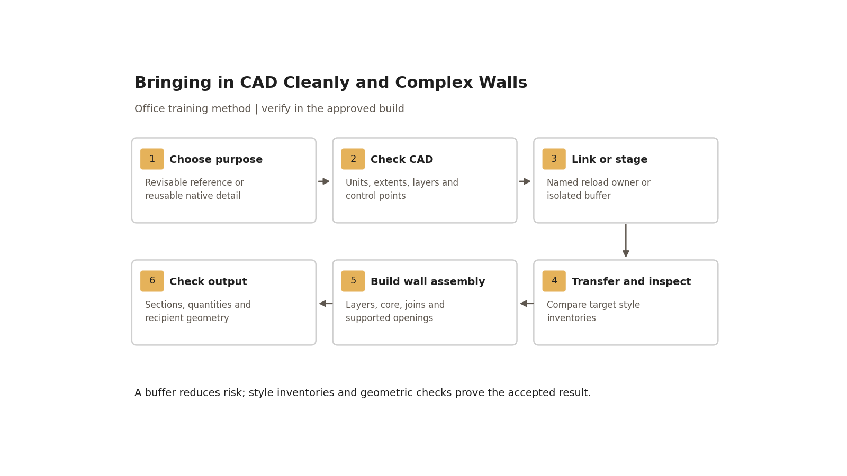
A buffer reduces risk; style inventories and geometric checks prove the accepted result.

Step-by-step procedure
1. Record why the CAD is needed and who owns it. Obtain the approved revision and permission to use it. Inventory units, declared origin/coordinate basis, extent, required layers, external references and missing dependencies. Remove unrelated distant objects in an authorised copy; preserve the donor source.
2. Test a known dimension and two separated alignment points plus elevation where applicable. Select the approved positioning method deliberately. Do not use automatic centring to claim surveyed alignment. Record expected and measured values/tolerance with units; reject unknown units or unresolved datum for coordination.
3. For a revisable reference, use Link CAD. Select Current View Only for an approved 2D view-specific detail where supported; model placement is for geometry needed across views. Check the actual view visibility. Register path, source revision, positioning, view/model scope, workset if applicable, reload owner and next review. Pin when appropriate; pinning is accidental-movement protection, not a security lock.
4. Manage visibility through Imported Categories/layers and view controls. Query can identify source layers/elements where supported; use deliberate view controls for hiding. Reload through the registered owner after reviewing a new source revision. Repeat dimension/alignment/style checks; never silently replace the source mid-issue.
5. For native conversion create a disposable buffer from the approved template. Capture its style/type inventory. If standards need transfer, select only required settings from a named approved donor; review overrides before applying them.
6. Import only the selected CAD scope into the buffer. Explode only if conversion is necessary and permitted in the adopted build. Replace linework with approved thin/medium/wide/hidden styles, rebuild dimensions as real dimensions, correct text and hatch patterns, and reconstruct centre lines as intended. CAD text that merely looks like a dimension is not a checked dimension.
7. Copy the cleaned detail into a trial drafting view in a project copy. Compare pre/post line, text, dimension, fill-pattern and imported-category inventories. Remove unexplained additions by correcting the buffer content and repeat; do not blindly purge the live file. Only then transfer the accepted detail to the office library and project. Record source and library revisions and references to the detail on the sheets.
8. For a wall duplicate an approved type before altering it. Enter each layer’s function/material/thickness, locate core boundaries and select the correct Wall Function type property. Check wrapping and layer priority at inserts, ends and joins. Inspect Coarse versus Medium/Fine: coarse fill/type graphics and material layer patterns can differ; view overrides can mask the assembly.
9. Build a complex form with controlled reference planes/lines and dimensions. Prefer a reusable loadable family when suitable; use an in-place exception only with category, scheduling and maintenance justification. A mass is a study/host with a Mass category. Create supported wall/roof/floor/curtain elements by face, then test host edits and the supported update method. Preserve host provenance; do not delete the mass simply because current geometry remains visible.
10. Test openings on the actual wall type/shape. The standard Wall Opening tool has limits; a mass void does not automatically cut the resulting wall. Use a supported opening/profile or cutting family method, check the category/cut relationship in a copy, and verify plan/section/3D and quantities. Escalate unsupported sloped/curved combinations rather than promising a universal void technique.
11. Before issue remove obsolete CAD only after the reload owner and detail/model owner confirm dependencies and retained evidence. Check sheets after unload/removal and archive the referenced revision according to the CDE plan. Complete the acceptance record and exchange check for model geometry.

Worked exercise — CAD detail and compound wall
Prepare a synthetic CAD detail with a known 1,000 mm dimension, three required layers and one unrelated far-away line. Record the source extents/units. Link it into the agreed trial view and demonstrate a revised source reload. Separately convert the detail through a buffer, then record before/after project style inventories.
Create a 5,000 mm long, 3,000 mm high straight training wall with 200 mm core and 15 mm finish each side (230 mm total), initially with no openings or joins. The analytical full rectangular volume is 3.45 m³; the core is 3.00 m³ and each finish 0.225 m³. Compare an itemised wall/material schedule using the agreed net/gross rule. Then add one opening and a return wall: record expected changed volumes and join deductions rather than reusing the simple rectangle total. Retain plan, section and schedule screenshots with units. Add a small face-based wall sample and demonstrate host-change/update checks.

Acceptance criteria / self-check list
Check | Pass evidence /​ failure action
CAD source | Purpose, owner, permitted use, revision, units, extents/​layers/​dependencies complete; unknown basis holds alignment-dependent use.
Placement | Known dimension and separated points match within approved tolerance; view/​model scope documented.
Reload/​removal | Assigned owner demonstrates revised reload and obsolete-reference removal without missing sheet content.
Style control | Named inventories prove no unexplained imported styles/​types after transfer; rejected content returns to buffer.
Wall assembly | Layer sum, materials/​core/​function and opening/​join sections agree with the stated construction.
Quantities | Simple case and changed geometry reconcile under recorded net/​gross rules; unexplained variance fails.
Complex geometry | Actual category, host/​cut/​update behaviour and agreed receiving-tool geometry checked; render alone fails.

Common mistakes
• Exploding in the live model: return to isolated staging and inspect contamination before any cleanup.
• Treating the office no-linked-library-detail preference as an Autodesk ban: obtain a scoped exception for a revisable reference.
• Guessing units from screen appearance: use a known dimension and recorded coordinate basis.
• Copying a “clean” buffer without checking styles: compare actual target inventories.
• Changing a mass and assuming walls updated: run supported update and recheck cuts/quantities.
• Accepting coarse fill as proof of construction: inspect Fine sections and material quantities.

Related guides
• 21 — starter wall/datum; 22 — linked references and workset ownership.
• 24 — curtain systems; 28 — drawing graphics; 29 — complex/adaptive geometry.
• 30 — site alignment; 35 — controlled content admission; 36 — quantity schedules.

Assessment record and release
Retain the exercise model/family, annotated screenshots, schedules or exports named above, and the completed checks together in the controlled training evidence location. Record learner, task, exact revisions, checker, date, result, defects, correction and retest. A mandatory failure means rework and reassessment; attendance alone is not a pass. The trainer records competence for this task; project use still follows the approved BEP and appointment authority. Do not distribute sensitive models or screenshots beyond their authorised audience.

Research coverage and correction trace
R03.1: method table; R03.2: steps 1–2; R03.3: steps 3–4/11; R03.4: steps 5–7; R03.5: steps 8–10 and worked quantities. G23 has no independent P1 release-blocking item; reference/staging scope clarified. P2: CAD/reload/removal/wall checks and local link-policy qualification. CROSSWALK C20/C17: scoped guidance and selective transfer.

References
Sources used from RESEARCH.md (with supplemental verification in GAPS.md where identified). Edition labels describe source evidence; confirm applicability against the approved project baseline. Standard-level references are used because the supplied research does not verify individual ISO clauses.
Source | Title | Publisher | Year /​ edition | URL /​ evidence note
S02 | ISO 19650-2 — Delivery phase of the assets | ISO | 2018, ed.1 | Catalogue /​ abstract; publisher result exposes English abstract and status
S04 | ISO 19650-4 — Information exchange | ISO | 2022, ed.1 | Catalogue /​ abstract
S07 | ISO 7817-1 — Level of information need: concepts and principles | ISO | 2024, ed.1 | Catalogue /​ abstract
A04 | About Importing or Linking CAD Files; About Linking CAD Files | Autodesk Revit Help | Revit 2026 | Import/​link and performance; link reload behaviour
A10 | How to set up Shared Coordinates using one Revit model as the Site or Base file | Autodesk Support | 15 August 2026 | Local workflow and cloud limitation
A19 | Model Efficiently | Autodesk Revit Help | Revit 2024 | Warnings, links, constraints and content performance
A20 | Compound Structure | Autodesk Revit Help | Revit 2026 | Layers, material, thickness and function
A21 | Schedules; About Schedules | Autodesk Revit Help | 2026 /​ 2024 | Schedule types and outputs; grouping and live model data
X06 | Transfer Project Standards | Autodesk | Revit 2025 | Official Help. User selects standards and duplicate-type handling; supports scoped review rather than blanket transfer assumptions.

Office source: BBM-STD-01-MANUAL-V0.1, sections identified under Standards basis; applicable confirmed project BEP and controlled Glossary. Preserve the source workshop export unchanged.

