24 · Curtain Walls and Curtain Systems
Linked copies: ID STD-24 · TBP page · BABOOM edition · ArchHub: BABOOM companion
BABOOM-BIM-STANDARD · Office BIM workshops · Presenter: Ahmed Fargaly · Revision v0.2 · 14 October 2026 · Status: training draft for office review

Purpose & scope
Build a curtain assembly that can be edited, counted, drawn and exchanged. Keep the workshop focus on grids, mullion joins, corners, door panels and planned panel counts. Use mass-hosted curtain systems for justified irregular surfaces. Neither a smooth render nor a dense pattern proves buildability or information quality.

Standards basis
ISO 19650-2:2018 supports planned production; ISO 19650-4:2022 supports checked exchange; ISO 7817-1:2024 ties geometry/data/documents to purpose. This serves office Manual v0.1 §3.2 Parameters, §3.3 Model Partitioning, §6.1 Content Libraries, §8.2.1 Modelling Methodologies, §9 Quality and §11 IFC. Panel sizes and optional worksets are office/project decisions; ISO prescribes no universal facade panel dimension.

Prerequisites and controlled baseline
Work in a training copy until the exercise is checked. Obtain the applicable exchange information requirements (EIR), confirmed BEP, office Manual and approved content library. The BIM manager assigns the trainer/checker; the task-team lead owns the model work. These instructions do not confer project acceptance authority.
Record before use | Value /​ evidence to enter
Project/​training model and revision | [identifier; WIP location; baseline revision]
Revit release and full build | [Help > About; record all build digits; check every collaborator]
Template and content revision | [approved RTE/​RFA identifiers, revision and controlled location]
Requirements and office documents | [EIR/​BEP/​Manual revisions; approved deviations]
Exchange and recipient | [native/​open format, IFC schema/​profile, exporter build and receiving tool]
Trainer, checker and date | [roles; test date; evidence location; decision]

The 2024 workshop is historical teaching evidence. No exact installed build or approved library revision was supplied for this rewrite. Complete this form and run the exercise in the adopted release before project use; do not substitute “latest” for a tested version. References to Autodesk Help identify the documented release, not an office installation.

1. Assembly and edit scope
Part | Function /​ control
Curtain wall/​system | Parent assembly; choose a curtain-wall type or a supported face-based curtain system according to geometry.
Grid | Divides faces into panel cells; layout/​spacing/​number and justification determine boundaries and residual bays.
Panel | Infill component within a cell; family/​type/​category/​host behaviour affects tags, schedules and exchange.
Mullion | Member along grids/​borders; interior and border types may differ. Joins determine continuity and cutting.
Door panel | Approved curtain-wall door family replacing a compatible panel; check category, handing, dimensions and data.

Duplicate the parent type before changing its layout or default panel/mullion definitions: type edits can change every instance. Instance changes to offset/justification, added grids, selected panels and mullion joins affect the chosen assembly where supported. Some system-generated parts are pinned; deliberately unpin only the intended exception and record it. Do not delete every pinned member to achieve a visual shortcut.
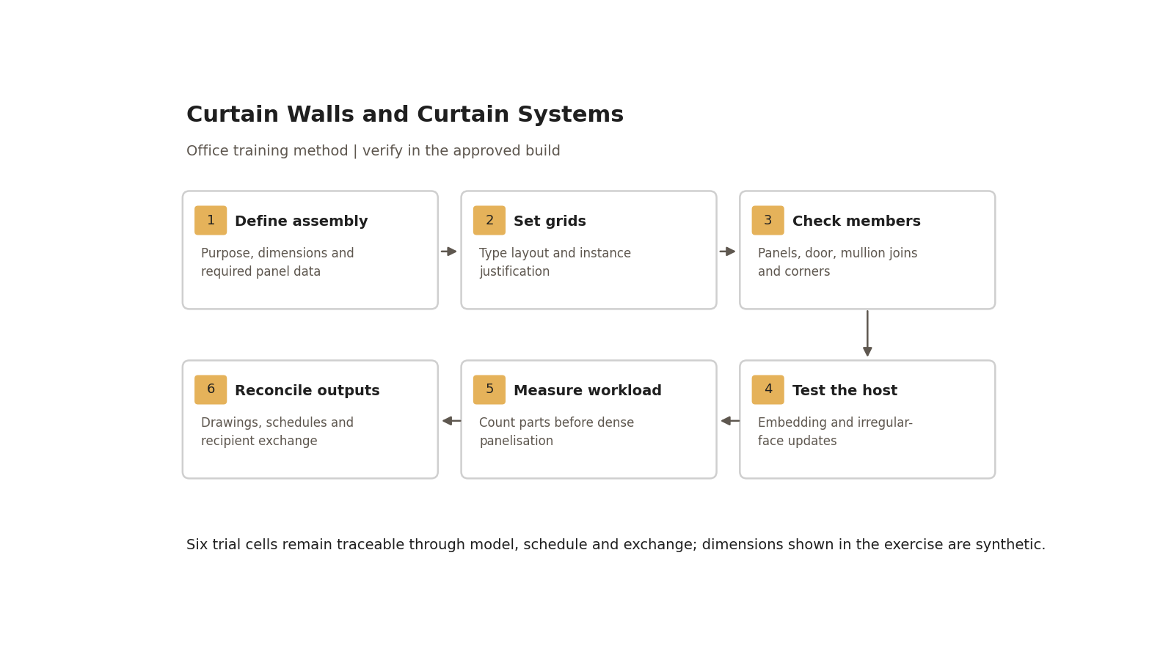
Six trial cells remain traceable through model, schedule and exchange; dimensions shown in the exercise are synthetic.

Step-by-step procedure
1. Define purpose and LOIN: coordination envelope, panel take-off, drawing or fabrication support are different uses. Record overall dimensions, module strategy, materials, required panel identifiers/properties, tolerances, connections and receiving format. Obtain approved panel/mullion/door families and actual build from the baseline form.
2. Make a trial curtain wall. Duplicate an approved type, set vertical/horizontal grid layout and spacing/number, justification/offsets, default panel and interior/border mullion types. Read the resulting residual bays; do not assume a nominal spacing divides the overall length exactly. Compare type changes on a second instance to identify propagation.
3. Add/remove individual grid segments only as a controlled exception. Use supported selection modes to select mullions on a gridline, vertical/horizontal grids, inner/border or all; inspect the selection before changing types. Check that the intended instance changes leave the second assembly unchanged.
4. At intersections choose Make Continuous/Break at Join for the intended running member, then inspect plan/section/3D. At corners test the appropriate L/V/trapezoid/quad corner type when available; duplicate and dimension it deliberately. Straight mullion profiles and corner-specific types have different controls. Do not guarantee that an arbitrary angled profile or deletion of a duplicate creates a correct corner.
5. Select one intended panel, unpin if necessary and substitute a compatible curtain-wall door. Check handing, clear opening, top/bottom boundaries and schedule category. If the family is missing, load the approved version first. A door-looking panel without required data/category is not an accepted door.
6. Test embedding in a sample host wall. Review the curtain-wall type’s supported Automatically Embed setting and actual opening/cut behaviour; check both with and without embedding where the build permits it. Inspect wall solids in section and check no duplicate host remains behind glazing. If it fails, use an approved opening/cut method and record the exception.
7. For an irregular system create a small controlled mass surface and record host face/reference. Use Curtain System by Face on supported faces, then establish grids/panels/mullions. Change one host dimension and use the supported update/recreate workflow; inspect split edges, orientation, missing/overlapping panels and intersections. Do not assume any face, spline or family will behave identically across templates/releases.
8. Choose curve geometry for its design/construction purpose. Arcs are useful for circular definitions; splines or segmented surfaces may be appropriate elsewhere. Do not teach that splines are always uncloseable or only presentation curves. Test the intended surface and panelisation in the adopted build, record which face owns each bay, and distinguish faceting from the design’s intended curvature.
9. Estimate element count before creating dense patterns. Record timing/file metrics for a small and representative dense sample on the same hardware, view and build. Consider a coarser cell with a repeated pattern inside an approved panel family, but check count/geometry/IFC semantics. Do not recategorise panels as walls merely to obtain a graphic result; verify templates, tags and export first. Close an optional facade workset only if the approved register supports a demonstrated loading need; keep the checker’s scope open.
10. Assign panel identifiers and required properties, build itemised panel/mullion/door schedules, and check drawings at intended scale/detail level. Export the agreed sample IFC and compare counts, dimensions, categories and required mapped properties in the recipient tool. Reject duplicate/absent panels and unexplained quantity differences; record whether nested decorative pieces are counted as fabrication components or only visual geometry.

Worked assembly and irregular-host exercise
Use a synthetic planar assembly 6,000 mm wide × 3,000 mm high, divided into three equal columns and two equal rows. Expect six cells with nominal 2,000 × 1,500 mm grid dimensions; actual glass/member clear sizes depend on the chosen mullion/panel types and must be measured, not assumed. Replace one cell with a compatible door. Record five ordinary panels plus one door cell, category-specific schedule counts and the receiver’s representation of all six cells.
Duplicate the assembly and change a type setting: show which instances change. Make a local panel exception and show the second assembly remains as expected. Add an approved corner sample and inspect member overlap/continuity. On a small curved host, alter radius/edge position, update the system and reconcile panel counts. These synthetic values are training inputs, not facade design approval.
Trial | Evidence to enter
Parent/​grid baseline | Type name/​revision, layout, justification/​offset, expected six cells, measured residual bay sizes.
Corner/​door/​embedding | Annotated plan/​section/​3D; handing/​category and host-cut checks.
Host change | Before/​after host revision, count/​orientation comparison and supported update action.
Performance | Panel/​member count, open/​regenerate/​export timing, hardware/​build, accepted project limit and result.
Information exchange | Native/​receiver object comparison, mapped property values and exceptions.

Acceptance criteria / self-check list
• All six trial cells are present; five ordinary panels and the intended door are accounted for without hidden duplicates.
• Type versus instance edits produce the recorded propagation; unpinned exceptions are identifiable and controlled.
• Corner/member joins have no unintended overlaps/gaps in plan/section; supported host embedding/cutting is verified.
• The irregular-host revision produces the intended orientation/count and no unexplained missing or overlapping cells.
• Panel identifiers are unique where required; material/type/size/classification fields meet the approved dictionary, with no mandatory blanks.
• Itemised schedules, plotted drawings and receiving-tool geometry/properties reconcile with the tested revision.
• Representative performance is within the project-approved measured limit; optional workset/nested-pattern decisions have recorded reasons.

Common mistakes
• Dividing first and counting later: estimate cells/members before dense modelling.
• Editing a shared type for one bay: duplicate the type or use an approved local exception.
• Trusting a pretty corner: inspect section/plan and member continuity.
• Calling every panel a wall: retain meaningful categories and verify the actual exchange.
• Assuming mass edits update the system: run the supported update and retest.
• Declaring curtain systems “always heaviest”: measure actual workload and approve only useful worksets.

Related guides
• 21 and 23 — walls, mass faces and compound wall checks; 22 — optional worksets.
• 26–27 — panel properties/family control; 28 — sheet graphics.
• 29 — adaptive/complex geometry; 35–36 — library admission and schedule validation.

Assessment record and release
Retain the exercise model/family, annotated screenshots, schedules or exports named above, and the completed checks together in the controlled training evidence location. Record learner, task, exact revisions, checker, date, result, defects, correction and retest. A mandatory failure means rework and reassessment; attendance alone is not a pass. The trainer records competence for this task; project use still follows the approved BEP and appointment authority. Do not distribute sensitive models or screenshots beyond their authorised audience.

Research coverage and correction trace
R04.1: assembly table/worked six-cell case; R04.2: steps 2–3; R04.3: steps 4–6; R04.4: steps 7–8; R04.5: step 10/acceptance. G24 has no demonstrated P1 defect; release-specific claims explicitly require tests. P2: versioned assembly, embedding and drawing/schedule/IFC checks. CROSSWALK C05/C12/C14/C20: measured worksets and scoped claims.

References
Sources used from RESEARCH.md (with supplemental verification in GAPS.md where identified). Edition labels describe source evidence; confirm applicability against the approved project baseline. Standard-level references are used because the supplied research does not verify individual ISO clauses.
Source | Title | Publisher | Year /​ edition | URL /​ evidence note
S02 | ISO 19650-2 — Delivery phase of the assets | ISO | 2018, ed.1 | Catalogue /​ abstract; publisher result exposes English abstract and status
S04 | ISO 19650-4 — Information exchange | ISO | 2022, ed.1 | Catalogue /​ abstract
S07 | ISO 7817-1 — Level of information need: concepts and principles | ISO | 2024, ed.1 | Catalogue /​ abstract
A05 | About Curtain Walls; Curtain Wall Type Properties | Autodesk Revit Help | Revit 2026 | Panels, grids and mullions; type controls
A09 | Adaptive Components; Place an Adaptive Component | Autodesk Revit Help | 2016 /​ 2023; concept references | Reference points, repetition and hosting; placement
A19 | Model Efficiently | Autodesk Revit Help | Revit 2024 | Warnings, links, constraints and content performance
A02 | Workflow: Setting up a Workshared Project; Enable Worksharing | Autodesk Revit Help | Revit 2026 | Central/​local workflow; enablement and ownership
A08 | Visibility and Graphic Display in Project Views; About View Filters | Autodesk Revit Help | 2026 /​ 2025 | Category/​filter/​element controls; filter priorities and templates
A21 | Schedules; About Schedules | Autodesk Revit Help | 2026 /​ 2024 | Schedule types and outputs; grouping and live model data
S12 | Industry Foundation Classes (IFC) | buildingSMART International | Undated live page; 2024 ISO edition | Version and implementation context

Office source: BBM-STD-01-MANUAL-V0.1, sections identified under Standards basis; applicable confirmed project BEP and controlled Glossary. Preserve the source workshop export unchanged.

