25 · Project Initiation — Worked Example
Linked copies: ID STD-25 · TBP page · BABOOM edition · ArchHub: BABOOM companion
BABOOM-BIM-STANDARD · Office BIM workshops · Presenter: Ahmed Fargaly · Revision v0.3 · 4 November 2026 · Status: training draft for office review

Revision history
Revision | Date | Change
v0.2 | 14 October 2026 | Training draft for office review
v0.3 | 2026-11-04 | folder names without dots (O-DEC-149): §2 points to the one project folder tree in Manual V0.4 §12.1

Purpose & scope
Read the commission before drawing. Break it into tasks, buildings, discipline scope, stages and exchanges; then plan people and time. This worked example keeps the office workshop’s initiation method without carrying a client project identifier into its title or reusable example. It covers project planning and enough software mobilisation to prove the starter environment is usable.

Standards basis
ISO 19650-1:2018 provides the requirements and party concepts; ISO 19650-2:2018 supports appointment, confirmed BEP, mobilisation and information delivery planning; ISO 19650-4:2022 supports exchange decisions; ISO 19650-5:2020 supports sensitivity-based custody. RIBA Plan of Work 2020 stages 0–7 are a framework, not a requirement for two revisions at every stage. This serves office Manual v0.1 §§2.1–2.3 governance/roles/milestones, §3.3 partitioning, §8.1 Project Initiation Protocol, §8.2.3 initiation methodology and §12 CDE. UK BIM Framework Guidance C (2020) and F (2020) explain workflow and planning implementation.

Prerequisites and controlled baseline
Work in a training copy until the exercise is checked. Obtain the applicable exchange information requirements (EIR), confirmed BEP, office Manual and approved content library. The BIM manager assigns the trainer/checker; the task-team lead owns the model work. These instructions do not confer project acceptance authority.
Record before use | Value /​ evidence to enter
Project/​training model and revision | [identifier; WIP location; baseline revision]
Revit release and full build | [Help > About; record all build digits; check every collaborator]
Template and content revision | [approved RTE/​RFA identifiers, revision and controlled location]
Requirements and office documents | [EIR/​BEP/​Manual revisions; approved deviations]
Exchange and recipient | [native/​open format, IFC schema/​profile, exporter build and receiving tool]
Trainer, checker and date | [roles; test date; evidence location; decision]

The 2024 workshop is historical teaching evidence. No exact installed build or approved library revision was supplied for this rewrite. Complete this form and run the exercise in the adopted release before project use; do not substitute “latest” for a tested version. References to Autodesk Help identify the documented release, not an office installation.

1. Read and break down the commission
Use a synthetic two-task commission. Task A refurbishes existing buildings, with interiors, services, facade and structural intervention subject to survey. Task B designs new low-rise buildings using the accommodation brief; its discipline scope includes landscape. Specifications, permits, studies, tender and supervision are separate explicit scope entries, included only where appointed. An early area estimate informs workload; it does not establish accepted accommodation or verified existing conditions.
Package | Synthetic stage sequence | Required clarification
A — refurbishment | A1 concept; A2 technical development; A3 tender package | Any omitted schematic package must have its required decisions/​information allocated elsewhere.
B — new building | B1 concept; B2 schematic development; B3 technical development; B4 tender | Confirm procurement, authority route, discipline responsibility and review periods.
Supervision | Separate appointment, if required | Confirm appointment, deliverables and mobilisation; do not assume it follows design automatically.

A1/B1 are local package labels, not RIBA stage numbers. Map them to required outcomes and exchanges; RIBA Stage 3 is Spatial Coordination, Stage 4 Technical Design, and Stages 4/5 can overlap by procurement. The nine manual phases (Intro, Setup, Modeling, Delivery, Information, Coordination, Discipline, Authority, Handover) organise training/workflows and do not replace those project stages.
The workshop planned a review issue followed by an approval issue. Use that pattern only if the actual commission agrees it; revisions are not limited to two, and final submission still needs checks and receiving acceptance. Approval comments and changes must have owners, dates and revised scope/programme consequences.
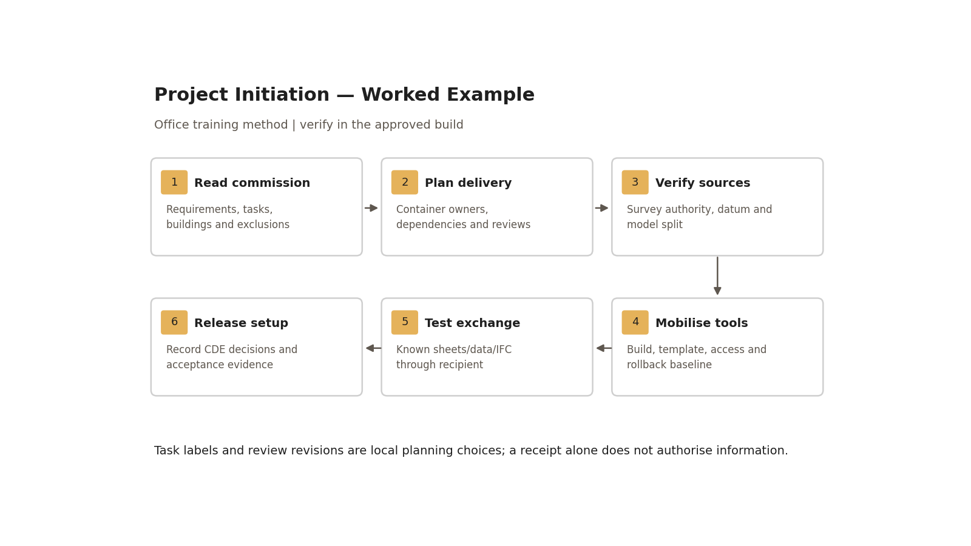
Task labels and review revisions are local planning choices; a receipt alone does not authorise information.

2. Project records and CDE mapping
Keep the office’s useful PM, Correspondence/Submittals, MOM/Memo/Report and Supervision record classes. Replace catch-all “Misc” with a controlled intake/index queue: assign an owner, sensitivity, destination and review date. These are record classes, not new top-level workspace folders. Inside ArchHub they stay within the authorised numbered area; do not create MISC or scatter files at root.
Record /​ container | Working state and access | Transition and retained evidence
Commission, contract, authorisations, CV evidence | Restricted project administration; approved copies separately controlled | Requirements owner confirms applicable revision; minimise personal data and distribution.
Task-team models/​calculations/​drawings | WIP; producer/​checker access | Internal check and approval for sharing before Shared.
Coordinated discipline package | Shared; permitted delivery-team recipients | Lead-appointed-party review/​authorisation for intended use; failed information returns for correction.
Authorised contractual exchange | Published/​accepted-use baseline under the agreed CDE workflow | Appointing-party acceptance decision against requirements; revision, suitability, transmittal and receipt retained.
Superseded issues, decisions and audit history | Archive; controlled read access | Retain exact versions and decisions; do not overwrite the accepted record.
Authority submission and receipt | Submission record linked to exact exchange revision | Receipt proves delivery, not technical approval or all CDE decisions. Record authority disposition separately.

A portal can implement some CDE functions; its existence alone does not prove the agreed permission/state workflow. Record the actual platform, state names, access groups, transition actors and evidence links. Contract/protocol particulars determine who can authorise and accept. A job title or folder name does not grant that power.
Folder locations for these records follow the one project folder tree in Manual V0.5 §12.1 (state → data type → discipline; folder names NN-NAME without dots, O-DEC-149). This guide defines no folders of its own.

Step-by-step procedure
1. Project manager and requirements owner review the commission/RFP, signed appointment and information protocol. Record decisions, exclusions, interfaces, assumptions and requested clarifications. Confirm legal document precedence with the authorised contract owner; this guide supplies no replacement hierarchy.
2. Split scope by task/building/discipline/package. Assign accountable package leads and detailed production responsibilities, including specialist studies. Assess CV/competence evidence, actual staff availability and required experience. Allocate work by expertise where useful (sections, finish schedules, details) while retaining a named owner for each delivered container and cross-building interface.
3. Define each exchange’s purpose, recipient, date, LOIN, formats, quality criteria and sensitivity. Derive task-team TIDPs and consolidate the MIDP; a RACI is not a delivery plan. Include dependencies, production duration, review/authorisation/acceptance windows and an agreed baseline/change owner.
4. Build the programme in the approved scheduling tool; the workshop used a scheduling application, but the tool is not an ISO requirement. Include team mobilisation, authorisations, authority registration, surveys, design and realistic review time. Test a delayed review scenario and adjust dependencies; do not assume a two-week review will always finish in two weeks.
5. Collect existing drawings/archive records, site observations/photos and available surveys. Log origin, revision, date, survey method, accuracy/uncertainty and intended permitted use. Designate the coordinate/datum owner and authoritative levels, units, reference system, origin/north strategy and survey controls. Approximate/as-recorded inputs stay provisional until independently verified for the intended use.
6. For new development confirm the applicable controlled regulation/brief: height, floors, coverage, uses, access and interfaces with demolition/extensions. The authorised discipline/authority owner confirms current requirements and evidence. No generic numerical code limit is invented here.
7. Approve the model split and linked-reference register: datum/site file, discipline/building files, link owner/revision/reload route and coordinate method. Check two separated control points and one elevation against the accepted reference with recorded tolerances. Resolve misalignment before coordination.
8. Complete the exact software/build/template/content/exporter baseline. Create a representative starter model from the approved template. Set project units and discipline, controlled view templates/graphics, browser organisation, required parameters, title block and initial approved families. Verify datum/reference positioning and record any approved deviation. Guide 21 supplies detailed interface practice; these checks remain mandatory here.
9. Produce one starter plan/section sheet, an itemised schedule and a shared-parameter tag. Populate synthetic IDs and compare model/tag/schedule/title-block values. Export the agreed IFC profile and open it in the receiving tool; reconcile object counts, mapped properties, coordinates and dimensions. Log missing/invalid data and correct/retest before releasing setup.
10. Test permissions and the complete exchange route: producer check, sharing, team authorisation, receiving acceptance/rejection, resubmission, archive and transmittal receipt. Name each actor and retain the exact revisions and decisions. Platform publication and formal acceptance are separately recorded.
11. Agree the common architectural identity through approved option/mood-board review where appointed. Reuse facade/interior/room principles with controlled variations per building; a repeated theme must still meet each building’s constraints and required information.
12. Preserve the accepted compatible starter baseline and all linked/content revisions. Upgrade only a copy after approval, including add-in/exporter compatibility and representative output checks. Revit files are not backward-compatible. Rollback restores the preserved compatible baseline for the coordinated team; never upgrade the only copy.

Initiation register and worked assessment
ID | Decision/​output | Owner /​ dependency | Expected check | Evidence /​ status to enter
INIT-01 | Task/​building scope and exclusions | Project manager; appointment | Every deliverable/​interface has an owner | [matrix revision; unresolved query; date]
INIT-02 | Survey/​datum and source register | Datum owner; verified survey | Point/​elevation tests and uncertainty accepted | [reference revision; deviations; approval]
INIT-03 | TIDPs → MIDP baseline | Task leads /​ delivery-team planner | Dependencies and review windows reconciled | [container IDs; dates; baseline decision]
INIT-04 | Build/​template/​content baseline | BIM/​IT owner | Exact compatible revisions approved | [inventory; access test; rollback copy]
INIT-05 | Starter sheet/​schedule/​IFC | Author/​checker/​recipient | Known values reconcile end to end | [model; PDF; schedule; IFC; report]
INIT-06 | CDE and mobilisation release | Assigned authoriser/​acceptor | Permission/​state/​decision loop exercised | [transmittal; rejection/​retest; acceptance]

Exercise: build the two-task scope and programme, including one delayed client review, then populate INIT-01–06 using a synthetic two-level starter building. Include one deliberately wrong parameter value and one rejected exchange; show correction and resubmission. Retain scope/programme, baseline, annotated datum/sheet screenshots, itemised schedule, receiver report and CDE decision record. Assessor checks that no activity starts on an unresolved critical dependency and that authority is assigned by appointment.

Acceptance criteria / self-check list
• Scope/stage outcomes, discipline interfaces, excluded supervision and change authority are explicit.
• Named container producers, dependencies, production/review periods and exchange recipients form a reconciled baseline.
• Authoritative datum/source provenance and point/elevation tests are complete; provisional data is labelled and excluded from inappropriate use.
• Units, graphics/templates/content and exact builds are approved; compatible rollback baseline exists.
• Starter sheet/tag/schedule and recipient IFC reconcile required geometry/data/documents with no mandatory failures.
• Tested CDE workflow separates submission receipt, authorisation, technical acceptance and rejected/resubmitted revisions.
• Team access, competence/capacity and assessed mobilisation evidence are recorded before project use.

Common mistakes
• Starting geometry before reading the commission: record scope and requirements first.
• Treating task labels or two issues as universal RIBA rules: map actual outcomes and review obligations.
• Calling archive drawings verified as-built: record uncertainty and independent verification.
• Confusing a receipt with approval: retain separate receiving decisions.
• Assuming the team will cope with a late review: update dependencies and escalate the programme impact.
Keep the workshop attitude: problems require a clear owner and next action. That includes pausing an exchange whose critical requirements remain unresolved; determination is not a reason to issue unverified information.

Related guides
• 21–22 — starter model/worksharing; 26–28 — parameters and documents.
• 30 — datum/site setup; 31 — daily controls; 32 — existing-condition checks.
• Office OIR/BEP, Directory, TIDP and MIDP: approved editions and project-specific responsibilities.

Assessment record and release
Retain the exercise model/family, annotated screenshots, schedules or exports named above, and the completed checks together in the controlled training evidence location. Record learner, task, exact revisions, checker, date, result, defects, correction and retest. A mandatory failure means rework and reassessment; attendance alone is not a pass. The trainer records competence for this task; project use still follows the approved BEP and appointment authority. Do not distribute sensitive models or screenshots beyond their authorised audience.

Research coverage and correction trace
R01.1: steps 1/8; R01.2: step 8; R01.3: steps 5/7; R01.4: steps 9–10; R01.5: step 12. G25 has no independent P1 factual defect; private case replaced by a synthetic office example and retitled. P2: initiation/CDE/baseline/exchange controls. CROSSWALK C03/C04/C07/C08/C10/C11/C12/C14: explicit boundaries and tested mobilisation.

References
Sources used from RESEARCH.md (with supplemental verification in GAPS.md where identified). Edition labels describe source evidence; confirm applicability against the approved project baseline. Standard-level references are used because the supplied research does not verify individual ISO clauses.
Source | Title | Publisher | Year /​ edition | URL /​ evidence note
S01 | ISO 19650-1 — Concepts and principles | ISO | 2018, ed.1 | Catalogue /​ abstract; published, revision underway
S02 | ISO 19650-2 — Delivery phase of the assets | ISO | 2018, ed.1 | Catalogue /​ abstract; publisher result exposes English abstract and status
S04 | ISO 19650-4 — Information exchange | ISO | 2022, ed.1 | Catalogue /​ abstract
S05 | ISO 19650-5 — Security-minded approach to information management | ISO | 2020, ed.1 | Catalogue /​ abstract
S07 | ISO 7817-1 — Level of information need: concepts and principles | ISO | 2024, ed.1 | Catalogue /​ abstract
S21 | RIBA Plan of Work 2020 | Royal Institute of British Architects | 2020 | Current resource page; 2020 template
G-C | Guidance C — Facilitating the CDE workflow and technical solutions | UK BIM Framework | ed.1, September 2020 | Official PDF; archived guidance
G-F | Guidance F — About information delivery planning | UK BIM Framework | ed.1, September 2020 | Official PDF; edition actually verified. Its federation section is a placeholder; use other sources for technical federation guidance.
G-E | Guidance E — Tendering and appointments | UK BIM Framework | ed.2, February 2021 | Official PDF; archived guidance
A01 | Project Templates; Create a Model | Autodesk Revit Help | Revit 2026 | Template contents; creation and backward-compatibility warning
A06 | Create Shared Project Parameters | Autodesk Revit Help | Revit 2026 | Category bindings, instance/​type and tag/​schedule use
A10 | How to set up Shared Coordinates using one Revit model as the Site or Base file | Autodesk Support | 15 August 2026 | Local workflow and cloud limitation
A21 | Schedules; About Schedules | Autodesk Revit Help | 2026 /​ 2024 | Schedule types and outputs; grouping and live model data
S12 | Industry Foundation Classes (IFC) | buildingSMART International | Undated live page; 2024 ISO edition | Version and implementation context

Office source: BBM-STD-01-MANUAL-V0.1, sections identified under Standards basis; applicable confirmed project BEP and controlled Glossary. Preserve the source workshop export unchanged.

