26 · Introduction to Families and Parameters
Linked copies: ID STD-26 · TBP page · BABOOM edition · ArchHub: BABOOM companion
BABOOM-BIM-STANDARD · Office BIM workshops · Presenter: Ahmed Fargaly · Revision v0.2 · 14 October 2026 · Status: training draft for office review

Purpose & scope
Plan the family before drawing it. Keep the workshop sequence: reference planes, dimensions/parameters, constraints, then geometry. Begin each training session with a short task/blocker review. This introduction explains categories, hosting and parameter choices, then proves one required property through a family, project, tag, schedule and exchange.

Standards basis
ISO 19650-2:2018 supports controlled production; ISO 19650-4:2022 supports exchange checking. ISO 23386:2020 supports identified property definitions/change ownership; ISO 23387:2025 supports object data templates. This serves office Manual v0.1 §3.2 Parameters/Data Dictionaries, §4.2 Object Styles, §6.1 Content Libraries, §8.2.2 Family Creation Methodologies and §11 Exchange. Revit shared GUIDs implement property identity within the authoring workflow; they are not automatically IFC property names or data-template identifiers.

Prerequisites and controlled baseline
Work in a training copy until the exercise is checked. Obtain the applicable exchange information requirements (EIR), confirmed BEP, office Manual and approved content library. The BIM manager assigns the trainer/checker; the task-team lead owns the model work. These instructions do not confer project acceptance authority.
Record before use | Value /​ evidence to enter
Project/​training model and revision | [identifier; WIP location; baseline revision]
Revit release and full build | [Help > About; record all build digits; check every collaborator]
Template and content revision | [approved RTE/​RFA identifiers, revision and controlled location]
Requirements and office documents | [EIR/​BEP/​Manual revisions; approved deviations]
Exchange and recipient | [native/​open format, IFC schema/​profile, exporter build and receiving tool]
Trainer, checker and date | [roles; test date; evidence location; decision]

The 2024 workshop is historical teaching evidence. No exact installed build or approved library revision was supplied for this rewrite. Complete this form and run the exercise in the adopted release before project use; do not substitute “latest” for a tested version. References to Autodesk Help identify the documented release, not an office installation.

1. Category, family, type and instance
A category groups objects for behaviour, visibility and scheduling. A loadable family contains types; placed objects are instances of those types. A system-family type (wall/floor/roof etc.) is defined in the project/template; it is not a standalone RFA. Model and annotation categories have different geometry/tools. Subcategories give separately controlled graphics to parts of a family; use approved names and cut/projection settings.
Template choice | Placement concept /​ test
Non-hosted generic/​model category | Place using the chosen level/​work plane; category change does not create a new hosting template.
Face-based | Place on a supported face; test face removal, orientation and linked-host behaviour as applicable.
Wall/​floor/​ceiling/​roof-hosted | Specific host behaviour; a wall-hosted opening is not the same as a generic face-based object.
Two-level based | Base/​top relationships; test level moves and offsets in the selected category/​template.
Line based | Two-point/​path placement with supported controls; it does not automatically sweep/​array arbitrary content.
Pattern based/​adaptive | Reference/​placement-point workflow; use the appropriate template and verify hosting/​order.
Detail/​annotation | View/​paper-oriented content appropriate to category; test scale, nested content and tags.

Choose hosting at creation. Changing category may be allowed for some compatible content, but cannot be taught as switching the underlying template or turning any generic solid into a working wall-hosted door. Rebuild in the correct approved template if hosting differs. Work planes can be horizontal, vertical or inclined; a 3D view itself is not a work plane. Set and inspect the actual plane before sketching.

2. Parameter choice
Kind | Purpose | Tag/​schedule/​exchange decision
Family parameter | Local family geometry/​behaviour | Ordinary custom family parameters are not automatically available for project tags/​schedules; use an appropriate shared definition where required.
Project parameter | Data bound to chosen project categories | Can support compatible schedules; a non-shared definition is not a custom tag label identity.
Shared definition used in family/​project | Stable identified property usable across compatible contexts | Tag/​schedule availability still depends on matching definition, category, binding and target tool; test actual outputs.
Global parameter | Project-level constraint, dimension/​formula or reporting control | Not the property-exchange mechanism; associate only compatible supported properties and test dependencies.

Type values affect all instances of a type; instance values belong to individual objects, subject to group/host/formula behaviour. Select by meaning: a manufactured type width is usually type data; a unique installed asset identifier is instance data. A value’s frequency of change alone is insufficient. Global values can change; they are not inherently frozen project constants. Formula links can be useful when the units, logic and extremes are tested, rather than being universally fragile or safe.
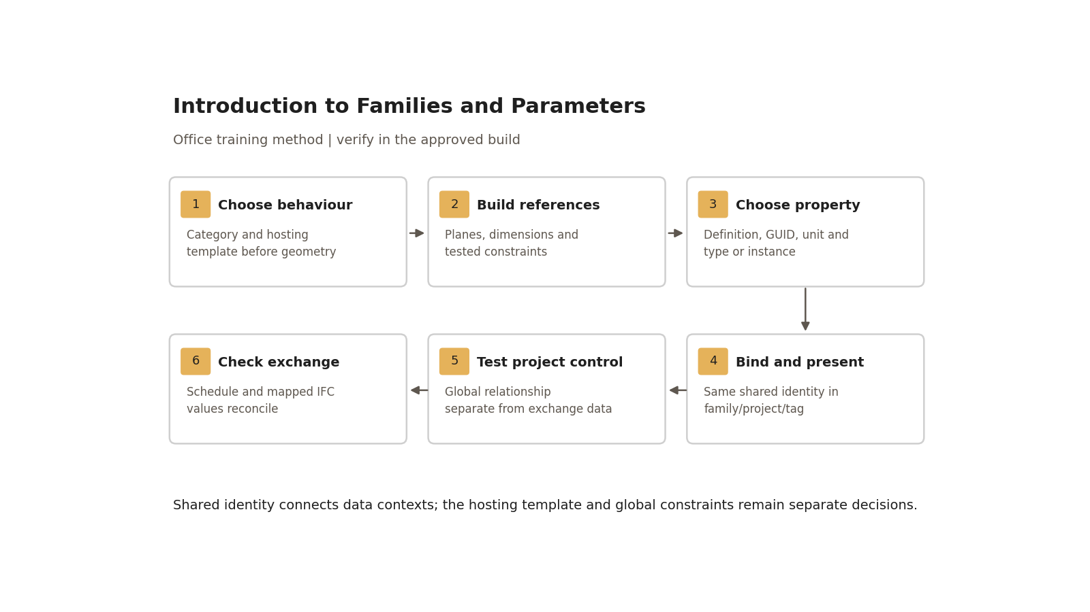
Shared identity connects data contexts; the hosting template and global constraints remain separate decisions.

Step-by-step procedure
1. Define the object’s purpose, category, host, type variations, placement use and required outputs. Select the approved family template/build. Record content owner/version and whether a reusable loadable family is suitable.
2. Establish reference planes and origin; dimension width, height and thickness, set labels and intended equality/alignment constraints. Constrain geometry to the reference framework. Test parameters before adding detail. Standard extrusion/blend/revolve/sweep/swept-blend tools suit many component families; adaptive/pattern content uses its appropriate form workflow.
3. Use approved subcategories/materials. If selective standards transfer is available in the source/target context, record selected settings and duplicate handling; do not assume wholesale transfer sets every graphic correctly. Compare family/project cut/projection and line weights in a test project. Do not teach an unverified fixed line-weight count for all templates.
4. For each required property obtain the controlled definition: identifier/GUID, meaning, data type/unit, allowed/null rules, type/instance, categories and outputs. The BIM/property owner controls the shared definition file, its access, revision and backup. Reuse the exact GUID; a matching display name with a different GUID is not the same property.
5. Add the shared definition to the family where required. In Manage > Project Parameters bind the approved shared definition to the intended categories and type/instance scope; ensure any group-varying behaviour is explicitly chosen/tested. Add matching definitions to the compatible tag/title-block family and schedule fields. Drawing-sheet/project-information fields need their own appropriate bindings; not every title-block field is automatically shared data.
6. Load into a project copy. Select overwrite behaviour deliberately: replacing family definitions and replacing existing parameter values are different decisions. Record target type values before reload, diff after reload and retest affected types/instances. Never overwrite project values simply to clear a dialog.
7. Populate two sample instances with distinct IDs, then tag and itemise them in a schedule. Confirm the tag and schedule show exactly the recorded expected values. Check category/filter choice, instance/type binding and GUID before inventing a duplicate property to repair a blank label.
8. Create a training global Length parameter, Ceiling_Offset_Test, and associate a supported sample element offset or labelled dimension. Record the affected element IDs. Change 2,700 to 3,000 mm and verify every intended target, no unintended target, and no constraint warning. Test a project-approved minimum/maximum and one invalid relationship in a copy; retain the rejected result and correction. Remove the training association before production use.
9. Map the required shared property to the agreed object data template/classification and IFC target property. Record IFC entity, property set/name and mapping method in the project dictionary; do not assume Revit shared names export by default. Export the adopted profile and compare native values with the receiving tool’s objects/properties. Category and required values must reconcile.
10. For a change, submit definition/binding/value-migration impact to the property owner. Preserve the old shared-file/content baseline, approve the new revision, migrate in a copy and compare tags/schedules/formulas/IFC. Existing elements retain definitions; editing the definition file alone does not update every loaded family/project. Do not casually delete/recreate a GUID.

Worked door/property example
Build a synthetic door sample in an approved wall-hosted door template. Reference planes define Width/Height/Thickness; use the template’s valid built-in parameters where appropriate. Create two types at 900 and 1,000 mm nominal width, both 2,100 mm nominal height. Place two instances of the first type and one of the second in a test wall. Type-width changes must affect both first-type instances; a unique instance ID must affect only its selected door.
Training property /​ control | Definition and ownership | Binding /​ expected output
TRAIN_Asset_ID | Text; non-empty unique identifier; property owner records one training GUID in the controlled file before use | Doors; instance; D-001/​D-002/​D-003 in tag and itemised schedule.
Width /​ Height | Approved length definitions; mm displayed; use valid template definitions | Type; dimension and schedule agree with actual geometry.
Ceiling_Offset_Test | Project-global Length; geometric test control | Only supported nominated targets; not an asset exchange field.
IFC asset property | Agreed training target [entity /​ property set /​ property] | Explicit mapping from TRAIN_Asset_ID; receiver sees the same three IDs.

The training identifier/name is synthetic; do not introduce it into the production dictionary. Record actual GUID and target mapping before the test, not after observing an export. Obtain a tagged plan, parameter/binding screenshots, itemised schedule and receiver report. Annotate host/category/template choice and the two-type versus three-instance result.

Acceptance criteria / self-check list
• Correct host/template selected and family places/cuts as intended; category change is not claimed to change hosting.
• Reference framework flexes at nominal/minimum/maximum sizes without unexplained constraints or distorted geometry.
• Controlled GUID, data type/unit, category and type/instance are recorded and consistent in all required contexts.
• All three IDs agree across instance, tag, schedule and required mapped IFC property; mandatory blank/invalid values fail.
• Global test changes only intended relationships at tested values; warnings/invalid associations are corrected and retested.
• Reload/change migration preserves required existing values and a compatible rollback baseline; output diffs are reviewed.
• Graphic/subcategory behaviour is legible at the intended scales/detail levels and does not rely on unapproved overrides.

Common mistakes
• Confusing face-based with wall-hosted: select the needed template before modelling and test placement/cuts.
• Recreating a shared parameter with the same name: recover the approved GUID definition and migrate under control.
• Putting unique IDs on a type: correct binding and inspect every affected instance.
• Assuming a shared parameter is automatically taggable/exported: test category, tag label and explicit exchange mapping.
• Treating global parameters as immutable: track affected relationships and verify changes.
• Loading with blanket overwrite: diff target values before/after and record the decision.

Related guides
• 21 — title-block setup; 24 — curtain panel/door hosting.
• 27 — parameter dictionary and library release in practice; 28 — subcategory graphics.
• 29 — adaptive content; 35–37 — intake, schedules and complete family exercise.

Assessment record and release
Retain the exercise model/family, annotated screenshots, schedules or exports named above, and the completed checks together in the controlled training evidence location. Record learner, task, exact revisions, checker, date, result, defects, correction and retest. A mandatory failure means rework and reassessment; attendance alone is not a pass. The trainer records competence for this task; project use still follows the approved BEP and appointment authority. Do not distribute sensitive models or screenshots beyond their authorised audience.

Research coverage and correction trace
R05.1: category/template/parameter tables and steps 1–3; R05.2: steps 4–5/dictionary; R05.3: steps 7/worked IDs; R05.4: step 8; R05.5: step 9/acceptance. G26 P1: hosting and parameter-capability claims corrected; GUID/binding control added. P2: units/change ownership and tag/schedule/IFC tests. CROSSWALK C09/C17/C14 addressed.

References
Sources used from RESEARCH.md (with supplemental verification in GAPS.md where identified). Edition labels describe source evidence; confirm applicability against the approved project baseline. Standard-level references are used because the supplied research does not verify individual ISO clauses.
Source | Title | Publisher | Year /​ edition | URL /​ evidence note
S02 | ISO 19650-2 — Delivery phase of the assets | ISO | 2018, ed.1 | Catalogue /​ abstract; publisher result exposes English abstract and status
S04 | ISO 19650-4 — Information exchange | ISO | 2022, ed.1 | Catalogue /​ abstract
S16 | ISO 23386 — Methodology to describe, author and maintain properties in interconnected data dictionaries | ISO | 2020, ed.1 | Catalogue /​ abstract
S17 | ISO 23387 — Data templates for objects used in the life cycle of assets | ISO | 2025, ed.2 | Catalogue /​ abstract
A18 | Create a Family from a Template | Autodesk Revit Help | Revit 2026 | Template selection and testing before sharing
A06 | Create Shared Project Parameters | Autodesk Revit Help | Revit 2026 | Category bindings, instance/​type and tag/​schedule use
A07 | Global Parameters | Autodesk Revit Help | Revit 2026 | Project-level parametric controls
A21 | Schedules; About Schedules | Autodesk Revit Help | 2026 /​ 2024 | Schedule types and outputs; grouping and live model data
S12 | Industry Foundation Classes (IFC) | buildingSMART International | Undated live page; 2024 ISO edition | Version and implementation context
X03 | About Family Templates | Autodesk | Revit 2023 | Official Help. Hosting/​template choice differs from category choice.
X06 | Transfer Project Standards | Autodesk | Revit 2025 | Official Help. User selects standards and duplicate-type handling; supports scoped review rather than blanket transfer assumptions.

Office source: BBM-STD-01-MANUAL-V0.1, sections identified under Standards basis; applicable confirmed project BEP and controlled Glossary. Preserve the source workshop export unchanged.

