27 · Families and Parameters in Practice
Linked copies: ID STD-27 · TBP page · BABOOM edition · ArchHub: BABOOM companion
BABOOM-BIM-STANDARD · Office BIM workshops · Presenter: Ahmed Fargaly · Revision v0.2 · 14 October 2026 · Status: training draft for office review

Purpose & scope
Decide type/instance behaviour from how the object is bought, built and identified. Keep the workshop’s patterned-panel exercise, constraint troubleshooting and simple plan symbols. This guide turns those habits into a controlled property dictionary and an assessed family release. Office templates are a starting baseline; they do not eliminate admission checks or future cleaning.

Standards basis
ISO 23386:2020 supports definitions/identifiers and change ownership; ISO 23387:2025 supports object data templates. ISO 19650-2:2018 supports planned production and ISO 19650-4:2022 supports checked exchange. This serves office Manual v0.1 §3.1 naming, §3.2 data dictionaries, §6.1 libraries, §8.2.2 family creation, §9 quality and §11 IFC. Classification uses the approved system/table/release (for example Uniclass 2015 with an explicitly recorded table release); a family filename is not a classification code.

Prerequisites and controlled baseline
Work in a training copy until the exercise is checked. Obtain the applicable exchange information requirements (EIR), confirmed BEP, office Manual and approved content library. The BIM manager assigns the trainer/checker; the task-team lead owns the model work. These instructions do not confer project acceptance authority.
Record before use | Value /​ evidence to enter
Project/​training model and revision | [identifier; WIP location; baseline revision]
Revit release and full build | [Help > About; record all build digits; check every collaborator]
Template and content revision | [approved RTE/​RFA identifiers, revision and controlled location]
Requirements and office documents | [EIR/​BEP/​Manual revisions; approved deviations]
Exchange and recipient | [native/​open format, IFC schema/​profile, exporter build and receiving tool]
Trainer, checker and date | [roles; test date; evidence location; decision]

The 2024 workshop is historical teaching evidence. No exact installed build or approved library revision was supplied for this rewrite. Complete this form and run the exercise in the adopted release before project use; do not substitute “latest” for a tested version. References to Autodesk Help identify the documented release, not an office installation.

1. Parameter relationships and visibility
Category determines supported family behaviour, tag/schedule context and intended export class; family contains types and placed instances. The template determines hosting/reference behaviour. Choose the right category/template before geometry, not after a generic object becomes difficult to schedule. Family-local parameters drive geometry; project bindings add category data; shared definitions provide stable identities for compatible tags/schedules/exchanges; global parameters drive supported project constraints separately.
A type formula cannot depend on different per-instance values. An instance formula can reference compatible type/instance values. A reporting dimension measures geometry; change that geometry rather than typing a new reported measurement. Reporting/formula availability depends on the parameter/template context: test it. When a formula fails, inspect data types/units, circular dependencies, locks, EQ constraints and host references instead of deleting all constraints blindly.
Type Width is appropriate for a repeatable product type; sill/placement offset or unique installed ID is usually instance data. An adaptive panel’s geometric width may follow its host while its product identifier is controlled type data: document the distinction. Global parameters can be used at any suitable stage and remain editable project controls. Restricting their use until a design freeze is an optional approved office convention, not a Revit capability limit.
For each solid set supported view/detail-level visibility intentionally. Symbolic lines can simplify a plan representation; model lines exist in model space. Check the family’s intended view directions and cut settings, then view range, discipline, template, filters and category visibility before remodelling an apparently missing object. Plan symbol behaviour is not proof of correct 3D or quantities.
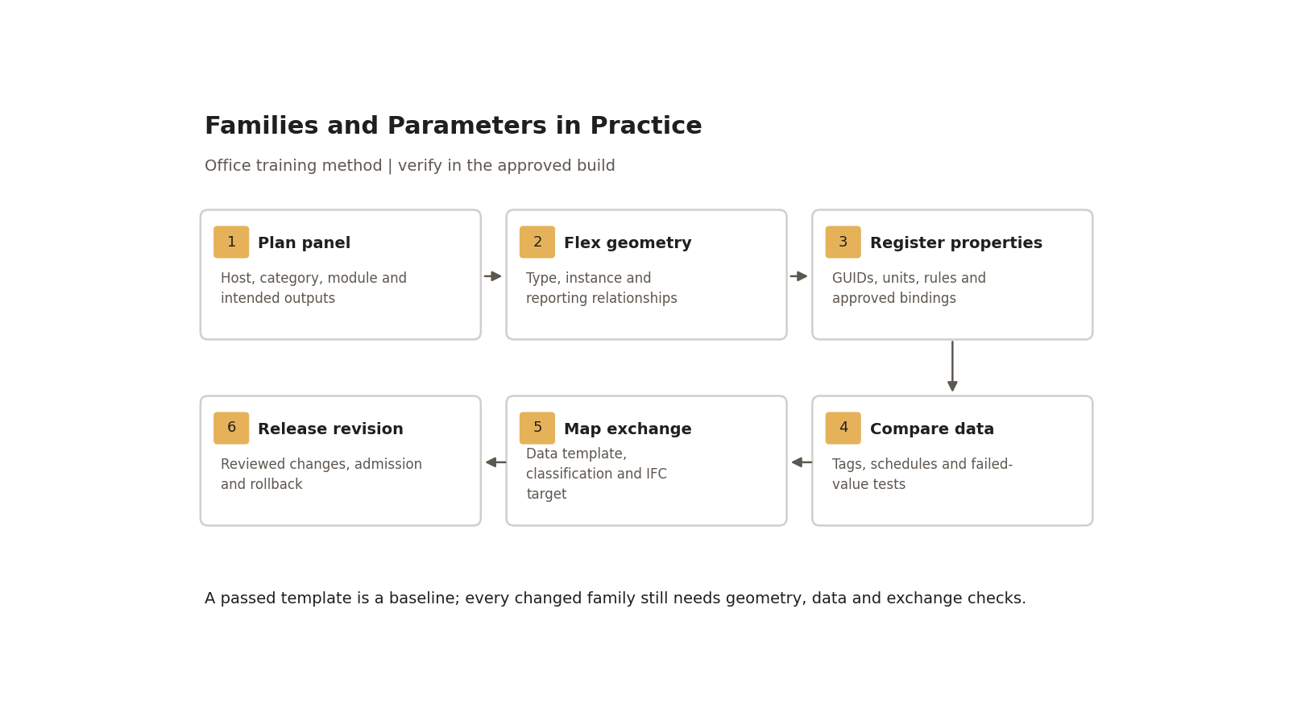
A passed template is a baseline; every changed family still needs geometry, data and exchange checks.

2. Property register — fill before authoring
Field | Required entry /​ governance
Property ID and meaning | Unique office dictionary ID; unambiguous definition and intended purpose.
Identity | Actual shared GUID and definition-file revision; built-in identity or family-local name where applicable.
Data type/​unit | Length/​area/​number/​text etc.; storage semantics, displayed unit and conversion rule.
Allowed/​null rule | Enumeration/​range/​pattern; required/​optional applicability and reason for permitted null.
Revit binding | Family/​project, categories, type/​instance, group variation, tag/​schedule requirement.
Data-template/​classification | Approved object-template ID/​revision and classification system/​table/​code/​release.
Exchange map | IFC entity, property set/​property, source field, exporter mapping/​profile and receiver test.
Owner/​change | Property owner, approving role, proposed change, migration, test evidence and rollback revision.

Resolve aliases before use: “Asset ID”, “Asset Tag” and another office acronym are not interchangeable merely because they look similar. For service-life properties select one approved numeric definition/unit such as years, or an explicit coded/text meaning; do not silently map numerical life expectancy to free text. Never invent a production GUID from a display-name match. Required classification codes must exist in the adopted table/release; retain provenance rather than guessing one from an old filename.

Step-by-step procedure
1. Set the patterned-panel purpose, module, host and accepted outputs. Start with the approved curtain-panel/template behaviour and record content revision. A 1,500 × 1,500 mm training module is a local example, not a standard size. Choose a true curtain panel category/template appropriate to the host.
2. Set reference planes/dimensions and a thickness control, then model the geometric repeat with constrained forms, offsets, rotation/mirror as appropriate. Decide whether thickness defines a product type or varies intentionally per instance. Generic component families cannot be scaled externally as a substitute for proper parameterisation; do not promise that a sketch resize command works identically in every editor.
3. Define at least two product types and three placed instances. Flex nominal/minimum/maximum sizes recorded by the trainer. Check formula units and host-imposed dimensions, and inspect symbolic versus 3D geometry at Coarse/Medium/Fine. Elaborate repeating patterns require an intentional proportion/rule system, not arbitrary repetition; retain the designer’s geometry basis.
4. Map the old workshop E-CURTAIN-style name to the current approved office naming convention. Record category, function, differentiating attributes and type suffix in a naming cross-reference. The approved Manual/BEP naming annex wins for actual identifiers; do not introduce another undocumented discipline prefix.
5. Populate the property register. Property owner supplies existing shared definitions/GUIDs and approved categories. Bind them as the selected type/instance; use the same shared definition in compatible panel tag and itemised schedule. Add family geometry parameters separately from required exchange properties.
6. Load into a project copy and assign the intended panel to the curtain wall. Adjust the grid/module and inspect edge/residual cells; nominal module does not guarantee every edge cell is identical. Record overwrite choices and compare existing target values before/after reload.
7. Test a supported global Length control in the project on nominated geometry/dimensions. Record affected element IDs and change the value within approved bounds; verify only those targets change and constraints remain valid. Keep this control out of the shared exchange-property map unless an explicit separately governed property is required.
8. Fill sample property values, tag and itemise the instances, and run null/duplicate/invalid-value tests below. Compare actual data, not only colours or a count of filled fields. Required invalid values must fail regardless of average completeness.
9. Export the recorded IFC profile/mapping, open in the recipient and compare categories, counts, values, units and geometry. Where an agreed IDS 1.0 requirement is used, audit that file and run an IFC information check; IDS does not replace geometric/host/visual checks. Correct, re-export and retain the passing report.
10. Admit external content through quarantine: check origin/licence, compatible build, category/host, constraints, properties, graphics and performance. Preserve donor/approved baseline; rebuild only if justified. Selectively transfer only approved standards; do not delete required parameters/formulas/styles indiscriminately. Even content created from the office template repeats these release tests.
11. For dictionary/family changes, property/library owners approve the impact, migration and new revision. Preserve old GUID definitions/content and values. Diff existing tags/schedules/IFC and sample formulas after migration; release only the reviewed library revision and record rollback. Changing the shared-file text alone does not migrate already loaded definitions.

Worked panel and data-validation exercise
Use three synthetic panels with IDs P-001, P-002 and P-003 and two controlled product types. Trainer records the family’s valid dimension range before testing; nominal module is 1,500 mm and suggested smaller/larger test cases are 1,200 and 1,800 mm if that family’s intended host permits them. Inspect actual width/height/thickness and required type/material/classification data. Keep training definitions separate from the production dictionary.
Deliberate test | Expected decision /​ retained evidence
Empty required P-002 ID | Fail; exception schedule identifies element ID; populate and retest.
P-003 duplicates P-001 | Fail for the declared unique-ID scope; restore distinct ID and rerun.
Thickness outside recorded valid range | Reject or controlled constraint prevents it; record actual warning/​result and correction.
Classification absent from adopted table | Fail applicable requirement; replace with verified permitted value.
Same display name, wrong GUID | Binding/​tag test fails identity check even if a value looks right; migrate under owner approval.
Type edit and instance edit | Type data propagates to relevant instances; unique ID changes only the nominated instance.
Global control change | Only nominated supported relationships change; no unintended data overwrite.
IFC unit/​property check | Receiver gets the same three IDs and required mapped values with correct units; no default-assumption pass.

Record native and receiving-tool rows side by side with model/object identifiers and exact revisions. Retain flex screenshots, plan/3D comparison, binding/GUID register, itemised schedule, tag sheet, exchange report, invalid tests and corrected retests. Do not certify an installed family based solely on this written example.

Acceptance criteria / self-check list
• Hosting/category, type/instance semantics, valid dimensions and intended graphic representation are approved and tested.
• Property register contains actual identities, types/units, bindings, null/allowed-value rules, object-template/classification and exchange mapping.
• Three instances have correct tag/schedule values; all deliberate null/duplicate/invalid tests fail and subsequent corrections pass.
• Global relationships are explicitly separate from shared data, with affected elements and tested limits recorded.
• IFC/IDS information checks and independent geometry/visual checks meet the agreed recipient criteria.
• Naming cross-reference resolves the workshop prefix; no uncontrolled parameter alias or duplicate GUID is introduced.
• Released family/library revision has an owner, approved changes, licence/provenance, output diff and rollback baseline.

Common mistakes
• Treating every dimension as a product type: identify host-derived geometry and its reporting behaviour.
• Putting required values in a family-local field: use the approved shared identity where tags/exchange need it.
• Measuring “data filled” without testing validity: fail wrong units, duplicate IDs and invalid classifications.
• Deleting formulas during cleaning: identify dependency/impact and retest before approved removal.
• Assuming templates remove admission tests: run the release checks for every changed family.

Related guides
• 24 — curtain assemblies; 26 — hosting and parameter introduction.
• 28 — symbolic/subcategory graphics; 29 — adaptive constraints.
• 35 — external-family admission; 36 — schedules; 37 — family creation assessment.

Assessment record and release
Retain the exercise model/family, annotated screenshots, schedules or exports named above, and the completed checks together in the controlled training evidence location. Record learner, task, exact revisions, checker, date, result, defects, correction and retest. A mandatory failure means rework and reassessment; attendance alone is not a pass. The trainer records competence for this task; project use still follows the approved BEP and appointment authority. Do not distribute sensitive models or screenshots beyond their authorised audience.

Research coverage and correction trace
R05.1–5: sections 1–2, steps 1–9 and exercise. T13.1: register; T13.2: mapping/classification and step 9; T13.3: steps 5/8; T13.4: step 7; T13.5: step 11 and deliberate null/duplicate/invalid tests. G27 has no independent P1 defect; stage-based globals identified as optional convention. P2: identity, validation, naming and outputs. CROSSWALK C09/C17/C14 addressed.

References
Sources used from RESEARCH.md (with supplemental verification in GAPS.md where identified). Edition labels describe source evidence; confirm applicability against the approved project baseline. Standard-level references are used because the supplied research does not verify individual ISO clauses.
Source | Title | Publisher | Year /​ edition | URL /​ evidence note
S02 | ISO 19650-2 — Delivery phase of the assets | ISO | 2018, ed.1 | Catalogue /​ abstract; publisher result exposes English abstract and status
S04 | ISO 19650-4 — Information exchange | ISO | 2022, ed.1 | Catalogue /​ abstract
S16 | ISO 23386 — Methodology to describe, author and maintain properties in interconnected data dictionaries | ISO | 2020, ed.1 | Catalogue /​ abstract
S17 | ISO 23387 — Data templates for objects used in the life cycle of assets | ISO | 2025, ed.2 | Catalogue /​ abstract
S10 | Uniclass — Download tables and change history | NBS | Live; July 2026 release observed | Downloads /​ licence
S12 | Industry Foundation Classes (IFC) | buildingSMART International | Undated live page; 2024 ISO edition | Version and implementation context
S20 | Information Delivery Specification (IDS) | buildingSMART International | 1.0, approved 2024 | Standard, audit/​check distinction and limits
A18 | Create a Family from a Template | Autodesk Revit Help | Revit 2026 | Template selection and testing before sharing
A06 | Create Shared Project Parameters | Autodesk Revit Help | Revit 2026 | Category bindings, instance/​type and tag/​schedule use
A07 | Global Parameters | Autodesk Revit Help | Revit 2026 | Project-level parametric controls
A21 | Schedules; About Schedules | Autodesk Revit Help | 2026 /​ 2024 | Schedule types and outputs; grouping and live model data
X06 | Transfer Project Standards | Autodesk | Revit 2025 | Official Help. User selects standards and duplicate-type handling; supports scoped review rather than blanket transfer assumptions.

Office source: BBM-STD-01-MANUAL-V0.1, sections identified under Standards basis; applicable confirmed project BEP and controlled Glossary. Preserve the source workshop export unchanged.

