28 · Documentation: Overrides, View Templates and Filters
Linked copies: ID STD-28 · TBP page · BABOOM edition · ArchHub: BABOOM companion
BABOOM-BIM-STANDARD · Office BIM workshops · Presenter: Ahmed Fargaly · Revision v0.2 · 14 October 2026 · Status: training draft for office review

Purpose & scope
Make drawings whose graphics communicate true, traceable information. Keep the workshop’s starting-view legend, parameter-based tags, controlled templates and simple geometry. Working views help investigation; issued sheets must be checked against an identified model revision. This guide covers styles, overrides, filters, view duplication, linked visibility and publication QA.

Standards basis
ISO 19650-2:2018 supports collaborative production and controlled delivery; ISO 19650-4:2022 supports information-quality decisions. ISO 19650-5:2020 supports appropriate distribution. This serves office Manual v0.1 §4.2 Object Styles, §§4.9–4.13 start view/title blocks/browser/templates/filters, §7.3 Publishing and Revisions, §9 Quality and §12 CDE. Contract/protocol particulars determine document precedence; this teaching guide cannot declare specifications always outrank drawings/messages. BIM can still contain conflicts: raise an issue and obtain the authorised resolution.

Prerequisites and controlled baseline
Work in a training copy until the exercise is checked. Obtain the applicable exchange information requirements (EIR), confirmed BEP, office Manual and approved content library. The BIM manager assigns the trainer/checker; the task-team lead owns the model work. These instructions do not confer project acceptance authority.
Record before use | Value /​ evidence to enter
Project/​training model and revision | [identifier; WIP location; baseline revision]
Revit release and full build | [Help > About; record all build digits; check every collaborator]
Template and content revision | [approved RTE/​RFA identifiers, revision and controlled location]
Requirements and office documents | [EIR/​BEP/​Manual revisions; approved deviations]
Exchange and recipient | [native/​open format, IFC schema/​profile, exporter build and receiving tool]
Trainer, checker and date | [roles; test date; evidence location; decision]

The 2024 workshop is historical teaching evidence. No exact installed build or approved library revision was supplied for this rewrite. Complete this form and run the exercise in the adopted release before project use; do not substitute “latest” for a tested version. References to Autodesk Help identify the documented release, not an office installation.

1. From data to useful information
Organise information so a recipient can act on it: identify purpose, origin, revision, relationships and required quality. A model supplies many drawings and schedules, but it is one container among drawings, specifications, registers and decisions. Uncertain as-recorded inputs remain labelled; graphics cannot make them accurate. Populate real element properties for fire rating/hardware/material, then use tags/schedules; a loose note is suitable for an approved instruction/exception, not a substitute for required structured data.
The starting view should show the approved concrete/masonry/glass/earth graphics, text, line styles/weights, template/library revision and issue instructions. Material graphics must not falsely depict another construction. Use a documented schematic/analytical override only with a clear legend explaining its purpose. Paint changes face material in model data, beyond one view; check take-off/specification implications instead of treating it as a harmless colour tool.

2. Graphics controls and precedence
Templates control selected view properties; they are not a separate universal layer above every element override. Assignment means later template changes propagate to controlled properties; a one-time Apply Template action does not create the same continuing relationship. Record which properties the template includes and which remain permitted local settings.
Control | Scope /​ expected priority in the stated test
Project Object Styles | Category/​subcategory baseline; govern centrally.
View category settings | Override baseline for that view’s supported cut/​projection/​surface properties.
Phase graphics | Can supersede category graphics; phase/​filter purpose must be checked.
View filters | Rule/​selection-based overrides; overlapping filters use the order in the Filters list, top first for competing settings.
By Element | Can supersede the listed category/​phase/​filter controls for the same graphic property.
Linework and special controls | Local edge/​silhouette/​halftone/​host-layer/​depth controls can affect the effective result; inspect the actual property.

This is a scoped explanation, not a complete universal rendering equation. Autodesk’s documented Element Visibility Override Hierarchy, Revit 2026 identifies additional priorities and exceptions. Test cut versus projection, visibility versus colour, detail level, linked views and phase settings separately. A higher colour override does not make a hidden/out-of-range element reappear.
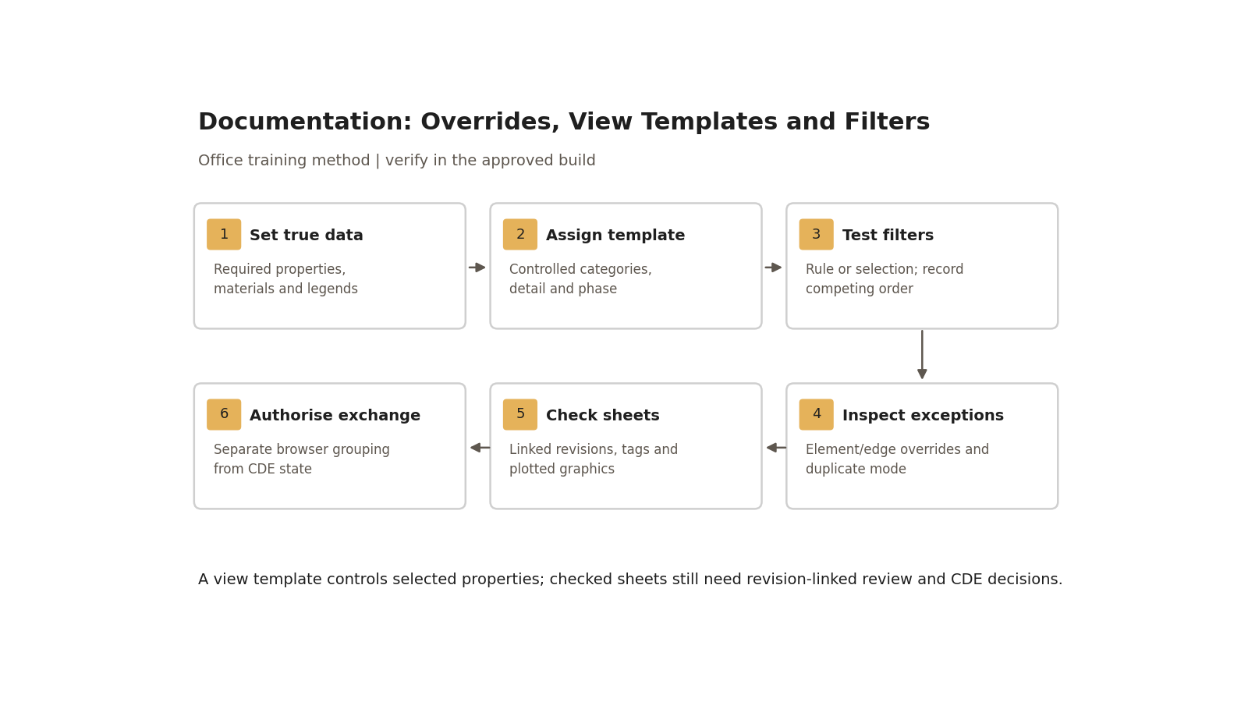
A view template controls selected properties; checked sheets still need revision-linked review and CDE decisions.

Step-by-step procedure
1. Confirm baseline, drawing purpose and approved material/annotation codes. Identify the exact model revision, sheet set, referenced links and required PDF/native outputs. Populate required element and sheet parameters; check tags, schedules and title-block drawn-by/revision fields against those values.
2. Create named working and documentation views using the approved browser scheme. Workshop category abbreviations (WAL/CWA/FLR/ROF/CLM/BEM/STR/SAN/FRN) are local examples; reconcile ambiguous codes such as STR against the approved discipline/category dictionary. Final identifiers follow the adopted BEP annex. Ask the BIM team to add missing worksets/templates/filters rather than inventing private variants.
3. Assign the correct controlled template to documentation views. Verify scale, detail level, view range, discipline, phase/phase filter, crop/scope box, annotation, categories and links. Use Temporary View Properties for investigation where suitable; restore and check the issued configuration. Removing a template for a working investigation requires a clearly named view and cannot silently alter the issued parent.
4. Create one rule-based filter from supported category/parameter rules and one selection filter containing explicit element IDs. Rules update membership when qualifying values change; a selection set is deliberately maintained. Demonstrate AND versus OR with known sample values; list selected categories and the actual rule result. Category/parameter support must be verified before promising filters can hide every section/callout by “WIP status”.
5. Apply two overlapping filters with different styles to the trial view. Record their order, Enable in View/visibility settings and competing properties; swap the order and verify the expected top-filter precedence. Selection filters are not intrinsically always higher/lower than rule filters: the actual list/settings matter. Put approved repeated filters into the template and recheck assigned views.
6. Apply a By Element override as a temporary documented exception, compare it to the competing filter/category graphics, then remove/reset it and verify the baseline returns. Track Linework edges separately and reset through the supported linework method. Do not assume a template will erase all manual exceptions. Use overrides to reveal true information, such as phase or rating, with a suitable legend.
7. Duplicate a sample view by each supported option. Duplicate produces an independent view without copying annotation/detailing; With Detailing also copies those items; Dependent maintains a linked relationship for supported shared properties/annotation with independently useful cropping. Do not claim overrides never carry over. Record initial copied graphics and subsequent propagation for the exact operation/build; the two independent modes do not make future edits propagate automatically.
8. Check the linked model: source revision/path, load/open state, host versus linked-view display method, phase mapping, categories/worksets and named linked view where used. Record a permitted linked-view exception, affected sheets and its approver. A closed workset may explain invisible links, but also check path/access/version and link display; do not prescribe one cause for every reload failure.
9. Prepare the sheet set from the checked views. Browser “WIP/Publish” grouping is navigation only; it neither changes CDE container status nor supplies authorisation. Restore temporary hides/isolation/properties, remove unapproved element/linework exceptions, and verify legends/tags/dimensions/callouts/linked references at intended plot scales. Check a plan, section and linked-model view at representative detail levels.
10. Export/publish the prescribed sheets from the retained checked revision. Compare complete plotted sheets with model/tag/schedule information, linked revisions and issue/revision marks; review page size, line weights/hatches, text legibility, hidden critical objects and cut/projection results. Correct data/model defects at source; record any permitted graphic exception and retest all affected sheets.
11. Have the assigned checker sign the output record and the appointed authoriser/acceptor perform the agreed CDE transitions. Record transmittal, state/suitability, acceptance/rejection and superseded versions. Cloud publication, browser organisation and a PDF file’s existence are not equivalent to that decision loop. Do not infer “true file size” solely from eTransmit; performance/pack size depends on included content and settings.

Duplicate/filter/publish practical exercise
Use three synthetic walls: two with the approved test fire-rating value and one without. Place a tag and a detail line on a plan. Apply two overlapping filters to one wall plus an explicit selection filter. Record before/after graphics when rule values and filter order change. Add and reset one element override and one Linework edge.
Test | Expected observation /​ record
Rule membership change | Edited parameter changes qualifying membership; tags/​schedule and colour agree.
Selection membership | Explicit IDs remain the maintained set; no assumed rule membership.
Competing filters | Top relevant filter controls the competing property in the scoped test; screenshot order and output.
Duplicate | Independent view; annotation/​detail item not copied; record copied graphic settings and later isolated edit.
With Detailing | Annotation/​detail items copied; future edits to independent copies tested separately.
Dependent | Supported shared edits/​annotation propagate; record parent/​dependent relationship and crop behaviour.
Linked display | Known linked element visible with correct phase/​detail/​category; controlled exception recorded.
Issued sheet | Checked revision and output match; material meaning, tag/​rating and reference callouts truthful.

Retain three duplication screenshots, filter configuration and known-value comparison, reset-override proof, linked-view settings and checked PDF/native revision record. Assessor must identify the exact source revision and each permitted exception from the evidence, not from verbal explanation.

Acceptance criteria / self-check list
• Assigned templates/properties, filters/order and permitted local exceptions are registered; project styles are not casually edited.
• Rule/selection membership, competing graphic priority and all duplication behaviours match recorded expected results in the adopted build.
• Representative plan/section/linked views show required categories, annotation, phases and detail levels at intended plot scales.
• Required rating/material values are attached to correct objects; graphics/legends do not imply false material or status.
• All published sheets identify checked model/link revisions; visual correction history and affected-sheet retests are retained.
• CDE authorisation/acceptance is separate from browser grouping/publication; contract owner resolves conflicts through the actual appointment hierarchy.

Common mistakes
• Painting/overriding a material to look correct: fix the data or label an approved analytical exception.
• Treating every duplicate as independent or override-free: test the selected mode and relationship.
• Losing a linked element: check loaded scope, path/access, phase and display method systematically.
• Relying on a template to remove manual overrides: inspect element/edge exceptions and reset them.
• Moving a view to “Publish” and assuming it is issued: complete the recorded check/authorise/accept workflow.

Related guides
• 21 — starting view/title blocks; 22 — collaboration and loaded scope.
• 23–24 — material/assembly drawings; 26–27 — property and family graphics.
• 30 — links; 31 — daily controls; 36 — model/tag/schedule checks.

Assessment record and release
Retain the exercise model/family, annotated screenshots, schedules or exports named above, and the completed checks together in the controlled training evidence location. Record learner, task, exact revisions, checker, date, result, defects, correction and retest. A mandatory failure means rework and reassessment; attendance alone is not a pass. The trainer records competence for this task; project use still follows the approved BEP and appointment authority. Do not distribute sensitive models or screenshots beyond their authorised audience.

Research coverage and correction trace
R06.1: graphics table/steps 3–6; R06.2: steps 4–5; R06.3: steps 2–3/6; R06.4: steps 8–10; R06.5: steps 9–11 and issue record. G28 P1: duplication/contract precedence/browser status corrected. P2: selection/order, linked exceptions and revision-specific QA. CROSSWALK C04/C18/C14 addressed.

References
Sources used from RESEARCH.md (with supplemental verification in GAPS.md where identified). Edition labels describe source evidence; confirm applicability against the approved project baseline. Standard-level references are used because the supplied research does not verify individual ISO clauses.
Source | Title | Publisher | Year /​ edition | URL /​ evidence note
S02 | ISO 19650-2 — Delivery phase of the assets | ISO | 2018, ed.1 | Catalogue /​ abstract; publisher result exposes English abstract and status
S04 | ISO 19650-4 — Information exchange | ISO | 2022, ed.1 | Catalogue /​ abstract
S05 | ISO 19650-5 — Security-minded approach to information management | ISO | 2020, ed.1 | Catalogue /​ abstract
S37 | Information protocols supporting delivery and operational phases — Guidance | UK BIM Framework | ed.3, August 2022 | Official PDF; linked through current IMI resources
G-C | Guidance C — Facilitating the CDE workflow and technical solutions | UK BIM Framework | ed.1, September 2020 | Official PDF; archived guidance
A08 | Visibility and Graphic Display in Project Views; About View Filters | Autodesk Revit Help | 2026 /​ 2025 | Category/​filter/​element controls; filter priorities and templates
A21 | Schedules; About Schedules | Autodesk Revit Help | 2026 /​ 2024 | Schedule types and outputs; grouping and live model data
X01 | Duplicate Views | Autodesk | Revit 2024 | Official Help. Distinct duplication and dependent-view behaviour.

Office source: BBM-STD-01-MANUAL-V0.1, sections identified under Standards basis; applicable confirmed project BEP and controlled Glossary. Preserve the source workshop export unchanged.

