29 · Complex Geometry: Pattern-Based and Adaptive Families and Quick Renders
Linked copies: ID STD-29 · TBP page · BABOOM edition · ArchHub: BABOOM companion
BABOOM-BIM-STANDARD · Office BIM workshops · Presenter: Ahmed Fargaly · Revision v0.2 · 14 October 2026 · Status: training draft for office review

Purpose & scope
Read the object before modelling it: identify the module, nodes, members, rise and information needed. Keep the workshop’s reference-point logic, constant flexing and lightweight live-project intent. This guide covers pattern-based/adaptive construction, host changes, performance and outputs. It also gives controlled quick-render steps, without treating a rendered image as geometric/data acceptance.

Standards basis
ISO 7817-1:2024 ties detail to purpose, timing, actors and objects. ISO 19650-2:2018 supports planned production and ISO 19650-4:2022 supports checked exchanges. This serves office Manual v0.1 §3.2 data, §3.3 partitioning, §6.1 libraries, §8.2.1/§8.2.2 modelling/family methods, §9 Quality and §11 IFC. Rendering tools, licence entitlement and add-in availability are provider/project matters; office training notes do not prove a tool is free, safe or installed.

Prerequisites and controlled baseline
Work in a training copy until the exercise is checked. Obtain the applicable exchange information requirements (EIR), confirmed BEP, office Manual and approved content library. The BIM manager assigns the trainer/checker; the task-team lead owns the model work. These instructions do not confer project acceptance authority.
Record before use | Value /​ evidence to enter
Project/​training model and revision | [identifier; WIP location; baseline revision]
Revit release and full build | [Help > About; record all build digits; check every collaborator]
Template and content revision | [approved RTE/​RFA identifiers, revision and controlled location]
Requirements and office documents | [EIR/​BEP/​Manual revisions; approved deviations]
Exchange and recipient | [native/​open format, IFC schema/​profile, exporter build and receiving tool]
Trainer, checker and date | [roles; test date; evidence location; decision]

The 2024 workshop is historical teaching evidence. No exact installed build or approved library revision was supplied for this rewrite. Complete this form and run the exercise in the adopted release before project use; do not substitute “latest” for a tested version. References to Autodesk Help identify the documented release, not an office installation.

1. Plan the unit and its hosting
For a synthetic repeating space-frame study, start with an approximately 1,800 × 1,800 mm square module, four corner nodes, a raised centre/reference node and members. These are training inputs. A photograph cannot establish surveyed dimensions, connection strength or construction tolerances; record measured/assumed status and obtain verified sources before design/fabrication reliance.
Component /​ point | Behaviour to define
Reference point | Hosts/​controls reference geometry; not every reference point is an adaptive placement point.
Adaptive placement points | Numbered user-selected locations; order, orientation and supported hosting control the placed instance.
Shape-handle points | Exposed adjustment controls where defined; do not confuse with the numbered placement sequence.
Derived centre/​rise | Constrained from the perimeter/​reference framework and a compatible Length parameter.
Profiles/​paths/​members | Host on the intended reference planes/​points, with documented section/​radius/​material.
Pattern/​divided surface | Defines host cell pattern and number/​distance/​orientation rules appropriate to the selected template.

A pattern-based component fits its supported host pattern; an adaptive component can use numbered placements without a divided-surface grid. Do not assume they are interchangeable curtain-panel families. Select the correct template/category/host and prove it loads/places in the chosen build. Pattern availability/base geometry and edge behaviour depend on that template/release, so inspect the offered controls rather than claiming every pattern derives from one rectangular grid.
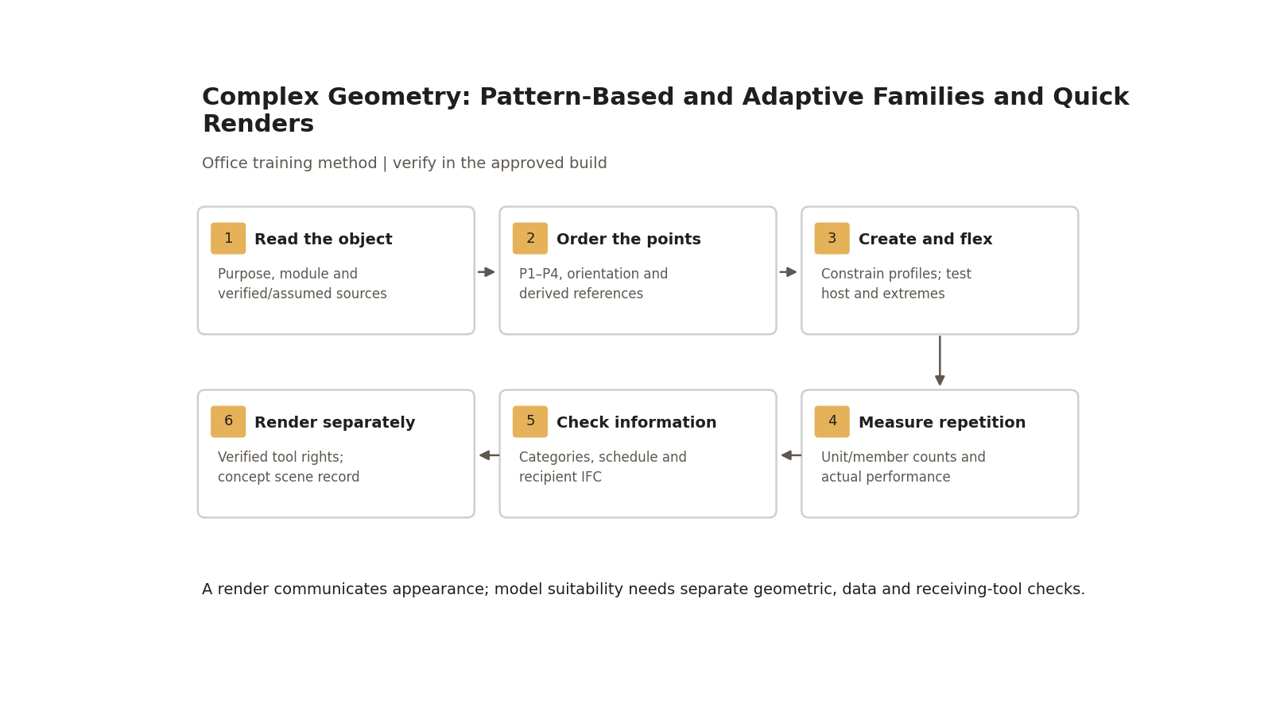
A render communicates appearance; model suitability needs separate geometric, data and receiving-tool checks.

Step-by-step procedure
1. Write the intended use: concept envelope, coordination, quantity study or fabrication support. Specify needed geometry, classifications/identifiers, materials, dimensions and documents; identify what is omitted. Choose the approved family template/category, host, build and information exchange. Structural/fabrication calculations and connection approval remain with the authorised designer.
2. Make reference geometry first. For the four-point adaptive exercise number perimeter placement points P1, P2, P3, P4 in the chosen consistent order. Define orientation/reference planes explicitly. Host paths/profiles on the intended references, then derive centre/rise. A 3D view is not a work plane; set the actual reference before drawing a profile.
3. Add a simple member form and controlled radius/thickness; confirm valid units and constraints. Test each parameter immediately. Keep an intermediate saved revision before adding complexity. If form creation fails, inspect self-intersection, plane/reference and overconstraints, then repair only the failed feature. Deleting/rebuilding is an option in a copy, not the default destructive live-project fix.
4. For curves create the intended reference-point/path and verify controls in the adopted release. Remove the workshop’s unverified “two points at a time / degree-two spline” claims: no universal mathematical assertion is made here. Test point movement, end conditions and divided-path spacing; compare measured intervals rather than assuming total-length divisions behave identically for every curve mode.
5. For a divided surface, record host face, pattern, U/V orientation and number/distance controls. Load the compatible pattern family and apply it through the supported pattern selector. Check residual/edge panels and permitted Partial/Empty/Overhanging behaviour where available. Rotate only through supported controls and verify intended geometry/counts. For an adaptive placement, click P1–P4 in the defined order and inspect orientation before repetition.
6. Change host dimensions and selected points, then use the supported update/repetition workflow. Test nominal, smaller/larger and skew cases; inspect twist, inverted normals, member collisions/gaps, disappearing geometry and host loss. Check shape handles separately. Record which changes are automatic and which require update/recreation; never promise every hosted object follows every host change correctly.
7. Scale the trial from one unit to a small patch and representative dense patch. Record unit/member counts, hardware/build, file size, opening/regeneration/export duration and warnings on the same baseline. Agree numerical performance limits with the BIM manager before measurement; a heavy-pattern warning alone is not a measured pass. Consider coarser visual representation or approved nested pattern only if information/exchange requirements remain met.
8. Validate categories and schedule semantics. Assign unit identifiers and required shared properties through controlled GUID/bindings. Record whether nested members are shared/separately scheduled or part of one parent assembly; compare physical units and scheduled objects deliberately. A generic mass or rendered member is not automatically a correctly classified asset/structural object.
9. Export the agreed IFC schema/profile/mapping and open it in the recipient. Check shape/orientation/coordinates, parent/member representation, count, material/dimensions and required property values. Record any tessellation/simplification and whether it meets the intended use. Re-export/retest failures; a successful file or attractive render is insufficient.
10. Release the assessed family revision through the library owner, retaining original intermediate/accepted baseline and test record. Do not load a downloaded/add-in-generated family into production solely because it sits in an office share. Record origin/licence, exact build, changed objects, reviewer and fallback/rollback.
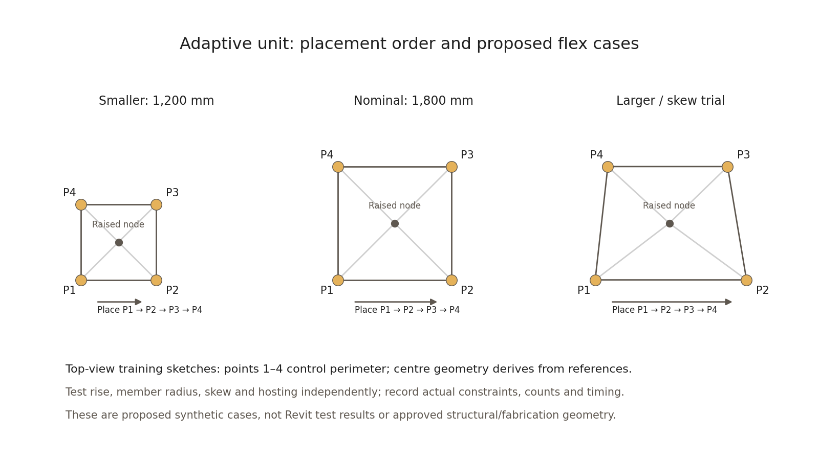
Numbered placement order and proposed synthetic flex cases; the office must record actual adopted-build results.

Worked flex and performance exercise
Start with one four-point unit. Trainer confirms valid dimension/rise/radius ranges before use. Proposed plan cases are a 1,200 mm square, 1,800 mm nominal square and a larger/skew perimeter with 2,400 mm bottom span and 1,800 mm depth. Add two recorded rise/radius cases within the approved family range and one intentionally invalid constraint in a copy. The diagrams are expected-input sketches, not executed Revit evidence.
Test | Expected result /​ evidence
Ordered P1–P4 placement | Intended perimeter/​orientation; numbered-point screenshot and reference-plane record.
Nominal and extremes | Continuous members/​nodes without unexplained distortion/​gaps; actual dimensions compared to inputs.
Reversed/​invalid placement | Identify orientation/​constraint defect and demonstrate correction; do not accept a mirrored/​twisted unit silently.
Host change | Expected automatic/​update behaviour recorded; patch count and geometry rechecked.
Small versus dense patch | Counts/​timings/​warnings against pre-agreed project limits; decision and lighter fallback if needed.
Category/​schedule | One row per unit or documented member scheme; identifiers/​material/​required data reconcile.
IFC recipient | Expected objects, shape and required mapped data present; exclusions/​simplification explicitly accepted for purpose.

Retain family/project revisions, min/nominal/max screenshots, timing/count table, schedule and receiving-tool report. The learner must explain how references drive the geometry and demonstrate one detected/rectified failure. Attendance or a finished image alone fails the assessment.

Quick renders — controlled convenience workflow
The recording demonstrated a real-time renderer and mentioned other engines. Current pricing, free entitlement, engine-specific material restrictions and library rights were not established by RESEARCH.md. Remove those claims; choose the office-approved engine only after the responsible owner records current provider/licence evidence and tests the compatible link/export version. Do not infer licence or safety from a “Libraries/Plug-ins” folder.
1. Approve the exact renderer/add-in/link build, provider source, entitlement, third-party asset/material reuse rights and permitted model distribution. Record the test/fallback and reviewer. Use a copy and log installation/configuration; no production version change just for a fast image.
2. Send the checked model revision through the supported link/export route. Compare orientation/scale/categories and one known material before rendering. Document whether material edits live only in the render scene or alter authoring data; do not promise a capability difference between vendors without tested current evidence.
3. Set camera and intended conceptual quality. For sun use approved orientation/location/time when relevant; for a synthetic scene record assumptions. Check lights and licensed HDRI/asset sources, material assignment and clipping. Concept speed is a local objective, not permission to imply verified existing conditions or construction detail.
4. Save the source revision, scene/settings and output with a caption describing concept status and omissions. Recheck the link after geometry changes. Model/schedule/IFC acceptance remains step 9; rendering is a separate communication check.
Tool gate to complete | Evidence required
Provider/​build/​compatibility | Official provider URL/​date, exact version, supported link route and successful representative test.
Licence/​asset rights | Entitlement holder/​scope/​expiry and authorised reuse of assets/​materials.
Operational trust | Source/​change record, isolated test, output diff, named reviewer and rollback/​fallback.

Workshop recordings may be indexed under the office Training/Workshops location. Record the actual approved location/access and recording date; availability there is not a release test.

Acceptance criteria / self-check list
• Purpose/LOIN, host/template/category and omitted information are stated; assumed measurements are labelled.
• Numbered placements and orientation are reproducible; representative extremes/host changes and invalid cases are documented and corrected.
• Model performance is measured against an approved baseline/limit, with a usable fallback where needed.
• Unit/member category, quantities, identifiers and required properties reconcile through native schedule and recipient exchange.
• Library revision is approved with provenance/rights and compatible rollback baseline.
• Rendering has a separate concept/scene check; all current vendor/licence/capability claims require actual provider evidence before adoption.

Common mistakes
• Modelling a photo as fabrication truth: verify dimensions and assign uncertainty/approval.
• Clicking points in an unrecorded order: label P1–P4 and test orientation.
• Treating all curves/pattern templates alike: use adopted-release controls and measured results.
• Repeating thousands of units before testing one: flex one, test a patch, then measure a representative workload.
• Counting nested graphics as physical assets automatically: declare schedule/exchange semantics.
• Calling tools “free and checked” from a share-folder name: retain provider/licence/test evidence.

Related guides
• 23–24 — mass faces and curtain hosting; 26–27 — templates, constraints and properties.
• 28 — documentation/graphics; 30–31 — supported tool baseline and operational controls.
• 35–37 — library intake, schedule QA and family release.

Assessment record and release
Retain the exercise model/family, annotated screenshots, schedules or exports named above, and the completed checks together in the controlled training evidence location. Record learner, task, exact revisions, checker, date, result, defects, correction and retest. A mandatory failure means rework and reassessment; attendance alone is not a pass. The trainer records competence for this task; project use still follows the approved BEP and appointment authority. Do not distribute sensitive models or screenshots beyond their authorised audience.

Research coverage and correction trace
R07.1: purpose/step 1; R07.2: points table/step 2 and numbered diagram; R07.3: steps 3–6; R07.4: steps 6–7/test table; R07.5: steps 8–9/acceptance. G29 has no independently verified P1 defect; unsupported curve/vendor claims removed. P2: build, extreme/performance and category/schedule/IFC checks. CROSSWALK C12/C14/C20: evidence-based tool and geometry controls.

References
Sources used from RESEARCH.md (with supplemental verification in GAPS.md where identified). Edition labels describe source evidence; confirm applicability against the approved project baseline. Standard-level references are used because the supplied research does not verify individual ISO clauses.
Source | Title | Publisher | Year /​ edition | URL /​ evidence note
S02 | ISO 19650-2 — Delivery phase of the assets | ISO | 2018, ed.1 | Catalogue /​ abstract; publisher result exposes English abstract and status
S04 | ISO 19650-4 — Information exchange | ISO | 2022, ed.1 | Catalogue /​ abstract
S07 | ISO 7817-1 — Level of information need: concepts and principles | ISO | 2024, ed.1 | Catalogue /​ abstract
A09 | Adaptive Components; Place an Adaptive Component | Autodesk Revit Help | 2016 /​ 2023; concept references | Reference points, repetition and hosting; placement
A19 | Model Efficiently | Autodesk Revit Help | Revit 2024 | Warnings, links, constraints and content performance
A18 | Create a Family from a Template | Autodesk Revit Help | Revit 2026 | Template selection and testing before sharing
A06 | Create Shared Project Parameters | Autodesk Revit Help | Revit 2026 | Category bindings, instance/​type and tag/​schedule use
A21 | Schedules; About Schedules | Autodesk Revit Help | 2026 /​ 2024 | Schedule types and outputs; grouping and live model data
S12 | Industry Foundation Classes (IFC) | buildingSMART International | Undated live page; 2024 ISO edition | Version and implementation context
A11 | About Graph Security and Trusted Folders | Autodesk Dynamo Player Help | Revit 2026 | Trusted folders and source verification
A12 | Add-in Registration | Autodesk Revit API Developer's Guide | Revit 2026 | Manifest and loading behaviour
P09 | Choose a License for Your Work | Creative Commons | Undated live chooser | Licence rights and ownership/​authority questions

Office source: BBM-STD-01-MANUAL-V0.1, sections identified under Standards basis; applicable confirmed project BEP and controlled Glossary. Preserve the source workshop export unchanged.

