34 · Railings, Stairs and Ramps
Linked copies: ID STD-34 · TBP page · BABOOM edition · ArchHub: BABOOM companion
Office BIM Workshops · Presenter: Ahmed Fargaly · Recorded session: 18 December 2024 · BBM-STD-34 · V0.2 · 14 October 2026 · WIP training revision; office approval pending

Purpose & scope
Build railings, stairs and ramps with simple, controlled components, then measure the actual circulation route. Retain the workshop preference for approved office types, level references and clear architectural/structural responsibility. The library of system types is a controlled WIP resource until its individual entries are approved; availability is not proof of accepted geometry or quantity output.
This is a modelling and QA guide, not a project code table. The discipline designer/code reviewer selects the applicable access, egress and safety criteria. The author models and measures; the structural/architectural owners resolve interfaces; the BIM coordinator checks model/data/exchange evidence. The appointed recipient accepts the exchange separately from the designer's compliance decision.

Standards basis
• ISO 19650-1:2018 and ISO 19650-2:2018 support agreed responsibility, requirements and information delivery. Office Manual BBM-STD-01 V0.1 §§6.1, 8.2, 9–11 and BEP BBM-STD-10 V0.2 §§6.2, 6.5–6.6, 8.2, 8.5 and 10 serve the circulation model/QA arrangement.
• ISO 19650-4:2022 supports checked exchange decisions and retained evidence. ISO 19650-6:2025 supports recording/exchanging relevant health and safety information; it does not prescribe a universal stair or ramp dimension.
• ISO 7817-1:2024 supports purpose-led geometry, properties and documents. An early model may simplify construction detail but must not imply an unverified safe route.
• Autodesk A15 describes railing components/hosts and ramp properties; A22 describes runs, landings, supports and component modifications. A22 is Revit LT 2026 guidance for common concepts; test full-Revit commands in the adopted build. A21 supports schedule output and A19 efficient/warning review.

What V0.2 corrects
Recording statement | Corrected scope /​ why
Ramp type settings ensure accessibility code cannot be broken | Limits assist modelling; separately verify every adopted criterion, including width, landings, crossfall, clearance, edge protection and transitions (C16)
Baluster is the only loadable railing family | Railings are systems using loaded profiles and baluster/​post/​support components as applicable. Continuous top rails/​handrails and their extensions need separate review
A railing always follows any host perfectly | Verify supported host, path, slope, offsets, joins and changes in the approved release; inspect the resulting 3D path
Multistorey is always prohibited or incapable | Separate flights remain the office default where floor heights/​landings vary; a multistorey route needs tested grouping and individual-change behaviour, not an unsupported universal ban
Every top must be connected and attachment is always forbidden | Use a documented constraint strategy. Level constraints are preferred where suitable; unconnected heights or attachments require an intentional, tested exception
Mirroring always creates a new wall ID | Do not infer identity behaviour from the recording. Test the actual operation/​release and inspect IDs, hosts, dimensions and schedules before accepting a change
Two overlapping stairs automatically give accurate quantities | Separate structural/​finish ownership can help, but every physical layer needs one quantity source and explicit exclusions

Office templates/types remain the starting point. Controlled external component admission follows guide 35. Record local naming/capitalisation rules as office conventions; no software family type alone establishes a procurement or code rule.

Design and model criteria register — fill before construction
Check | Adopted requirement /​ source /​ edition | Owner | Model evidence /​ actual | Decision
Route use and population /​ access purpose | [approved design basis] | Discipline/​code reviewer | [route ID /​ phase] | [fill]
Base/​top level and finish datum | [survey/​level register] | Coordinate + designer roles | [level /​ offset /​ measured height] | [fill]
Stair rise, going and uniformity | [project rule with units] | Designer | [count and dimensions in section] | [fill]
Clear width and headroom | [project rule /​ measuring method] | Designer | [narrowest section incl. finishes/​rails] | [fill]
Landing size, doors and turning space | [project rule] | Designer | [plan/​section and door swing] | [fill]
Handrail/​guard height, extensions, openings | [project rule] | Designer | [host/​path and finished-surface checks] | [fill]
Ramp slope, flight/​landing limits, crossfall | [project rule] | Designer/​access reviewer | [rise/​run, segmented flights and landings] | [fill]
Edge protection, transitions and surface specification | [project rule /​ spec reference] | Designer | [details /​ model-data check] | [fill]
Structural/​architectural layers and quantities | [responsibility/​measurement rule] | Both discipline owners | [source IDs /​ exclusions /​ reconciliation] | [fill]

If a limit or jurisdiction/source is unknown, record it as unresolved with owner and due date; hold the relevant compliance decision. Do not populate this register with generic training numbers as if they were applicable law.

Step-by-step procedure
1. Confirm route, level and ownership. Identify the route and intended phase/use, approved levels from the URS, finish build-ups, structural support, connected doors and adjacent circulation. Complete the criteria register and required information need. Assign architecture to finish/space/access intent and structure to structural design, with shared interface checks.
2. Choose a stair type deliberately. Review assembled, cast-in-place or precast construction against the design. A stair comprises runs, landings and supports. Set base/top levels and intended offsets; compare desired and actual riser count to measured floor-to-floor rise. Do not trust a type calculator to verify the whole route. Use regular component tools first; convert/sketch only where needed and record why.
3. Build runs and landings. Check run shape, width, risers, going, nosings, numbering/start tread, landing dimensions and support connections. Automatic landings and sketched landings behave differently. A sketched run-width change may not reshape a sketched landing; update and recheck it explicitly (A22). Where an architectural landing is a floor, verify stair/landing elevation, material/phase, gaps/overlaps and quantities against the structural landing.
4. Model the physical layer split. For renovation, retained structural stair and new finishes may have different ownership and phase. Record what each representation includes. Do not include a full concrete body in the architectural finish model if structure already supplies its quantity; exclude structural material there or adopt a verified alternative representation. A single integrated stair may also be valid if ownership, phases and measured take-off are proved. Choose by purpose and tested outputs, not a universal statement that integrated quantities never work.
5. Configure railing components. Confirm host or free-standing level and sketch path. Set path direction/start/end, offset, rail structure heights/material/profile, baluster repeat spacing, start/end/corner posts and base/top offsets. Review continuous top rail and handrail types, supports, extensions and termination separately. Load only approved profiles/components. Inspect corners, slope changes, transitions and the effect of flipping direction on posts/terminations.
6. Test supported hosts. Place a sample on the adopted stair/ramp/floor/wall or site host where the release supports it. Change host height/shape and observe the railing's actual path, gaps, clearances and offsets. Terrain/shape-edited hosts need especially explicit 3D and section review. A railing used as a boundary-wall modelling aid must have an approved category/data/exchange mapping and must not be mistaken for a compliant guard or quantified wall merely because its geometry resembles one.
7. Choose single-floor or multistorey modelling. Separate stair assemblies are the default for floors with differing rise/landing requirements. For a proposed multistorey stair, record build, connected levels/grouping, identical versus differing heights and intended individual edits; test a level/riser/landing change on one storey and inspect every affected assembly. If copied/grouped stairs are used, test group constraints and instance identity. Reject any result that prevents the required per-floor design or produces stale landings/quantities.
8. Build the ramp and independently measure it. Use the ramp tool when its behaviour suits the design; an approved floor/custom geometry solution needs the same data/measurement review. Set base/top, offsets, shape/thickness/material, Ramp Max Slope (1/x) and the appropriate Maximum Incline Length property according to the adopted release. These controls do not cover all access requirements. Measure actual rise and horizontal run for each flight, slope = rise/run and percentage = 100 × rise/run. Inspect landings, clear width, crossfall, turning areas, thresholds, railing continuity, guards and edge details against the criteria register.
9. Run change tests. Save the test baseline. Change the top level, run width, riser count, railing path direction, extension or host shape one operation at a time. Capture affected IDs and before/after sections. Verify automatic and sketched components separately; inspect constraints, offsets, adjacent floors/doors and borrowed/grouped items. Apply the same check to approved attachment/unconnected exceptions. No exception is accepted merely because the model regenerates.
10. Check documents, data and intersections. Produce plans/sections with level datums, full route dimensions, handrail/guard locations, headroom and landing/door clearances. Test stair/ramp/railing tags and category schedules available in the adopted build; record required shared identifiers, type data, phase and material/quantity outputs. Where a category cannot provide a required field, use the approved separate report/mapping and verify it. Coordinate with structural, slab/beam, ceiling, door, wall and services geometry; inspect both intersections and required clearances. Confirm exchange objects/properties and receiver geometry under the agreed profile.
11. Obtain design review and exchange decisions. The designer/access/code reviewer records each applicable criterion's measured result, pass/fail and decision against the exact revision. Record residual health/safety concerns with route/element/location, responsibility and mitigation evidence; do not erase them with a green model-check flag. The author/coordinator complete information checks; appointed authority/recipient authorise and accept the exchange. Failed checks return to WIP for correction and remeasurement; preserve rejection/retest evidence and superseded revisions.
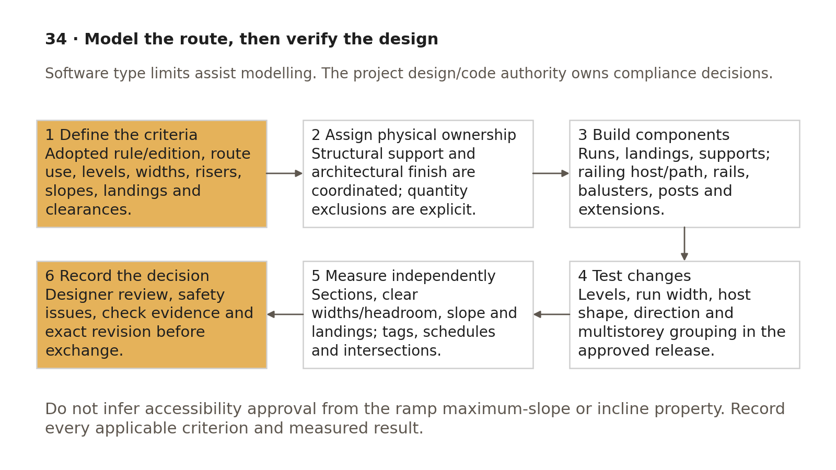
Circulation modelling is followed by versioned change tests, independent measurement and assigned design decisions.
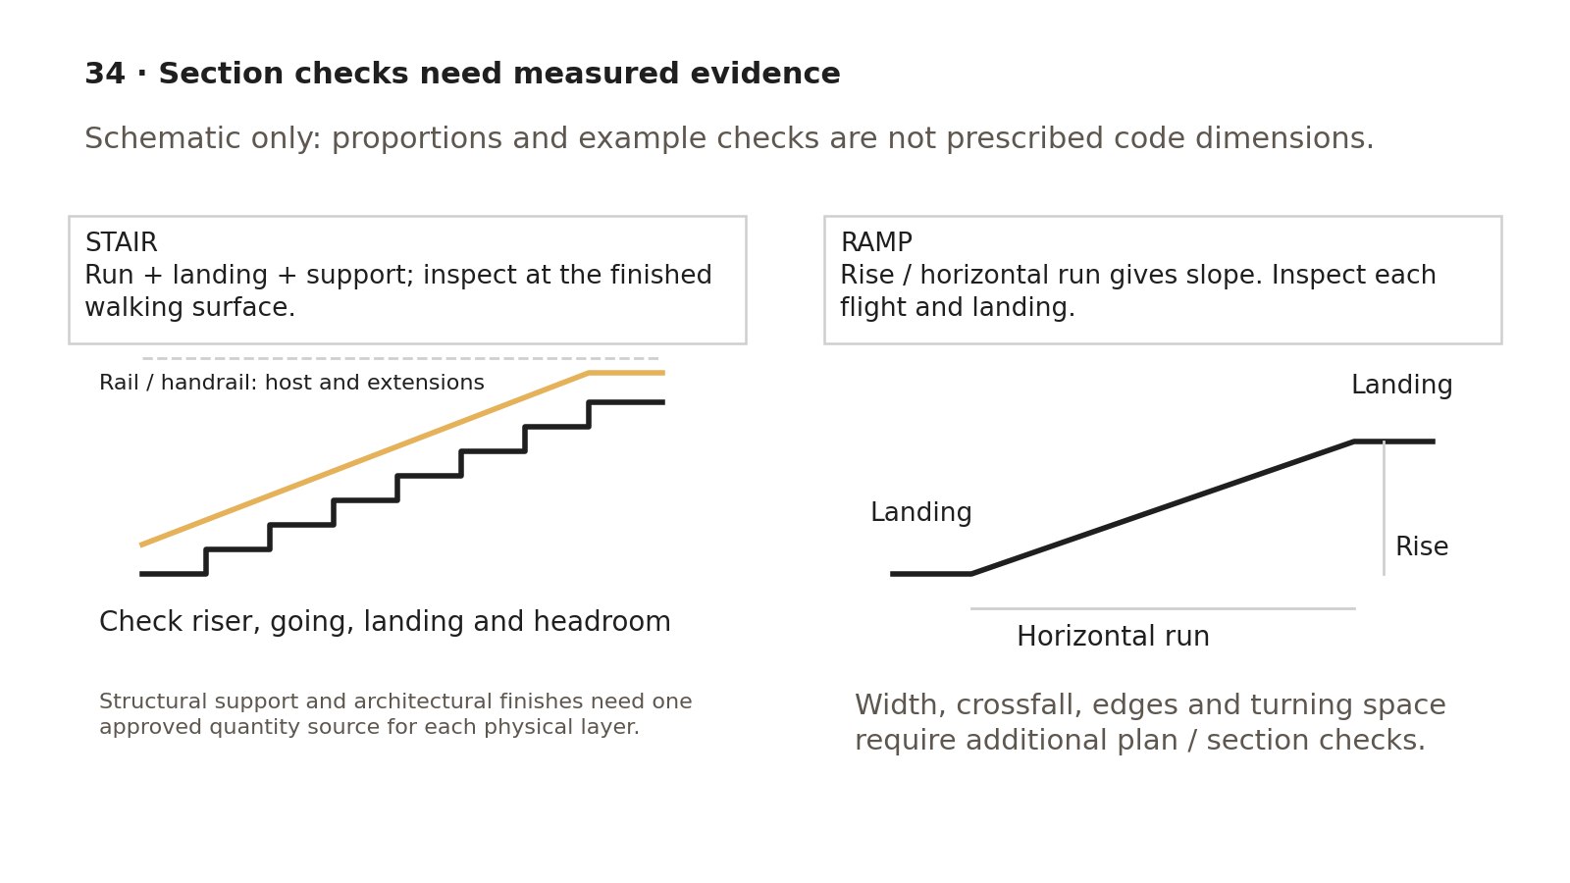
Stair and ramp sections expose rise/run, landing and host relationships; full route criteria still require plan, section and specification checks.

Worked exercise — two levels and one ramp
Use a synthetic floor-to-floor rise of 3.000 m. A training stair with 20 risers has a nominal rise of 0.150 m per riser; with a selected 0.300 m going, verify the actual tread arrangement and total horizontal travel of each run/landing. These are arithmetic/model-test inputs, not prescribed access/egress limits.
1. Model the two-level stair with a recorded landing/support strategy and approved sample railing; tag and schedule the required outputs. Independently confirm 20 risers and 3.000 m total rise, finished-surface levels, run/landing widths and connections.
2. Raise the top level to 3.100 m in a test copy. If riser count remains 20, nominal average rise is 0.155 m; inspect actual count/uniformity, landing/railing response and all failed criteria. Restore the baseline or submit an approved revised design. A successful regeneration alone is a failed assessment response.
3. Change one run width and one sketched landing; document which geometry updates and what requires manual editing. Test proposed multistorey/group behaviour on a second storey with a different rise. Record build, affected IDs and before/after results.
4. Create a test ramp with 0.600 m rise over 12.000 m horizontal inclined run: slope = 0.05 = 5% = 1:20. Landings are additional horizontal lengths and are checked separately. Compare actual segment slopes and adopted incline/landing properties; change top rise to 0.660 m to demonstrate that the design must be rechecked even if the type permits modelling.
5. Compare structural and architectural material/finish reports: every physical layer has one source, with phase/ownership exclusions. Submit plans, sections, measurements, tag/schedule/receiver output, intersections, change-test log and completed criteria register. Pass requires correct results and an explicit designer decision; missing applicable limits remain unresolved.

Acceptance criteria / self-check list
• Route purpose, adopted rules/editions, levels, finish datums and responsible design/code reviewer are recorded.
• Runs, landings/supports and architectural/structural physical-layer responsibilities are clear; quantities are reconciled without duplication.
• Actual risers, going, widths, headroom, landing/door clearances and supports are measured in plans/sections.
• Railing host/path, profiles, balusters/posts, continuous rails/supports/extensions and direction are tested.
• Ramp actual slope, flight/landing arrangement, crossfall, transitions, edges and route clearances are reviewed against applicable criteria.
• Single-floor/multistorey/group and level/host/component changes have versioned before/after evidence.
• Required tag/schedule/material/phase/receiving outputs and model intersections/clearances are checked.
• Design/code decisions and safety issues are recorded separately from software limits and information-exchange acceptance.
• Reviewed model revision, rejection/correction/retest and appointed exchange decisions are retained.

Common mistakes
• Calling a ramp compliant because its type has a slope value.
• Measuring width before finishes, rails, doors and turning constraints are included.
• Assuming a sketched landing resizes with the run or a copied/grouped stair suits differing floor heights.
• Ignoring railing extensions, direction, host changes or gaps at slope transitions.
• Quantifying two full stair bodies under the label structural/architectural.
• Copying recorded local attachment/multistorey bans as universal Revit behaviour.

Related guides
• 23: walls/constraints; 27 and 35: approved component parameters/content.
• 30: level and coordinate authority; 32: existing-condition/measurement QA.
• 33: phase/finish quantity splits; 36: schedule and receiving checks; 28: checked route documentation.

Editorial coverage record
R12.1–R12.5: procedure 2–4 covers components/change response; criteria register and sections cover level/dimension/clearance review; procedure 5–6 covers railing hosts/profiles/balusters/continuous rails/extensions; procedure 8 covers ramp controls and independent access checks; procedure 9–11 and exercise cover changes, tags/schedules, intersections and decisions. C16/C17/C20 corrected with assigned design authority and tested office conventions. P1 1/1 and P2 1/1 fixed; P3 two-level/ramp change exercise included. Full-Revit exercise execution and applicable code approval remain office tasks.

References
Source IDs refer to the supplied RESEARCH.md register. Autodesk Help describes the listed release; verify commands in the project-approved build. Public ISO abstracts establish scope and edition, not clause-level compliance.
• S01 — ISO 19650-1 — Concepts and principles. ISO, 2018, ed.1. https://www.iso.org/standard/68078.html?browse=tc
• S02 — ISO 19650-2 — Delivery phase of the assets. ISO, 2018, ed.1. https://www.iso.org/fr/standard/68080.html
• S04 — ISO 19650-4 — Information exchange. ISO, 2022, ed.1. https://www.iso.org/cms/live/live/en/sites/isoorg/contents/data/standard/07/82/78246.html?browse=tc
• S06 — ISO 19650-6 — Health and safety information. ISO, 2025, ed.1. https://www.iso.org/standard/82705.html
• S07 — ISO 7817-1 — Level of information need: concepts and principles. ISO, 2024, ed.1. https://www.iso.org/standard/82914.html?browse=tc
• A15 — About Railings; Ramp Type Properties. Autodesk Revit Help, Revit 2026. https://help.autodesk.com/cloudhelp/2026/ENU/Revit-ArchDesign/files/GUID-34DEB2F6-E66E-4801-8138-958DDB4D2A5A.htm ; https://help.autodesk.com/cloudhelp/2026/ENU/Revit-ArchDesign/files/GUID-D0A28BE6-BDD0-43D3-A2A5-3F0C867C55E5.htm
• A22 — About Stairs; Modifying Stair Components. Autodesk Revit LT Help, Revit LT 2026; common component concepts. https://help.autodesk.com/cloudhelp/2026/ENU/RevitLT-ArchDes/files/GUID-D4861B15-29FF-49F8-B292-39AD62EBCDD3.htm ; https://help.autodesk.com/cloudhelp/2026/ENU/RevitLT-ArchDes/files/GUID-62CAA251-BB6E-4394-8E9F-949C3BFEB674.htm
• A21 — Schedules; About Schedules. Autodesk Revit Help, 2026 / 2024. https://help.autodesk.com/cloudhelp/2026/ENU/Revit-DocumentPresent/files/GUID-F50D6FF4-859E-43A2-A2F6-81C84A1BA0EB.htm ; https://help.autodesk.com/cloudhelp/2024/ENU/Revit-DocumentPresent/files/GUID-73090B70-8A13-4E12-909C-F25D724D5BA7.htm
• A19 — Model Efficiently. Autodesk Revit Help, Revit 2024. https://help.autodesk.com/cloudhelp/2024/ENU/Revit-Customize/files/GUID-8287BB99-B15F-4809-B6AF-3DA26B8CD027.htm
• S12 — Industry Foundation Classes (IFC). buildingSMART International, Undated live page; 2024 ISO edition. https://www.buildingsmart.org/standards/bsi-standards/industry-foundation-classes/?lang=en
• G-C — Guidance C — Facilitating the CDE workflow and technical solutions. UK BIM Framework, ed.1, September 2020. https://ukbimframework.org/wp-content/uploads/2020/09/Guidance-Part-C_Facilitating-the-common-data-environment-workflow-and-technical-solutions_Edition-1.pdf

