35 · Importing Families from Outside
Linked copies: ID STD-35 · TBP page · BABOOM edition · ArchHub: BABOOM companion
Office BIM Workshops · Presenter: Ahmed Fargaly · Recorded session: 17 February 2025 · BBM-STD-35 · V0.2 · 14 October 2026 · WIP training revision; office approval pending

Purpose & scope
Outside families bring their own geometry, patterns, styles, materials and parameters. Keep the workshop's two practical routes: rebuild simple content on an office template, or selectively transfer/clean more complex content. No unreviewed outside family enters a live model. A reviewed native, manufacturer or library family may enter through this guide's admission gate; this replaces the absolute ban in guide 32 (C17).
The content author prepares the item; the data/discipline owner protects required manufacturer, specification and exchange semantics; the library owner approves the accepted version. The BIM coordinator checks integration and received outputs. Proposed project use, compatible build and reuse rights are required even when geometry is rebuilt.

Standards basis
• ISO 19650-1:2018 and ISO 19650-2:2018 support controlled shared information and agreed production methods. Office Manual BBM-STD-01 V0.1 §§6.1, 8.2, 9, 11 and 12 and BEP BBM-STD-10 V0.2 §§6.5–6.6, 8.3, 8.6, 8.10 and 10 serve library naming, information need and quality controls.
• ISO 19650-4:2022 supports checked information exchange. ISO 7817-1:2024 supplies purpose-led geometry/properties/documentation requirements; more geometry is not automatically better content.
• ISO 23386:2020 supports identified properties and controlled definition changes. Autodesk A06 supports shared bindings; A18 supports appropriate template/host and testing before sharing; A16 supports loading required types; A19 supports complexity/warning/performance review; S12 supports agreed IFC receiving checks.
• Creative Commons licence chooser guidance (P09, undated) is a rights/authority prompt, not a licence granted to downloaded content. Record the actual source permission; a missing licence is an unresolved admission condition.

V0.2 corrections — preserve required meaning
Recorded instruction | V0.2 control /​ reason
Transfer: Check All, Overwrite | Select approved standards only, document duplicate handling and compare changes in a quarantined copy. Blanket overwrite can destroy needed styles/​data/​constraints
Delete foreign or non-English parameters/​subcategories | Determine their purpose and dependencies; translate display documentation or map aliases without deleting required identities/​values
Constants in formulas are not real parameters | A constant may intentionally fix a type/​specification; document it. Flexability is purpose-dependent, not a reason to erase the formula
Constraints/​formulas are all overhead | Remove only proven unnecessary dependencies, one change at a time; retain design/​material/​type relationships and flex evidence
Geometry from a named tool is always fixed/​non-editable | Inspect actual forms/​category/​imports and record editable dimensions versus fixed geometry. Origin/​tool name does not establish editability
Save to Shared and it is available to everyone | Use a quarantine/​WIP intake first; release to the approved library only after owner acceptance, revision and evidence
Weekly cleanup deletes unexplained content | Quarantine/​report and resolve dependencies before removal. Do not silently remove used objects or required data

The office's uppercase/no-space family convention may be retained where the approved project/library annex adopts it. It is a local convention, not a universal ISO or Revit naming rule. Record any alias/migration and retain historical issue identities rather than renaming released references without coordination (C02).

Intake record — complete before opening the live model
Field | Required entry
Intake ID /​ proposed use | FAM-INT-[number]; discipline, object purpose, required geometry/​properties/​documents and project phase
Origin /​ custody | Source publisher/​provider, source URL/​receipt, download date, original filename/​revision/​hash and restricted intake location
Rights /​ permission | Licence/​terms and evidence, permitted modification/​reuse/​distribution, attribution obligations, rights reviewer and decision
Compatibility | Original Revit release if established; adopted major release/​build, upgrade necessity and approved test environment
Template /​ category /​ host | Office template revision; proposed category/​subcategories; unhosted/​face/​wall/​other hosting; rationale and exchange mapping
Types /​ dependencies | Required type list/​catalogue, nested/​shared nested content, materials/​textures, external resources, imported geometry and constraints
Required data | Property definitions/​GUIDs, type/​instance, units, allowed values, owner, classification release, tag/​schedule and IFC mappings
Review /​ recovery | Content author, discipline/​data reviewer, library approver, test file/​revision, original recovery copy and unresolved issues

If rights, compatibility or required meaning cannot be established, retain the item in restricted intake with a hold/reject reason. Do not load first and investigate later. Revit cannot natively save an upgraded family back to an older release; preserve the original and adopt the approved project version (A01).

Step-by-step procedure
1. Register and quarantine. Retain original bytes and provenance separately from the edited WIP item. Review proposed use, rights, source reliability and exact project build before content enters a project. Unknown permission is not repaired by copying geometry to a new template. Minimise downloaded dependencies and use the office-approved trust/inspection process.
2. Inspect the family. Identify template/category/host, forms/imports, origin, dimensions, reference planes, types, parameters/GUIDs, formulas, nested content, materials and visibility. Record which properties are required by manufacture, design, procurement, tags, schedules or exchange. Inspect foreign line/fill patterns for dependencies; different styling indicates review work, not meaningless data.
3. Choose a route and approved change list. For simple editable geometry, start from the approved category/host template, rebuild or copy only justified geometry, then recreate references/constraints and map the required data. For complex content, keep the intact original and selectively transfer only needed office standards into a WIP copy, if that family/release supports the selected operation. Record selection and duplicate decision; never Check All by default. Consider the cost of lost host/functionality before preferring a rebuild.
4. Map property identities before cleanup. Maintain source property → approved property/GUID → category/binding → type/instance → unit/value domain → tag/schedule/IFC mapping. A matching display name does not prove identity. Preserve required values when converting, and obtain approval for a category/binding or type-instance change. Do not rename material codes without specification/QS coordination. Retain manufacturer data where required and authorised; do not replace it with invented office performance claims.
5. Clean one reviewed dependency at a time. Align line weights, subcategory/object styles, fill/line patterns and approved material names. Before deletion search types/geometry/nesting/formulas/visibility for references; remove only unneeded items on the approved change list. Compare the result to the original after each destructive change. Keep intentional constants and formula/constraint chains; only simplify when min/nominal/max tests prove behaviour is preserved. Retest origin and host after rebuilding/copying.
6. Control nested content and complexity. Document nested family identities/revisions and shared versus non-shared behaviour. Shared nesting can change project counts/tags/schedules; do not count both parent and nested physical item without a measurement rule. Review unnecessary types, imported/high-detail geometry, arrays/constraints, warnings, textures/external references and regeneration behaviour. Agree a performance criterion for the approved hardware/sample size rather than inventing a universal file-size ceiling.
7. Load required types only. Use a reviewed type catalogue where available: confirm matching family/catalogue names and location, types/units/values, select the agreed subset in Load Family and compare imported types to the request. Preserve the approved master/catalogue; unneeded types in a working project are not a reason to destroy the library master. Where no catalogue exists, curate an approved load copy or selected type route and verify that only the intended content enters the test model.
8. Flex in family and project. Test minimum, nominal and maximum required dimensions; every approved type; instance offsets/rotation; host placement/changes; and plan/elevation/section/3D visibility at required detail levels. Verify origin, placement height, materials and meaningful geometry. Fixed geometry is acceptable only when the requirement explicitly permits its limits. Record warnings/errors and expected/actual results. Test family reload choices against existing parameter values in a controlled project; do not assume either overwrite option always preserves every value.
9. Check tags, schedules and exchange. Populate a synthetic type code and two distinct instance IDs. Test required tags, itemised/grouped schedules and material reports, including shared/nested counts. Verify data GUID/binding/type-instance semantics rather than only a legible label. Export the agreed IFC schema/profile with the approved exporter; inspect expected object category/class, required property names/values/units, geometry and counts in the receiving tool. A valid native family is not automatically a correct IFC object. Retain model/exporter/profile/receiver revisions and comparison.
10. Approve and release a library version. The discipline/data reviewer signs required geometry/semantics; the library owner records acceptance, exact filename/revision/hash, compatible build, test evidence, allowed use, restrictions and dependency/catalogue versions. Release only then to the controlled project library; include status metadata, not merely a Shared path. Load the exact accepted version into the project and perform the integration/reload check. At project close propose reusable items for the office library under a separate rights/use review; project approval alone may not grant organisation-wide redistribution.
11. Handle changes and failures. Reject or hold failed content with intake ID, reason, affected test/owner and remedy. Correct WIP, repeat affected and regression tests and submit a new revision. Preserve superseded/original items and recovery instructions in controlled custody; remove live content only after host/tag/schedule/quantity dependencies and replaced element IDs are reconciled. Weekly model health review reports and routes defects; it does not silently delete families. Retest after project upgrades or mapping changes.
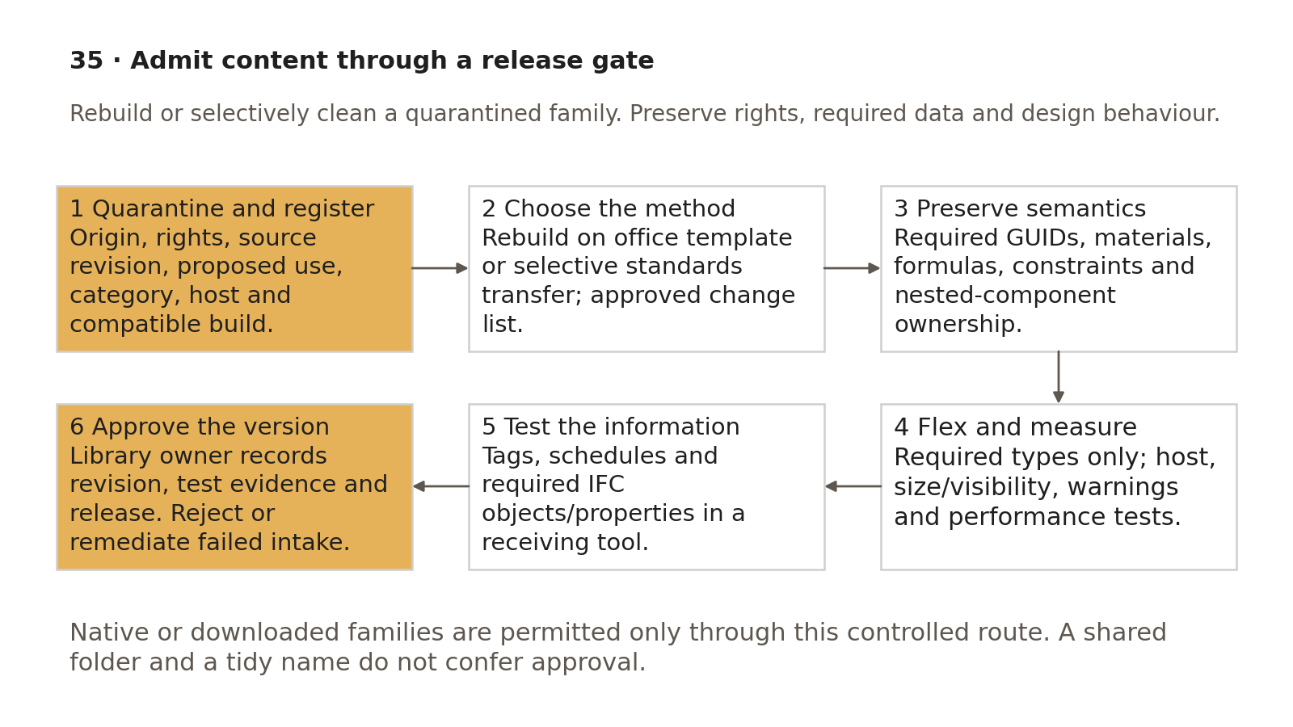
Quarantine, selective change and measured native/open exchange tests precede library release.

Selective change / test register
Source item | Proposed change | Protected dependency /​ data | Owner /​ approved scope | Expected /​ actual /​ evidence
[pattern/​subcategory] | Map to approved style | [geometry visibility] | [fill] | [before/​after views]
[parameter /​ GUID] | Retain, map or approved conversion | [formula/​tag/​schedule/​IFC] | [data owner] | [values, units, binding test]
[material code] | Approved alias /​ retained specification | [quantity/​spec/​appearance] | [discipline/​QS role] | [take-off and receiver check]
[nested family] | Retain/​update/​remove if unnecessary | [host/​shared counting] | [content owner] | [IDs/​counts/​flex]

Release test | Required evidence /​ condition
Rights and compatibility | Accepted origin/​permission and compatible build; no unresolved admission blocker
Category /​ hosting | Intended category and supported host; placement/​change tests match purpose
Flex /​ visibility | Required dimension/​type extremes and views behave without unresolved critical failures
Complexity /​ warnings | Reviewed nesting/​types/​imports, classified warnings and agreed performance results
Tags /​ schedules | Required IDs/​codes/​materials and type/​instance/​nested counts match known sample
IFC /​ receiver | Agreed object/​property mapping, values/​units, geometry and counts reconcile to the accepted native version
Release | Library approver, revision/​hash/​dependencies, allowed use, retained evidence and tested reload/​recovery

Synthetic accepted/rejected comparison
Candidate | Intake /​ test facts | Decision
Chair A | Authorised modification/​reuse; Furniture/​unhosted; three tested sizes; approved shared instance ID; two tagged/​scheduled instances; IFC mapping and selected two catalogue types reconcile | Eligible for owner approval and versioned release
Chair B | No established reuse permission; three same-name properties with unknown GUIDs; fixed imported geometry despite required resizing; tags blank; exporter returns wrong class | Hold/​reject. Record missing evidence and failed requirement; do not “clean” until ownership/​meaning is resolved

These are training expectations, not results for an actual downloaded family. Create a synthetic five-type master family with a catalogue; load only two requested types into a test project. Place one instance of each, give them distinct stable instance IDs, and verify count = 2 in the itemised schedule and receiver. Flex the approved size ranges, compare tags/properties and perform an intentional one-property removal in a disposable copy: the required-field check must fail. Restore it and retest. Submit intake/change map, views, warning/performance log, catalogue selection, tag/schedule/IFC evidence and release decision. Missing rights or a required-property failure prevents acceptance.

Acceptance criteria / self-check list
• Origin, rights, proposed use, original/revised identity and Revit compatibility are recorded before live loading.
• Default office templates and controlled native/external admission policy agree with guide 32.
• Rebuild/transfer scope is selected and diffed; required semantics, GUIDs, materials, formulas and constraints are preserved or approved/mapped.
• Category/host, nested content, warnings, complexity and unnecessary types have a reviewed result.
• Only required types are loaded; catalogue/dependency identities are retained.
• Required sizes/types/visibility/hosting and reload parameter behaviour pass recorded tests.
• Tags, schedules, material quantities and IFC receiving objects/properties/counts reconcile to the accepted native revision.
• Library owner approves a version with use limits, compatibility, evidence and recovery; failed or superseded intake remains traceable.

Common mistakes
• Rebuilding geometry to evade unresolved source rights.
• Deleting non-English or unfamiliar parameters without mapping their required meaning.
• Treating a formula constant or a nested shared family as automatically unnecessary.
• Transferring every setting, loading every catalogue type or blindly overwriting existing values.
• Approving content because it looks correct in one 3D view while tags/hosts/IFC fail.
• Copying a project-approved family into the office library without reviewing wider reuse permission.

Related guides
• 26–27: parameter identities and family flexing; 30: version/template baseline.
• 31: selective standards transfer and logged changes; 32: admission policy and model QA.
• 34: circulation components/hosts; 36: schedule/receiver checks; 37: family creation and assessed chair tests.

Editorial coverage record
R13.1–R13.5: intake record; category/host/flex procedure; complexity/nesting/warnings review; required-type catalogue selection; tags/schedules/IFC and library owner release. C02/C09/C12/C15/C17 are resolved through controlled naming, property identity, compatibility/rights and selective changes. P1 1/1 and P2 1/1 fixed; P3 accepted/rejected comparison and assessed two-type exercise included. No actual family licence, installed capability or model test is assumed.

References
Source IDs refer to the supplied RESEARCH.md register. Autodesk Help describes the listed release; verify commands in the project-approved build. Public ISO abstracts establish scope and edition, not clause-level compliance.
• S01 — ISO 19650-1 — Concepts and principles. ISO, 2018, ed.1. https://www.iso.org/standard/68078.html?browse=tc
• S02 — ISO 19650-2 — Delivery phase of the assets. ISO, 2018, ed.1. https://www.iso.org/fr/standard/68080.html
• S04 — ISO 19650-4 — Information exchange. ISO, 2022, ed.1. https://www.iso.org/cms/live/live/en/sites/isoorg/contents/data/standard/07/82/78246.html?browse=tc
• S07 — ISO 7817-1 — Level of information need: concepts and principles. ISO, 2024, ed.1. https://www.iso.org/standard/82914.html?browse=tc
• S16 — ISO 23386 — Methodology to describe, author and maintain properties in interconnected data dictionaries. ISO, 2020, ed.1. https://www.iso.org/standard/75401.html?browse=tc
• A01 — Project Templates; Create a Model. Autodesk Revit Help, Revit 2026. https://help.autodesk.com/cloudhelp/2026/ENU/Revit-Customize/files/GUID-4C16B54A-7ADA-4DEB-A278-C199B1BC4207.htm ; https://help.autodesk.com/cloudhelp/2026/ENU/Revit-GetStarted/files/GUID-3FF8DDB0-A015-4F94-B9DA-1FA96181FCA3.htm
• A06 — Create Shared Project Parameters. Autodesk Revit Help, Revit 2026. https://help.autodesk.com/cloudhelp/2026/ENU/Revit-Model/files/GUID-114C68A9-FF2B-4D4C-A2DF-3AE7E1F174C8.htm
• A18 — Create a Family from a Template. Autodesk Revit Help, Revit 2026. https://help.autodesk.com/cloudhelp/2026/ENU/Revit-Customize/files/GUID-228D213B-9497-48A6-AAE1-4E54F7834931.htm
• A16 — Load a Family with a Type Catalog. Autodesk Revit Help, Revit 2024. https://help.autodesk.com/cloudhelp/2024/ENU/Revit-Model/files/GUID-5DB0797C-B0CA-4C3F-B72A-84176738AEC5.htm
• A19 — Model Efficiently. Autodesk Revit Help, Revit 2024. https://help.autodesk.com/cloudhelp/2024/ENU/Revit-Customize/files/GUID-8287BB99-B15F-4809-B6AF-3DA26B8CD027.htm
• S12 — Industry Foundation Classes (IFC). buildingSMART International, Undated live page; 2024 ISO edition. https://www.buildingsmart.org/standards/bsi-standards/industry-foundation-classes/?lang=en
• P09 — Choose a License for Your Work. Creative Commons, Undated live chooser. https://creativecommons.org/chooser/

