36 · Data Control with Schedules
Linked copies: ID STD-36 · TBP page · BABOOM edition · ArchHub: BABOOM companion
Office BIM Workshops · Presenter: Ahmed Fargaly · Recorded session: 19 May 2025 · BBM-STD-36 · V0.2 · 14 October 2026 · WIP training revision; office approval pending

Purpose & scope
Every modelled element carries data: category, family/type, material layers, levels, constraints, phase, workset, marks and other required properties. Keep the workshop's principle that schedules expose and control that data. Build an audit schedule first; then use controlled grouping and formatting for an issued schedule or finishes legend.
This guide covers category/field definitions, itemised versus grouped edit scope, shared/key parameters, known-data validation, exceptions and export reconciliation. The author owns edits; the data/discipline owner defines fields/units/meaning; the BIM coordinator checks outputs; the appointed exchange roles authorise and accept the specific revision. The URS remains assigned to the responsible architect/coordinate owner with the BIM specialist under guide 30; scheduling does not transfer that authority.

Standards basis
• ISO 19650-1:2018 and ISO 19650-2:2018 support agreed requirements, responsibilities and information production. Office Manual BBM-STD-01 V0.1 §§3.2, 7.2–7.3, 9, 11–12 and BEP BBM-STD-10 V0.2 §§6.5–6.6, 8.6 and 10 serve controlled data, schedules and issue checks.
• ISO 19650-4:2022 supplies exchange-quality checks. ISO 23386:2020 supplies controlled property definition/identity; ISO 7817-1:2024 makes required geometry, properties and documentation purpose-specific.
• Autodesk A21 distinguishes schedule kinds, live records and grouping. A06/A17 support shared category bindings and instance-only keys; A14 supports phase checks. Microsoft Learn Data lineage (P05, undated) supplies the source/revision/dependency principle; no Power BI connection is required to keep a schedule lineage record.
• UK BIM Framework Guidance C, edition 1 (2020), distinguishes checked exchange/CDE decisions from a browser folder or sheet name.

V0.2 corrections and retained warning
Workshop shorthand | Correct scope /​ check
Every row is a real element | An itemised element schedule can show one instance per body row. Grouped rows can represent several elements; headers/​totals are not elements. Material take-offs can show multiple material records for one element; key rows are data definitions
Selecting any row selects its element | Use Highlight in Model where supported and inspect actual selected IDs/​count; schedule kind, linking and grouping matter
Grouped edits change only what I can see | Editable instance fields can affect the grouped instances; a type-field edit can affect all instances of that type, including outside the visible schedule. Computed, hosted, linked or read-only fields have different restrictions
All schedule kinds work identically | Element, material, sheet, view, annotation and key schedules have different fields, scope and editing behaviour
Filter by sheet always works and includes everything | Verify adopted release, category/​schedule kind and actual sheet visibility. Use a tested fallback where unsupported or incomplete
Multi-category includes all wall/​floor/​material data | Inclusion/​fields depend on category and release. Prove required category coverage; use per-category or material schedules and a controlled reconciliation if needed
Filter blanks out | Presentation may filter blanks only while a separate unfiltered exception audit exposes mandatory failures
Copy/​paste schedule brings every needed definition | Use the supported schedule-reuse route; inspect fields, bindings, filters/​templates/​phase and source/​target differences after transfer

Keep this warning: editing a schedule edits model information. A grouped row can contain many objects; deleting selected element records can remove their geometry and associated data. Key/material/linked schedule operations have distinct behaviour. Before an edit or deletion preserve a snapshot, identify schedule kind and affected IDs/types, inspect dependencies, obtain the required decision and prove the result in a controlled sample. Do not treat a blank-looking row as an empty spreadsheet row.

Schedule specification — fill before creating the view
Field | Required definition
Name /​ owner /​ use | Audit, quantity, issue schedule or legend; responsible data/​discipline owner
Scope | Category/​schedule kind; model + linked container revisions; level/​zone; intended phase/​filter and exclusions
Identity | Stable element key or agreed exchange identifier; unique instance mark; controlled type/​material code
Fields | Display label, source property identity/​GUID where applicable, category binding, type/​instance, definition and required status
Units and precision | Underlying data type/​unit; displayed/​export unit; precision; decimal symbol; calculation expression
Grouping | Sort keys; Itemize every instance on/​off; counts, totals, headers/​footers and handling of differing values
Filters | Exact field/​operator/​value, phase scope and link inclusion; hidden fields used for checks retained
Exceptions | Blank/​duplicate ID/​code, invalid key/​required property, wrong phase/​scope and abnormal quantity tests
Presentation | Template revision and controlled properties; column order/​headings, scale-independent sheet legibility
Export | Format/​delimiter/​encoding, profile, field mapping, receiver version and required comparison
Lineage /​ approval | Source model/​link revision, schedule settings revision, export revision/​date, checker and exchange decision

A visible heading renamed CODE does not change the underlying property's identity. Hidden fields can retain filtering/sorting information; document them. Combined text parameters can form a display label such as EF-01, but the receiver still needs defined fields/keys. Numeric calculated values require dimensionally consistent units and an independent expected-result test.

Step-by-step procedure
1. Select a purpose and schedule kind. Use View → Schedules and the supported Schedule/Quantities, Material Takeoff, Sheet List, Note Block, View List or key schedule route. Choose the category and phase where applicable. Confirm category/linked/sheet-filter capability in the adopted Revit build. Do not select a multi-category view merely because the title sounds inclusive.
2. Define fields and identities. Complete the specification. Order fields as the intended left-to-right report. Select built-in or approved project/shared fields; record their definitions, units, GUID/binding and instance/type scope. For repeated data use approved shared definitions rather than same-name copies. Type Mark/Description may carry the agreed type/material codes; unique instance IDs remain separate. Classification table/code/release belongs in the controlled dictionary if required.
3. Use controlled keys where suitable. Key schedules use instance parameters (A17). For room finishes, use the approved RoomFinishKey and fields from guide 33; test that changing a key populates intended instances and that overrides/exceptions follow the agreed policy. A type-level value is not a key-schedule instance field. Preserve required shared property identities in tags, schedules and exchange mappings.
4. Build the itemised audit first. Include stable ID, instance mark, type/material code, phase/level, required fields and quantity. Itemise every instance for element-level reconciliation. Keep counts and raw values visible. Identify read-only/computed/linked/type fields before any edit; not every parameter displayed can be changed. Link inclusion is a separate scope decision with source revision and tested host/linked counts.
5. Test filters, grouping and totals. Run the known dataset below. Compare itemised count and sum to independent arithmetic; then group by approved keys and ensure grouped counts/totals preserve the same scope. Differing values may show Varies or configured behaviour; neither an empty-looking cell nor a single row proves homogeneity. Test phase, linked scope, decimal units and numeric expressions before presentation.
6. Maintain exception schedules. Keep unfiltered QA scope alongside presentation schedules. Expose missing/duplicate instance IDs and required codes, invalid finish/classification keys, wrong worksets, unexpected phase, orphan/unmatched links and abnormal zero/unexpected values. A duplicate type code across multiple instances of the same type is expected; one code assigned to two distinct types may be a dictionary collision. Inspect duplicates against the correct identity level. Revit filters alone may not implement every duplicate/range test: use a keyed exported comparison with retained evidence where necessary.
7. Edit or delete only with the scope proved. Save model revision and pre-edit itemised values/IDs; ungroup for precise instance edits where practical. Highlight/select and inspect affected count. For type edits review all instances of that type across the project. For linked data route changes to the owning linked model. For computed/read-only values fix the responsible input/host under review. A grouped element-row deletion can remove several physical objects; require intent/dependency review and recovery, not merely a formatting preference. Test a reversible sample first and diff all affected fields/counts before the approved batch.
8. Format the checked presentation. Apply the approved schedule template and review which properties it controls; not every schedule setting is automatically locked. Set headings, field widths/order, unit display, alignment, grids/header shading and sheet legibility. Use an empty-code filter for a legend only after the exception audit is checked and required omissions are corrected. Do not hide unresolved failures in the issued output.
9. Build a finishes legend from controlled data. Use agreed wall/type codes and descriptions or material Mark/Description in a material take-off. Confirm whether the object type or the actual material is being tagged; a wall tag and material tag are not interchangeable. Test Filter by Sheet with the actual schedule/category/release and a sheet containing known views. If unsupported, use a documented sheet/zone key or a checked per-category list, with reconciliation to the placed views. Do not claim that a mixed-category legend covers categories that the test omits. Keep material code/specification ownership aligned with the QS/discipline role.
10. Reuse settings through a tested route. Use Revit's supported schedule insertion/reuse operation for the adopted release. Verify source/target category, fields/shared GUIDs, bindings, template, units, phase, filters and calculated values on a small target model. Retest after a transfer; an identical display name does not prove identical meanings or correct units. Record changed dependencies rather than copying from an unrelated project without review.
11. Export and validate the receiver. Export a delimited schedule or approved exchange; record model/link and schedule settings revisions, profile/format, delimiter/encoding, units/decimal policy, grouping and export date. Supply the mapping table below. In the receiver compare stable keys, row/element counts, expected fields/types/units, missing/duplicate codes and independently calculated totals. Preserve leading zeros and distinguish text codes from numbers. A grouped export needs count/key information sufficient for the intended purpose; retain the itemised audit for reconciliation.
12. Check the final sheet/package and issue. Reconcile the displayed/printed schedule and legend to the same model revision as the export; compare representative values and totals visually. Native model changes after review invalidate the output baseline until affected checks are repeated. Record producer/checker, appointed authorisation/recipient acceptance, rejection/correction/resubmission and retained superseded evidence. A renamed Published view or live schedule update does not update the recorded formal issue automatically.
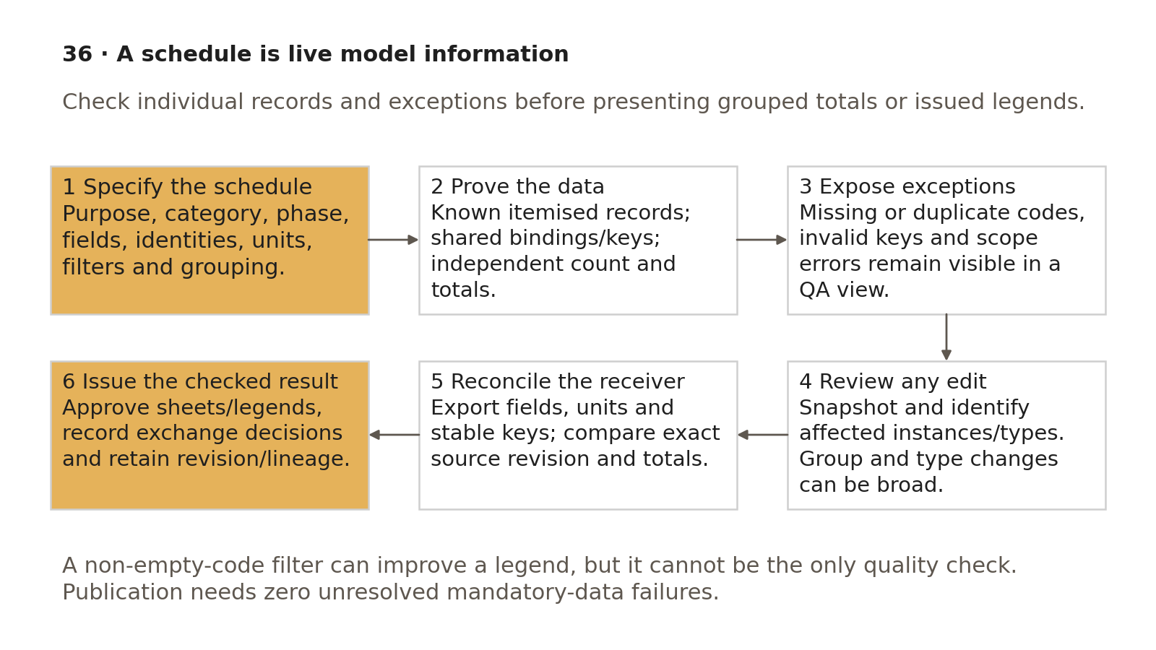
Specify, audit, expose failures, reconcile and approve a revision before using schedules as exchange evidence.
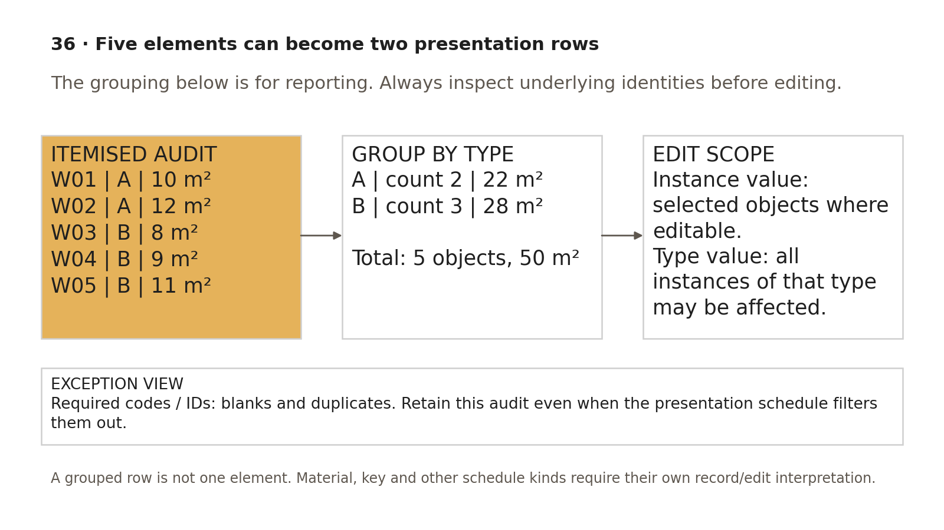
Grouping reduces presentation rows, while object count and edit scope remain explicit.

Known-data exercise — five elements and intentional faults
Create five synthetic wall instances in the exercise's New phase. Populate a required instance DataID with the listed test keys; link it to the office-approved shared definition and Walls instance binding. Use approved type-code definitions for the exercise; do not invent production GUIDs.
DataID | Type | Instance Mark | Type code | Known area m² | Phase
W01 | A | 001 | WF01 | 10.00 | New
W02 | A | 002 | WF01 | 12.00 | New
W03 | B | 003 | WF02 | 8.00 | New
W04 | B | 003 | WF02 | 9.00 | New
W05 | B | [blank] | WF02 | 11.00 | New

For this dataset define the area as simple test faces with no openings/joins that alter the intended area. If actual geometry reports another value, investigate and explain the measurement convention; do not type a fabricated replacement into a calculated field.
• Expected itemised count = 5, total = 50.00 m². Group by type: A count 2 / 22.00 m²; B count 3 / 28.00 m². Two report rows still represent five objects.
• Exception checks must detect duplicate instance Mark 003 and blank W05 Mark. Repeated type code WF02 on instances of one type is valid. Repair to 004 and 005 and recheck uniqueness/count/totals; missing required data prevents issue even when total area is correct.
• Add an Existing-phase control wall with 6.00 m². New-only total remains 50.00 m²; an agreed all-included-scope diagnostic total becomes 56.00 m². Test a linked wall separately with included/excluded flags and the correct phase mapping; record expected counts, not assumptions.
• Add an area-derived calculated field at a synthetic 2.00 currency units/m²: New total should be 100.00 currency units under the exercise rule. This is arithmetic training, not a cost estimate. Validate units/expression and receiver recomputation.
• In a disposable copy, edit one grouped instance field and a type field separately. Record all changed IDs and values; inspect instances outside the report scope for the type edit. Preview a grouped deletion's selection count and dependency impact without treating it as row formatting. Restore the controlled baseline after the sample.

Export mapping and reconciliation record
Schedule field | Receiver field /​ type | Conversion /​ check
DataID | ElementKey /​ text | Exact five unique keys; map linked keys with source-container identity if included
Instance Mark | InstanceMark /​ text | Preserve 001…005; no numeric coercion or blank/​duplicate
Type /​ Type code | TypeName /​ TypeCode /​ text | A→WF01 and B→WF02; approved dictionary semantics
Area | Area_m2 /​ decimal | Explicit m²; five expected values; independent 50.00 sum
Phase /​ source model | Phase /​ SourceRevision /​ text | Correct scope and exact retained model/​link revision
Calculated exercise value | TestValue /​ numeric unit | Same formula/​scope; independent 100.00 total

Retain specification/template revision, model and linked revisions, export filename/hash/date, receiver build, import field types, comparison report, reviewer and disposition. Missing receiver support needs a documented checked alternative. Join by stable key, never by row position after sorting/grouping. Issued sheet/legend and exported audit must reconcile to this same baseline; retain superseded results and repeat checks after changes.

Acceptance criteria / self-check list
• Purpose/category/schedule kind, scope, fields/identities, units, phase/filters, grouping and owner are defined.
• Shared GUID/category bindings, type/instance decisions and controlled key behaviour are tested.
• Itemised and grouped counts/totals/calculations pass the known dataset; phase/link/sheet capability is proved in the adopted build.
• Complete/exception views expose required missing/duplicate/invalid data even when presentation filters hide blanks.
• Edits/deletions have a pre-edit snapshot, known selected IDs/types, reviewed broad type/group scope and tested recovery.
• Material/type legend meaning and category coverage match actual tags and sheet views.
• Export field types, keys, units and totals reconcile in the receiver; source and published/printed schedule revisions match.
• Checker, authoriser and recipient decisions, failure/resubmission and lineage evidence are retained.

Common mistakes
• Counting schedule rows instead of elements or material records.
• Editing a type while expecting only one visible grouped row to change.
• Removing a blank-looking grouped row that contains physical geometry.
• Using non-empty-code presentation filtering as the only QA check.
• Assuming every category supports multi-category, linked or sheet filtering identically.
• Importing 001 as numeric 1, or joining exports by row order rather than stable keys.
• Issuing an updated live schedule without repeating the exchange checks against its new model revision.

Related guides
• 26–27: controlled parameter definitions/bindings; 28: templates and checked sheet outputs.
• 30: URS responsibility and source baseline; 31: logged data/numbering changes.
• 32: complete/exception room and area schedules; 33: finish keys, materials and phase quantities; 35: library information checks.

Editorial coverage record
R14.1–R14.5: specification/procedure 1–5; shared/key definitions; known-data filter/phase/count/totals and calculations; receiver mapping; source-to-issued lineage. C02/C04/C09/C13/C19/C20 addressed with controlled identity/revision, corrected record/edit scope, exceptions and tested capability. No independent P1 defect was established (0/0); the pre-edit/bulk-edit warning is strengthened. P2 1/1 fixed; P3 five-element missing/duplicate-code exercise included. Exercise results require office assessment in the adopted build.

References
Source IDs refer to the supplied RESEARCH.md register. Autodesk Help describes the listed release; verify commands in the project-approved build. Public ISO abstracts establish scope and edition, not clause-level compliance.
• S01 — ISO 19650-1 — Concepts and principles. ISO, 2018, ed.1. https://www.iso.org/standard/68078.html?browse=tc
• S02 — ISO 19650-2 — Delivery phase of the assets. ISO, 2018, ed.1. https://www.iso.org/fr/standard/68080.html
• S04 — ISO 19650-4 — Information exchange. ISO, 2022, ed.1. https://www.iso.org/cms/live/live/en/sites/isoorg/contents/data/standard/07/82/78246.html?browse=tc
• S07 — ISO 7817-1 — Level of information need: concepts and principles. ISO, 2024, ed.1. https://www.iso.org/standard/82914.html?browse=tc
• S16 — ISO 23386 — Methodology to describe, author and maintain properties in interconnected data dictionaries. ISO, 2020, ed.1. https://www.iso.org/standard/75401.html?browse=tc
• A21 — Schedules; About Schedules. Autodesk Revit Help, 2026 / 2024. https://help.autodesk.com/cloudhelp/2026/ENU/Revit-DocumentPresent/files/GUID-F50D6FF4-859E-43A2-A2F6-81C84A1BA0EB.htm ; https://help.autodesk.com/cloudhelp/2024/ENU/Revit-DocumentPresent/files/GUID-73090B70-8A13-4E12-909C-F25D724D5BA7.htm
• A06 — Create Shared Project Parameters. Autodesk Revit Help, Revit 2026. https://help.autodesk.com/cloudhelp/2026/ENU/Revit-Model/files/GUID-114C68A9-FF2B-4D4C-A2DF-3AE7E1F174C8.htm
• A17 — Key Schedules; Create a Key Schedule. Autodesk Revit Help, Revit 2026. https://help.autodesk.com/cloudhelp/2026/ENU/Revit-DocumentPresent/files/GUID-CD22DA24-4162-4AB2-B1D3-02CEBE918444.htm ; https://help.autodesk.com/cloudhelp/2026/ENU/Revit-DocumentPresent/files/GUID-75B3B9C4-6899-4DC9-8424-DFC901701B48.htm
• A14 — Project Phasing. Autodesk Revit Help, Revit 2026. https://help.autodesk.com/cloudhelp/2026/ENU/Revit-DocumentPresent/files/GUID-2E104AB8-68B9-46F2-9BE2-B54E767429E5.htm
• P05 — Data lineage. Microsoft Learn, Undated live documentation. https://learn.microsoft.com/en-us/power-bi/collaborate-share/service-data-lineage
• G-C — Guidance C — Facilitating the CDE workflow and technical solutions. UK BIM Framework, ed.1, September 2020. https://ukbimframework.org/wp-content/uploads/2020/09/Guidance-Part-C_Facilitating-the-common-data-environment-workflow-and-technical-solutions_Edition-1.pdf

