37 · Building a Family — Worked Example: a Chair
Linked copies: ID STD-37 · TBP page · BABOOM edition · ArchHub: BABOOM companion
Office BIM Workshops · Presenter: Ahmed Fargaly · Recorded session: 13 February 2025 · BBM-STD-37 · V0.2 · 14 October 2026 · WIP training revision; office approval pending

Purpose & scope
Build one reusable chair rather than redrawing a detail group in every project. Keep the workshop method: plan the questions the object must answer, start with a simple box, create reference planes and labelled dimensions, constrain each form and flex after every step. Add complexity only when the intended plan/3D/quantity/document use needs it.
This guide is a synthetic chair-family exercise, not a manufacturer specification or certification. The family author builds; the discipline/data owner defines purpose, materials and required data; the BIM/library owner approves the tested release. Project integration, exchange checks and wider library reuse are separate decisions. Existing externally sourced geometry also requires guide 35 intake/rights evidence.

Standards basis
• ISO 19650-1:2018 and ISO 19650-2:2018 support controlled methods and information production. Office Manual BBM-STD-01 V0.1 §§3.2, 6.1, 8.2, 9, 11–12 and BEP BBM-STD-10 V0.2 §§6.5–6.6, 8.3, 8.6 and 10 serve library/data/quality controls.
• ISO 19650-4:2022 supports tested exchange outputs. ISO 7817-1:2024 defines information need by purpose, exchange, actors and objects across geometry, properties and documentation. LOD 200–300 alone is not this specification.
• ISO 23386:2020 supports property definitions, identity and ownership. Autodesk A18 supports template/host choice and testing before sharing; A06 supports shared category bindings and type/instance semantics; A07 distinguishes project-level global constraints from the family parameters used here.
• Autodesk A19 supports warning/performance review, A20 material/layer principles where relevant and S12 agreed IFC receiving tests. Verify every command, category/host capability and export profile in the adopted build.

V0.2 corrections and retained workshop choices
Recording shortcut | V0.2 instruction /​ why
JPG is lossless; use one export setting always | Remove the unverified lossless label. Choose output format/​pixel dimensions for the use and inspect exported crop, text/​lines and artifacts. DPI alone does not establish image quality (C20/​X07)
Start a new project from the family template | Start a new family from the approved .rft category/​host template; do not edit the master template
Furniture means bought, Casework means custom | These are useful office procurement conventions, not universal category rules. Choose and test the actual category/​host/​tag/​schedule/​exchange purpose; a chair here uses Furniture
If unsure start Generic; category can always be swapped | Resolve required category and hosting first. Some templates/​hosts are specialised; changing category later is not guaranteed to preserve placement, tags, data or export
Spaces/​lowercase always break exports | Uppercase/​no-space codes are an office naming convention where adopted. Export safety is established by the actual mapping/​test, not letter case alone
Built-in parameters cannot be changed | Built-in definitions are managed by Revit. Values may be editable, computed or read-only depending on property/​context; inspect each value rather than claiming every one is immutable
Type seat height is universal; no shared data needed here | Type seat height suits the chosen product variants. Unique placement/​asset data is instance-level; required tag/​schedule/​exchange properties use controlled shared definitions as appropriate (C09)
One modelled real object satisfies later LODs | Specify required geometry/​data/​documents for each use. Simplify unseen detail; update tests when requirements change

A system family is edited through project types/settings; a loadable family is authored separately and loaded. Approved office defaults are a starting baseline, not proof that every required component/type is present. Detail-line furniture remains a labelled temporary graphic if retained; it is excluded from a physical-element procurement count until replaced and checked.

Chair requirement and ownership record
Requirement | Exercise decision /​ required office entry
Purpose /​ exchange | Plan layout and clearance, coordination geometry, chair count/​type data, one tag/​schedule and IFC receiving test
Category /​ template /​ hosting | Furniture; approved unhosted metric template; template revision/​hash and project Revit build
Origin /​ insertion | Base datum Z=0; named centre planes with agreed origin; tested level/​offset/​rotation behaviour
Geometry | Width, depth, total height and seat height control envelope; legs/​seat/​back remain inside defined extents
Materials | Seat/​back and leg material parameters; approved codes/​specification data, appearance checked separately
Type data | TypeCode and description; dimensions and chosen material variants; controlled dictionary owner
Instance data | Unique DataID/​Mark; level/​offset and purpose-specific asset/​property requirements
Property identity | Office registry definition/​GUID, data type/​unit, Furniture binding, type/​instance and tag/​schedule/​IFC mapping
Documentation | Plan symbol, section/​elevation/​3D, dimension/​flex report, material data and approved image export
Review /​ performance | Family author, discipline/​data reviewer, library approver; approved hardware/​sample size and explicit performance threshold

Fill actual registry GUIDs from the approved shared-parameter source; this guide intentionally does not invent production identities. A new property needs definition/owner/approval before binding. Record whether the requirement is family-only, built-in or shared. Project global parameters can drive permitted project constraints, but they are not substitutes for the family's controlled Width/Height dimensions or exchange property definitions.

Parameter and constraint plan
Parameter /​ reference | Data type /​ unit | Scope /​ owner | Relationship /​ expected behaviour
W /​ left-right planes | Length /​ mm | Type; family author | Dimension left→right; centre maintained by equality or documented symmetric constraints
D /​ front-back planes | Length /​ mm | Type; family author | Dimension front→back; origin/​centering intentional
H /​ base-top planes | Length /​ mm | Type; family author | Base at 0; top at H; back remains within total envelope
SEAT-H /​ base-seat plane | Length /​ mm | Type; family author | Seat height below H under valid input range
SEAT-T | Length /​ mm | Type; author | Positive seat thickness; underside and leg termination have an unambiguous relationship
SEAT-MAT /​ LEG-MAT | Material | Type for this exercise; discipline owner | Materials associated to relevant forms, not only to render appearance
TypeCode /​ Description | Text | Type; data/​discipline owner | Three controlled exercise variant codes and descriptions
DataID /​ instance Mark | Text | Instance; project author | Unique per placement; shared definition where required for tag/​schedule/​exchange

The geometry range is W450–600, D450–600, H750–900 and SEAT-H425–500 mm for this exercise only; SEAT-T30 mm is a fixed test choice. Validate every allowed combination used. Formula/constant choices must be intentional, documented and unit-consistent; avoid circular formulas, duplicated constraints or unconstrained forms. Nominal leg termination follows the seat underside at SEAT-H minus SEAT-T. Required input limits and geometry validation are separate from manufacturing or ergonomic compliance.

Step-by-step procedure
1. Set up the approved family. Use File → New → Family, choose the approved Furniture/unhosted metric .rft and save a WIP .rfa. Record template/source, Revit build, intended origin, author and permitted use. Do not open and edit the master. Establish category/subcategories and plan/3D visibility to suit the agreed output. For another purpose/category/host, resolve it before modelling and record a separate test plan.
2. Plan references and dimensions. Draw/name base, centre left/right, front/back, left/right extent, seat and top reference planes. Define origin planes intentionally. Dimension references and label W/D/H/SEAT-H/SEAT-T using the parameter plan. If centring uses equality constraints, avoid an additional conflicting formula on the same dimension. A clean set of controls is preferable to constraints on incidental geometry faces.
3. Flex the skeleton first. Enter the minimum, nominal and maximum values below before making detailed solids. Confirm planes, origin and dimensions remain consistent. Include mixed extremes; a family that passes only nominal values is not accepted. Resolve constraint warnings now rather than covering them with forms.
4. Build the simple seat/back. Create a simple extrusion or other appropriate form on the intended work plane, align/lock geometry to the named controlling planes and apply the agreed thickness. Shape using void extrusions/revolves only where the use needs it; constrain void positions/extents as well. Record any exceptions to the reference-plane method and test them. Flex after each new form/cut; inspect whether seat/back remain within envelope and material/void behaviour is correct.
5. Build and constrain legs. Use a simple extrusion or the workshop's tapered swept-blend approach where needed; set the intended work plane/path and top/bottom profiles. Reference the base and seat-underside controls rather than an unstable generated face. Mirror or array only if its constraint/dependency behaviour is reviewed. Re-flex and inspect each leg in 3D, including mixed extremes; an unconstrained leg that escapes the envelope fails. Avoid unnecessary arrays/joins/imported detail and document intentional formulas.
6. Associate materials and required data. Assign SEAT-MAT/LEG-MAT to forms, approved material codes/description and purpose-specific specification data. Apply controlled type codes/descriptions and required shared property definitions/GUIDs from the approved dictionary; distinguish instance identifiers. Material appearance alone is not a procurement/specification claim. Confirm dimensions and displayed values use the intended units; existing built-in values may be writable or read-only, and calculated values must be changed through their controlling inputs.
7. Set plan/3D representation. A clean symbolic plan representation may hide selected 3D geometry in plan while preserving it in 3D. Test actual Coarse/Medium/Fine and plan/section/elevation/3D visibility and cut behaviour in a project, not just the Family Editor. Constrain symbolic extents and avoid duplicate plan lines. Verify category/subcategory controls and bounding envelope needed for clearance/coordination; lightweight graphics must not hide required geometry from the exchange.
8. Create and test variant types. Create the min/nominal/max exercise variants with the matrix below. Test all supported values, material variants and mixed extremes. Record expected versus actual dimensions, legs/voids/symbol behaviour and errors. Use only required types in the project; a catalogue may manage larger variant libraries under guide 35. A “successful save” without dimensions and warnings is incomplete.
9. Load into a controlled project. Place two instances of each variant on an approved level. Test level/offset, rotation, mirrored placement if required and reloading with the selected parameter-value option. For hosted alternatives test both host placement and host modification/recovery; this exercise's unhosted choice needs a specific insertion/offset test instead of a fictitious host. Record IDs and type/instance data before/after loading or replacement.
10. Replace temporary layout graphics carefully. In a copy, edit the furniture group and replace an approved sample of old detail lines with the chair. Confirm every group instance's result, counts, annotation, phase and parameter variation settings. Group edits can propagate, while unique IDs must remain correctly governed; test aligned versus varies-by-group-instance behaviour for the shared instance fields where supported (A06). Swapping another same-category family can alter origin/constraints/materials/data; test replacement, record IDs and preserve required values rather than promising automatic equivalence.
11. Test tags, schedules and open exchange. Make a furniture tag reading the agreed fields and an itemised schedule with DataID, TypeCode, dimensions and materials. Confirm six distinct instance IDs, three types, two instances per type, correct units and controlled bindings. Group by TypeCode for presentation, retaining the itemised audit. Export the agreed IFC schema/profile; verify the required chair object/class and properties/units, geometry dimensions, materials and count in a receiving tool. Record native/exporter/profile/receiver revisions. Do not infer an IFC mapping from the category alone.
12. Measure efficiency and release. On the approved machine record open/load/regenerate timings and file size for the family/test model against an agreed baseline and threshold; classify warnings, nesting/imports, constraints and unnecessary detail. There is no universal acceptable file size here. Resolve critical faults, retain performance/flex/tag/schedule/receiver evidence and obtain discipline/data/library-owner acceptance. Release a revisioned file/dependency record with compatible build, allowed use, hash and recovery baseline; a Shared folder alone does not approve it. Later changes/new purposes require a new revision and affected regression tests.
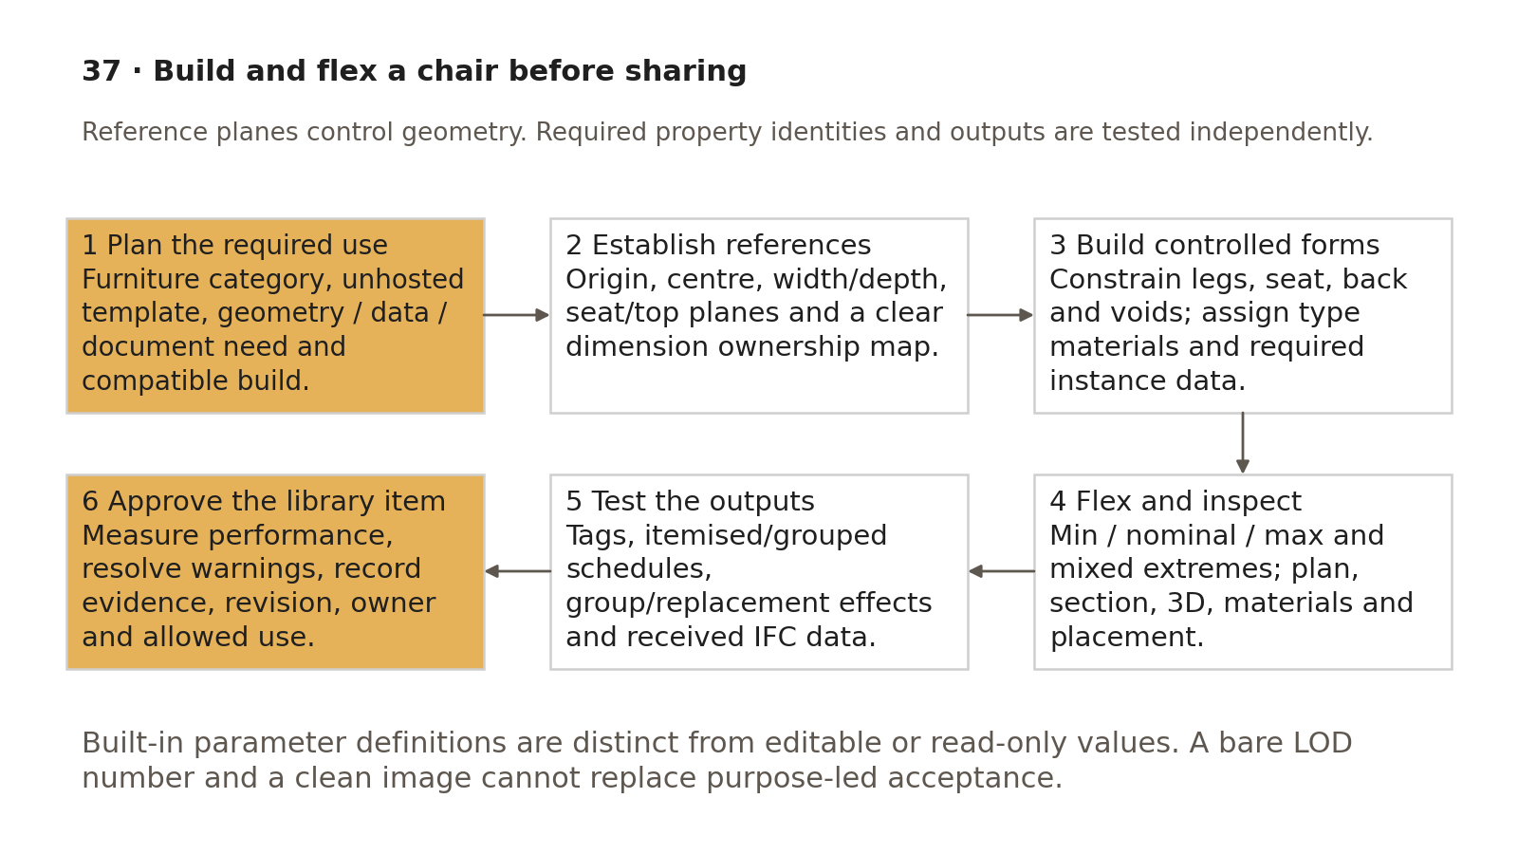
Plan references and controlled data, then flex and prove outputs before library release.
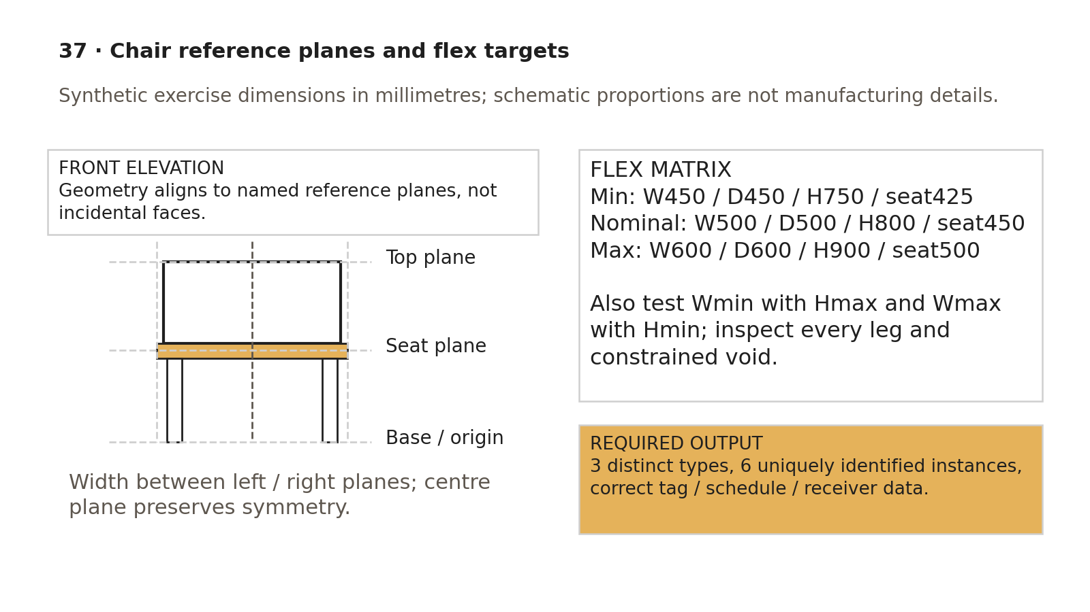
Named planes constrain the chair; dimension extremes and mixed cases expose geometry that a nominal-only test misses.

Assessed min / nominal / max exercise
Variant /​ TypeCode | W mm | D mm | H mm | SEAT-H mm | SEAT-T mm | Expected project instances
Minimum /​ CH-01 | 450 | 450 | 750 | 425 | 30 | 2
Nominal /​ CH-02 | 500 | 500 | 800 | 450 | 30 | 2
Maximum /​ CH-03 | 600 | 600 | 900 | 500 | 30 | 2

Use test DataIDs CH-I01…CH-I06 from the approved instance definition. In the itemised schedule expect six unique keys, correct type dimensions/material codes and a count of six. Grouped by TypeCode expect three rows, each count two; grouped rows are not three physical chairs. Change one instance's DataID and prove the other five are unchanged. Change CH-02's type seat height in a disposable copy and verify both CH-02 instances respond while their identifiers remain distinct; restore the accepted values after testing.
Test W450 with H900, W600 with H750 and the relevant depth/seat extremes. No leg/form/void may escape its intended references; seat underside must match the recorded control relationship. Capture plan, section/elevation, 3D, tag and itemised/grouped schedule plus received IFC dimensions/identities. If replacing grouped detail graphics, compare all group instance counts and unique ID behaviour. The assessor records each failed check, remedy and reassessment. Missing required tags/properties or incorrect count/geometry prevents release even when the rendered chair looks convincing.
Assessment evidence | Expected decision condition
Requirement/​template/​category/​origin record | Approved purpose, Furniture/​unhosted choice, exact template/​build and property owner
Plane/​constraint map and flex matrix | All three variants and mixed cases meet dimensions/​relationships without unresolved critical failures
Material/​visibility output | Approved codes, correct symbolic/​3D representation and required geometry visible/​exported
Placement/​group/​replacement tests | Origin/​offset and relevant IDs/​data/​counts preserved or explicitly migrated
Tags/​schedules/​receiver | Six unique instance IDs, three two-instance types and correct values/​units/​objects in the received profile
Performance/​warnings/​release | Measured accepted criterion, classified warnings and library owner revision/​approval/​evidence

No real chair file or test execution is supplied by this markdown exercise. The learner builds the file and the assessor retains actual results under the approved office training workflow.

Export a useful review image
1. Use the intended view/detail level and inspect crop, annotation crop, visibility and phase. Zoom to Fit can help review framing; it does not independently prove the exported crop or pixel dimensions.
2. Choose the supported Export → Images route and explicit view/window selection. Set intended pixel dimensions or scale/resolution for the use; inspect the actual exported dimensions. Avoid blanket “never Fit to” advice where fitting is the controlled way to obtain the intended output size.
3. For a line/text review select an appropriate tested format such as PNG where supported; do not call the recording's JPG choice lossless. Retain model/view revision and settings; inspect crop, small text/line legibility, material appearance, backgrounds and compression artifacts in the actual output.
4. Use screenshots/images as review evidence, with caption and source revision. They do not prove parametric behaviour, required data, manufacturing tolerances or IFC acceptance.

Acceptance criteria / self-check list
• Intended use/information need, exact template/build, category/host and origin are approved and recorded.
• Named references, dimensions, constraints and parameter/data ownership form a clear dependency map.
• Type/instance/material choices and required shared identities/bindings/units survive placement and reload.
• Minimum, nominal, maximum and mixed extremes pass geometry, legs, constrained voids and material checks.
• Required plan/section/3D visibility, symbols, insertion/offset/rotation and relevant host tests are demonstrated.
• Tags, itemised/grouped schedules and group/replacement effects preserve required counts/IDs/data.
• Received IFC class, properties/units, geometry and materials reconcile to the accepted native version.
• Measured performance and warning review meet the recorded purpose-specific criterion.
• Images have verified framing/dimensions/quality; no unsupported lossless or universal parameter/category claim remains.
• Library release has owner approval, compatible build, revision/hash, evidence, allowed use and recovery; new requirements trigger retests.

Common mistakes
• Modifying the master template or starting a project when a new family is required.
• Choosing Generic/Casework because the category can supposedly always be changed later.
• Locking forms to accidental faces, leaving mirrored legs or voids unconstrained, or testing nominal dimensions only.
• Confusing type dimensions, instance IDs, built-in value editability and shared definition identity.
• Optimising only a render while required tags/schedules/counts/IFC properties fail.
• Treating a group edit or same-category swap as automatically preserving all instance data.
• Sharing before tests or calling every image export lossless.

Related guides
• 26–27: type/instance/shared parameters and controlled family development; 28: view/template/output checks.
• 29: advanced geometry and purpose-led simplification; 31: logged changes and recovery.
• 35: external-content rights/intake/library admission; 36: known-data schedules and receiver reconciliation.

Editorial coverage record
R15.1–R15.5: requirement record and procedure 1/9; reference/constraint and property ownership maps; material/type/instance/data plan; min/nominal/max/visibility/placement/tag/schedule tests; performance and IFC library-release gate. C02/C09/C11/C12/C17/C20 addressed with controlled naming/property identity, purpose-led need and corrected image/built-in/template claims. No demonstrated P1 release defect was established (0/0); unsupported teaching statements are corrected before reuse. P2 1/1 fixed; P3 assessed dimension matrix and expected schedule outputs included. Exercise execution remains an office assessment task.

References
Source IDs refer to the supplied RESEARCH.md register. Autodesk Help describes the listed release; verify commands in the project-approved build. Public ISO abstracts establish scope and edition, not clause-level compliance.
• S01 — ISO 19650-1 — Concepts and principles. ISO, 2018, ed.1. https://www.iso.org/standard/68078.html?browse=tc
• S02 — ISO 19650-2 — Delivery phase of the assets. ISO, 2018, ed.1. https://www.iso.org/fr/standard/68080.html
• S04 — ISO 19650-4 — Information exchange. ISO, 2022, ed.1. https://www.iso.org/cms/live/live/en/sites/isoorg/contents/data/standard/07/82/78246.html?browse=tc
• S07 — ISO 7817-1 — Level of information need: concepts and principles. ISO, 2024, ed.1. https://www.iso.org/standard/82914.html?browse=tc
• S16 — ISO 23386 — Methodology to describe, author and maintain properties in interconnected data dictionaries. ISO, 2020, ed.1. https://www.iso.org/standard/75401.html?browse=tc
• A18 — Create a Family from a Template. Autodesk Revit Help, Revit 2026. https://help.autodesk.com/cloudhelp/2026/ENU/Revit-Customize/files/GUID-228D213B-9497-48A6-AAE1-4E54F7834931.htm
• A06 — Create Shared Project Parameters. Autodesk Revit Help, Revit 2026. https://help.autodesk.com/cloudhelp/2026/ENU/Revit-Model/files/GUID-114C68A9-FF2B-4D4C-A2DF-3AE7E1F174C8.htm
• A07 — Global Parameters. Autodesk Revit Help, Revit 2026. https://help.autodesk.com/cloudhelp/2026/ENU/Revit-HaveYouTried/files/GUID-84DC949A-D711-4AA7-A8EF-D6E8DAD5E386.htm
• A19 — Model Efficiently. Autodesk Revit Help, Revit 2024. https://help.autodesk.com/cloudhelp/2024/ENU/Revit-Customize/files/GUID-8287BB99-B15F-4809-B6AF-3DA26B8CD027.htm
• A20 — Compound Structure. Autodesk Revit Help, Revit 2026. https://help.autodesk.com/cloudhelp/2026/ENU/Revit-Model/files/GUID-08E47F82-BFA1-4CAB-B2EA-6C8DC9049AD8.htm
• S12 — Industry Foundation Classes (IFC). buildingSMART International, Undated live page; 2024 ISO edition. https://www.buildingsmart.org/standards/bsi-standards/industry-foundation-classes/?lang=en
• A21 — Schedules; About Schedules. Autodesk Revit Help, 2026 / 2024. https://help.autodesk.com/cloudhelp/2026/ENU/Revit-DocumentPresent/files/GUID-F50D6FF4-859E-43A2-A2F6-81C84A1BA0EB.htm ; https://help.autodesk.com/cloudhelp/2024/ENU/Revit-DocumentPresent/files/GUID-73090B70-8A13-4E12-909C-F25D724D5BA7.htm

